#### 33 A 4-year-old girl from a rural community in the southern USA is evaluated for anemia. She has not traveled outside the USA. Her hematocrit is 28o , leukocyte count is 8100/mm with 15% eosinophils, and mean corpuscular volume is 65 um. Which of the following tests is most likely to yield the correct microbiological diagnosis*

1. Blood smear
2. Bone marrow biopsy



1. Polymerase chain reaction
2. Serology

The Correct Answer is : C. Microscopic examination of stool

The girl's symptoms and laboratory findings suggest an iron-deficiency anemia caused by a parasitic infection. such as a hookworm. Examining the stool under a microscope is the best way to detect the presence of such parasites.

### 34 A 10-year-old girl of Hispanic descent is brought to the physician by her grandmother because of an intermittent nonproductive cough during the past 4 months. She eats mostly fast food and does not exercise. She lives in an inner city apartment near a highway. Family history includes debilitating multiple sclerosis in her mother and rheumatoid arthritis in her maternal grandmother. She is at the 10th percentile for height and 70th percentile for weight. Bilateral wheezes are heard on auscultation. Which of the following historic factors has most likely increased this patient’s risk for this condition*

1. Ethnicity
2. Family history of autoimmune disease
3. Gender
4. Height and weight percentiles

F. Poor diet and exercise

The Correct Answer is : E. Location of home

The girl's nonproductive cough and wheezing are most likely due to asthma, which can be exacerbated by exposure to air pollution. Living near a highway exposes her to higher levels of air pollution, which can increase her risk for developing asthma.

#### 35 A 20-year-old woman comes to the emergency department 30 minutes after slipping on ice and extending her hand to break her fall. Palpation of the anatomic snuff-box produces pain. A wrist x-ray is most likely to show a fracture of which of the following carpal bones?



1. Lunate
2. Triquetrum
3. Pisiform
4. Trapezium
5. Trapezoid
6. Capitate
7. Hamate

The Correct Answer is : A. Scaphoid

The anatomic snuff-box is a small. triangular depression on the lateral aspect of the wrist. Pain in this area after a fall is highly suggestive of a scaphoid fracture, the most commonly fractured carpal bone.

#### 36 A 25-year-old man is brought to the emergency department because of a

30-minute history of perioral tingling, difficulty breathing, sweating, vomiting, diarrhea, incoordination, and weakness. His symptoms began 30 minutes after he ate shellfish at a restaurant. His respirations are 25Tmin. Physical examination shows increased salivation and twitching of the muscles of the lower extremities. Laboratory studies of the ingested fish show a toxin that inhibits axonal transmission. This toxin most likely blocks the action of which of the following? A) B) C) D) E)

1. Inositol 1, 4, 5-triphosphate (IP3)-gated Ca 2+ channel
2. Na+-K+ ATPase
3. Na+-linked glucose transporter
4. Nicotinic acetylcholine



The Correct Answer is : E. Voltage-gated Na+ channel

The man's symptoms suggest he has been exposed to tetrodotoxin. a potent neurotoxin found in some shellfish. Tetrodotoxin blocks voltage-gated sodium channels. preventing the generation and propagation of action potentials in neurons and muscle cells.

### 37 A 35-year-old woman develops fever, headache, chills, and malaise 2 days after delivering a healthy female newborn at 38 weeks gestation. Her temperature is 38.3 C (101 F). Physical examination shows an enlarged, tender uterus. Lochia is profuse and malodorous. A complete blood count shows increased leukocytes. This patient is at greatest risk for developing which of the following complications*

1. Amniotic fluid overload
2. Cervical dysplasia
3. Eclampsia
4. Endometriosis
5. Inverted

uterus



The Correct Answer is : F. Thrombophlebitis

The woman's symptoms and findings indicate postpartum endometritis, an infection of the uterus. This condition increases the risk of developing thrombophlebitis, a blood clot in a vein accompanied by inflammation.

### 38 When control lymphocytes are treated with corticosteroids, a majority of cells shrink in size and develop peripheral chromatin condensation, cytoplasmic organelles are intact. DNA isolated from the control lymphocytes, electrophoresed on an agarose gel, and stained with ethidium bromide, shows a ladder of regularly spaced bands. When lymphocytes from the same culture are transfected so that they overexpress Gene X, which encodes a normal protein product, the cells continue to proliferate and do not undergo any of the morphologic changes seen in the control cells. Gene X is most likely to encode which of the following?



1. ERBB2 protein
2. P53 protein
3. Platelet-derived growth factor
4. Rb protein

The Correct Answer is : A. BCL2 protein

The overexpression of Gene X prevents cells from undergoing morphological changes characteristic of apoptosis, suggesting that it encodes an anti-apoptotic protein. BCL2 is an anti-apoptotic protein that prevents cell death by inhibiting the release of cytochrome c from mitochondria.

pain o'f the left leg after he fell down a 'flight o'f stairs 30 minutes ago. An x-ray of the left lower extremity shows a fracture of the left femur and shows adjacent radiolucent areas. During an operation on the 'femur, tissues 'from the radiolucent areas is obtained.

Analysis of the tissue shows clear cell carcinoma. A primary neoplasm of which of the following is the most likely cause of the 'findings in this patient?

1. Bone
2. 



E. Prostax

The Correct Answer is . C. Kidney

Clear cell carcinoma is most commonly associated with primary tumors of the I‹idney, SpecifiATly renal cell carcinoma. Radiolucent areas around the fracture site suggest metasatic spread of the primary cancer.

40 lesion in which of the 'following brain structure is most likely to change the affective aspect o'f pain sensation?



C. H ippoc.am pad for matron



E. Sopramar g\naT gyrus

The Correct Answer is . B. Cingulate gyrus

The cinguTam gurus is involved in be emotional processing of pain. Lesions in this area can affect be affective {emotional) aspect of pain sensation. while oder structures listed are less involved in this aspec of pain processing.

sudden onset of severe right-sided back pain. She has a history of recurrent urinary tract **infections.** Her most recent infection was 1 month ago, she was successfully treated for Klebsiella pneurrioniae with antibiotics. The patient is not taking any medication. She says that she has been eating more fast food and **drinking** less water during the past month because of a busy schedule. She is sexually active and uses a 9permicidal cream for contraption. Her temperature is 37 C (98.6 F), pulse is 100/min, **respirations** are **14/min, and** blood pressure is 138/66 mm Hg. Physical **examination** shows marked tenderness to palpation over the right flank. Urinaly9is shows:

Protein 1•

RBC

WBC 20 -2&/hpf

An excess of which of the following is the most likely underlying cause of this patient's

flank pain?

A. CaIc\om oxa\ate

B. Cystine





E. M nn acid

The Correct Answer is . C. Magneslum ammonium phosphate

The patients symptoms, history of recurrent UTIs, alkaline urine pH. and recent Klebsiella pneumoniae infection suggest a sliuvite (magnesium ammonium phosphate) kidney stone. which are often associated with recurrent UTIs caused by urease-producing bacteria.

42 A 43-year old worrian comes to the physician because of a 2-month history of intertriittent **abdominal pain.** The **pain** occurs after fatty meals and is localized to the right upper quadrant. Ultrasonography of the abdomen shows cholelithiasis. The patient elects to begin a trail of ur9odiol therapy before considering operative treatment. Which of the following is the primary mechanism of action of this medication?



B. Enhanced nho\weroI a bsorption

C. Enhanced hepawn nholwerol syMhesi s

D. Tnhi bition of bale acid syMhes\s

E. Inhibition of 3-HUG-CoA

The Correct Answer is . A. Decreased cholesterol secretlon Into blle

Ursodiol is a bile acid that reduces choleslerol secretion into bile, thus helping dissolve cholesterol gallstones. It is used in the treatment of cholelithiasis, as in his case.

A. Chrange maNrnaT infection prior to concep'tio n

B. Fai lure of mammal antibody to cross the placema

C. Maternal vacc\nation with love virus vacc ine during pregnancy

D. Presence of maNrnaT ant\v ira I antibody pnor to

The Correct Answer is . E. Primary maternal infection during pregnancy

The risk of vertical vansmission ffrom mother to fetus) is highest when the mother experiences a primary infection during pregnancy. This is because the mother has not yet developed immunity to the virus. making it easier for the virus to cross the placenta and infect the fetus.

53 A 13-year-old girl is brought to the physician by her mother because of several blemishes on her face and back 'for 8 months. Physical examination shows scattered comedones and papules on the face and back. Treatment with a medication that decreases cohesion between epidermal cells and increases epidermal turnover is initiated. Which of the 'following drugs was most likely prescribed?

1. Beozoy\ per ax\de
2. CI\ndamy ci n

C. Metroni dazo\e

The Correct Answer is . E. Tretinoln

Trefinoin. a retinoid, decreases cohesion between epidermal cells and increases epidermal turnover, helping to clear acne by promoting be shedding of dead skin cells and preventing the formafion of comedones.

54. A S-month-old boy is brought to the emergency department because of a 3-day history of fever and severe wet cough. His terriperature is 40.5 C (104.9 F), and respirations are 6S/min. Crackles are heard over all lung fields. A photomicrograph of a silver-stained specimen obtained via bronchoalveolar lavage is shown. In addition to a lack of expression of hurrian leukocyte antigen-DR molecules by lymphocytes, flow cytometry of a peripheral blood specimen will most likely show markedly decreased populations of which of the following cell types?



B. Dendr\ tic ce lbs

C. Monoc ytes

D. N#ura I kd ler ce lbs

E. Segmented ne utroph ids

The Correct Answer is . A. CD I+ T lymphocytes

The patients symptoms suggest severe combined immunodeficiency {SCID), which is characlerized by a lack of functional T lymphocyles. including CD4+ T cells. This leads to increased Susceptibility la severe infections.

1. E x am in aI iO r\ of sy iJ ov i a11Ioi d frown aiJ eiJIa rdu d ie iJ du r k r\uu s huwa rJ urri uro us leui km uytus w it t\

r\uu dluEU a pud ir\t ra yt op Isa rri i c inc Ioa i oiJ s. EU mil u f tt\u ft IIn wirJ¿ is I t\s rri Out Iikel y ua u se O f I hu a rtt\ r iti s '/

* 1. Autoimm une process



C. Ly me disease



E. Trauma

The Correct Answer is . B. Gout

The presence of needle-shaped intracyloplasmic inclusions within leukocyles in synovial fluid is characteristic of gout. hich is caused by the deposition of monosodium urale crystals in joinls.

S7 A 24-year-old man comes to the physician for a follow-up examination. He has severe Crohns disease that has not responded to initial standard therapy. lnfliximab is recommended. Before beginning this pharmacotherapy , which of the following tests is most appropriate to assess the risk o'f drug-induced complications?



C. Pri monary function @sting

D. E chocar di og raphy

E. EEG

The Correct Answer is . B. PPD skln testing

Infliximab. an anti-TNF-alpha monoclonal antibody, in reacfivate latent tuberculosis infection. Therefore, PPD skin testing is important to assess the risk of drug-induced complications before initiating his therapy.

1. A previously healthy 33-year-old man comes to the physician because of a 3-week history of cough and the frequent need to clear his throat. He takes no

medications. He does not smoke cigarettes. Examination of the nasopharynx shows secretions and cobblestoning. The patient says, “I am concerned that I may have lung cancer like my dad. His lung cancer started with a cough just like this.” Which of the following is the most appropriate response by the physician?

* 1. “T am concerned that you may have an anti eg disonder bet arse of your over r section be you r lakhe r's diagnosis’ &

C. "It's not a good idea to worry about somethi ng that hasn't happe ned yet. Let's discuss why you are bothersd by your father's diagnoses .”

1. “It's passible you do have c.ancar. but it's proba bly not long cancer since you don't smoke."
2. "You don't have to worry a bout the same thi ng happening to you bet.arse you don't smoke Tike your dad did.’

The Correct Answer is . B. "It Is unlikely that thls cough is a symptom of cancer. Let's talk about your symptoms and how we can treat them."

Let's talk about your symptoms and how we can treat them."

Explanation: The phySiWan's response should be empaletic and informative. addressing the patient's concern while providing reassurance.

1. A 23-year-old man is brought to the emergency department by the police after becoming agitated and throwing **milk cartons off** the shelves in a grocery store. When approached by the store rrianager, he screamed, “I found a **turtle!** The milk will curdle!” **His farriily is contacted, and** they describe him as having been **quiet** and **studious until** hi9 fre9hrrian year of college 5 years ago. Since then, he has become increasingly suspicious and has had rriinirrial contact with them. To their knowledge, he has never required admission to the **hospital. He is** disheveled, malodorous, and appears to be responding to internal stirriuli. During the examination he turn9 away from the **physician** and yells, “Shut up! I told you to stop talking about the poison.” His 9peech is incoherent but ha9 a norrrial rate and rhythm. He says his mood is “okay” but refuses to an9wer **additional** questions. Routine laboratory studies are within the reference ranges and urine toxicology screening is negative. Which of the following is the most likely diagnosis?
   1. Sch izoaffective disonder
2. Sertaoph renffor m dosor der
3. Sch izotypaT peraonality disorder

The Correct Answer is . C. Schlzophrenla

The patients symptoms, including disorganized speech, auditory hallucinations. and a prolonged duration of symptoms for more than six months. are consistent with a diagnosis of schizophrenia.

1. A 22-year-old woman comes to the physician because of increasing fatigue, lightheadedness, and **palpitations during** the **past** 6 rrionth9. She has been following a strict vegetarian diet for 6 years. Her pulse is 100/min. Physical examination shows pallor. There is nurribness and paresthesias of the upper and lower extremities. Serurri studies show increased concentrations of methylmalonic acid and homocysteine. This patient's symptoms are most likely due to a deficiency of which of the following vitamins?
   1. Foci n acid
   2. Vitami n B2 {r\bofIav\n}

 Vita man B6



E. Vita man C ascorbic acid]

The Correct Answer is . D. Vitamlne BJ2 fcobalamln)

The patients symptoms, including fatigue. lightheadedness, palpitations. numbness. pareslflesias, and increased levels of methylmalonic acid and homocysteine. suggest a vitamin B12 deficiency, which oan be common in strict vegetarians.

1. Investigators are evaluating oxygen consurription by different segments of the renal tubules in experimental animals. Arterial oxygen saturation is decreased in blood delivered to isolated perfused pig kidneys. Results show that as oxygen delivery declines, urine output decreases. A biopsy specimen of the ischemic model is obtained. Tubular cell death is most likely to be observed in which of the following areas?
   1. Cortic.aT col letting dunt
   2. D istaT non saluted TuboI e

C. Loop of he nie



The Correct Answer is . E. Proximal convoluted tubule

In the case of renal ischemia. the proximal convoluted Abule is the most susceptible to inju/ and cell death due to ils high metabolic activity and oxygen consumption. The other segments of the renal kbuTes listed have lower oxygen requirements and are less vulnerable to ischemic damage.

1. A 24-year-old woman comes to the physician because of a 3-day history o'f vaginal discharge with itching. She is currently being treated with cipro'floxacin for cystitis. Her vital signs are within normal limits. A photograph of the vaginal area is shown. Which of the 'following is the most likely causal organism?

B. Ch lamydia tr acho mad s

C. Herpes si mpTex virus

D. Neisseria go no r rhoeae

E. Trichomo nas vagi oakis

The Correct Answer is . A. Candida alblcans

The patient presents wit a 3-day history of vaginal discharge and itching and is currently being treated with ¢iprofloxacin for cystitis. These symptoms suggest a yeast infecfion. which is commonly mused by Candida albieans

Candida albicans is a type of fungus that can cause vaginal yeast infections. especially in situations where the normal bacterial flora is disrupmd, sub as during anñbiotic treauent. In this case. the patient’s recent use of ciproRoxacin for cysfitis may have disrup#d the normal vaginal flora. leading to an overgrowth of Candida albicans and the Subsequent development of a yeast infection.

1. A S2-year-old woman comes to the emergency department because o'f a 2-week history of progressive shortness of breath and fatigue. Her pulse is 102/min , respirations are 22/min, and blood pressure is 100/80 mm Hg. Physical examination shows muffled breath sounds. Echocardiography shows a large pericardial effusion. Pericardiocentesis yields cloudy, serosanguineous fluid. Analysis o'f the fluid shows an increased protein concentration, numerous RBCs, and a small number of WBCs, indicative of malignancy. Metastasis from which o'f the 'following sites is the most likely cause o'f the findings in this patient?
   1. Bradder



E. Stomach

The Correct Answer is . B. Breast

Malignant pericardial ePusions are most commonly associated with metastalic breast oancer. Other primary malignancies with a higher likelihood of metastasizing to the pericardium include lung cancer. lymphoma. and melanoma. The presence of a serosanguineous fluid with an increased protein concentration, numerous RBCs. and a small number of WBCs supports the diagnosis of malignancy.

68 A 66-year old woman comes to the physician for a follow-up examination 3 rrionth9 aRer she underwent a total colectomy for ulcerative colitis. She subsequently requ ired an ileostomy. She feels generally well and has resumed a nearly normal diet. Her temperature is 37 C (98.6 F), pulse i9 92/min, and blood pressure is 100/60 rrim Hg.

Physical examination shows mildly decreased skin turgor and a well-healed ileostomy

site. Laboratory studies show:

Serum

Na*

K+ CI-

HCO .

Urea nitrogen Creatinine

Arterial blood gas analysis on room air:



PCO2

PO2

138 mEq/L

3 mEp/L

114 mEq/L

1 I mEq/L

32 mg/dL

1 mg/dL

7.32



Which of the following best describes this patient's acid-base disturbance?

A. An ion gap m etabol ie an idosis, partial If compenned

B. An ion gap m etabol ie an idosis, uncompeosated

C. Chron\n raspi tory aIkaTos\s , partially compensatad

D. Chron\n raspi tory aIkaTos\s , Annompe nsated



F. Mon-anion gap metaboI\n ac\dos\s , Annompe nsated

The Correct Answer is . E. Non-anion gap metabollc acldosls, partially compensated

The patients laboratory results show low HCO3- (14 mEg/L) and low PCO2 {30 mm Hg). indicating melabolic acidosis with respiratory compensation. To determine if it's an anion gap or non-anion gap melabolic acidosis. we oalmlale the anion gap. AG = Nat - (CI-* HCO3-) = 136 - (114* 14) = 8 mEg/L. Since the anion gap is wilflin the normal range (8-12 mEq/L). his is a non-anion gap metabolic acidosis. The fact hat there is a decrease in PCO2 indicales partial compensation.

E xarnination of tissue obtained on biopsy of the mass shows a lesion composed of small, round, undifferentiated cells growing in sheets and rosettes . Cytogenetic analysis o'f these cells shows a reciprocal translocation involving chromosomes 11 and

22. Which o'f the following is the most likely effect o'f the translocation?

1. Aot\vad on of tbe R-ras oncogene
2. Deletion of be p52 Omar suppressor



1. MultionoftheRB ge ne
2. Over eaprsssion of the MS H2 gene

The Correct Answer is . C. Formation of a chimerlc EWSIFLI1 gene

The presence of a reciprocal translocation involving chromosomes 11 and 22 is indicafive of Ewing sarcoma, a malignant bone tumor. This translocafion results in the formafion of a chimeric EWSz’FLI 1 fusion gene. which leads to be production of an aberrant transcription factor that drives oncogenes is. The other options fA, B. D, and Ej do not involve translocations between chromosomes 11 and 22.

6S A 52-year-old woman comes to the emergency department because o'f a 2-week history of progressive shortness of breath and fatigue. Her pulse is 10Z/min , respirations are 22/min, and blood pressure is 100/80 mm Hg. Physical examination shows muffled breath sounds. Echocardiography shows a large pericardial effusion. Pericardiocentesis yields cloudy, serosanguineous fluid. Analysis o'f the fluid shows an increased protein concentration, numerous RBCs, and a small number of WBCs, indicative of malignancy. Metastasis from which o'f the 'following sites is the most likely cause o'f the findings in this patient?

1. Bradder



E. Stomach

The Correct Answer is . B. Breast

The presence of a large pericardial ellusion with serosanguineous fluid eoUtaining an increased protein concentration, numerous RBCs. and a small number of WBCs is Suggestive of a malignant pericardial eBuSion. Breast cancer is the most common malignancy associated wit malignant pericardial eBuSion. Although other malignancies listed can cause malignant pericardial effusion, they are less common than breast cancer in this context.

of blisters on her skin. The mother says that she has had several previous similar episodes earlier in the surrimer. Physical examination shows areas of dense freckling over sun-exposed areas, with hypo-and hyperpigmented macules. The skin appears dry and atrophic. This patient’s disorder is most likely caused by a defect in which of the following DNA repair mechanism?

1. Mismuch repair

 M onhomQogoos end



E. Recomb\na tion ra pair

The Correct Answer is . D. Nucleotide excision repalr

The patients symptoms, including sun sensitivity. freckling. and atrophic skin. are suggestive of xeroderma pigmentosum. This condition is caused by a defect in the nucleotide excision repair pathway. which is responsible for repairing DNA damage mused by ultraviolet light.

1. An 85-year-old man comes to the physician because of a 4-month history of headaches, shortness of breath, and leg swelling. He has a 1S-year history of well- controlled hypertension. His pulse is 80/rnin, respirations are 18/min, and blood pressure is 210/110 mm Hg. Crackles are heard at the lung bases. There is a bruit in the left 'flank and edema in both lower extremities. Urinalysis shows:

Speclflc gravity

Blood Proteln RBC WBC

Bacterla

1.015 (N=1.001-

1.038)

trace

30 mg/24 h 6/hpf 0/hpf negative

He dies the next day. Which of the 'following 'findings is most likely on autopsy?

A. Chrange Int erst\t\aT nephritis



C. Scatered nodalar aneurysm s in the renal a rteries



The Correct Answer is . B. Dstlal stenosis of one renal artery

The patient's presentation iUCudes a history of hypertension. headaches, shortness of breath, leg swelling. and a bruit in be left flank. These findings are Suggestive of renal army stenosis. which can cause secondary hypertension due to reduced blood Row to the allected kidney, leading to aclivauon of the renin- angiotensin-aldosmrone SyStem. Oslial stenosis of one renal anery fopuon Bj would be the most likely finding on autopsy. as il explains the clinical presen@tion and be presence of a bruit in be left flank.

1. researcher is evaluating the relationship between thrornbotic strokes and prior use of oral contraceptives (OCs) in women ages 60 to 80 years. The study consists o'f 1000 women with a history of thrornbotic strokes and 1000 women without a history o'f thrornbotic strokes. Each woman was interviewed, and her prior use of OCs was assessed. The results are as follows:

Thrornbotic Stroke s NO Strokes

Use of OCs

Yes 567 (57)

N(%)

410 (41)

p-value

0.01

No 433 (43) 590 (59)

Which of the following types of bias is most likely to affect the results of this study?

A.Qeezeonbias

* 1. 

ti me bias6

1. Test r ef err aT bias
2. Test rev iew bias

The Correct Answer is . C. Recall blas

In this case-control study. recall bias may affect the results. as participants wit a hisory of thrombotic strokes may be more likely to remember and report their use of oral contraceptives.

76 A 7-year-old boy is brought to the physician by his mother because of a 3-hour history o'f pain and stiffness of his neck. Two days ago, he fell off his bike and hurt his neck. Physical examination shows decreased range o'f motion of the neck. Neurologic examination shows no abnormalities. AP and lateral x-rays of the cervical spine show congenital fusion of the atlas to the occipital bone associated with C2-3 vertebral 'fusion. Flexion and extension o'f the neck are most likely placing additional strain on which of the following structures in this patient because o'f his congenital abnormalities?

B. \n@r ve ntr ie oIar f oramen of Monroe

C. Sternoclei domasto id mostles

The Correct Answer is . A. Atlantoaxlal jolnt

The patient has congenital fusion of the atlas to the occipilal bone and C2-3 venebral fusion. Due to these congenital abnormalities. flexion and exmnsion of the neck would place additional strain on the atlantoaxial joint. which is be articulation between the atlas fC1 j and the axis (C2j.

BS A 2-year-old boy is brought to the physician because of a 6-month history of failure to thrive. Cardiac examination shows a grade 4/6 systolic murmur caused by increased pulrnonic flow, 'followed by a 'fixed, widely split S2. Echocardiography shows hypertrophy o'f the right atrium, right ventricle, and pulmonary arteries. This patient most likely has which of the following congenital cardiac anomalies?

B. Paint doctusarter iosos



D. Ten alogy of Fal lot

E. Transposition of the great arse nes

F. \fentricuTar sept a I defect

The Correct Answer is . A. Atrial septal defect

The patient’s Symptoms, including a systolic murmur mused by increased pulmonic flow and a fixed. widely split 52, along wit right aerial. right ventricular. and pulmonary artery hypertrophy, are indicauve of an aerial septal defect. This congenital cardiac anomaly allows blood to flow from be left atrium to the right atrium, leading to increased blad flow through the pulmonary arteries and right-sided hypertrophy.

67. Which o'f the following enzymes in the pathway shown increases during fasting?

B. B

C.C

The Correct Answer is . A. A

A} Glucose O-WiosWiaie - Clucose Durng lasing. the bodyneeJs +oinainaii bood glucose levels o provide energy to the brain and oilier tissues. To do so. il i icrease s the production of glucose through a process called gluconeogenesis and the breakdown of glycogen stored in the live called glycogenolysis. The enzyme responsible for converri ig glucose G-phosphate to glucose is

glucose-G-phosphatase.

This enzyme is acute in be liver and plays a key role in maintaining blood glucose levels during fasting by releasing glucose into the bloodstream. Therefore. the activity of glueOse-6-phosphatase fA) increases during fasting.

90 A 37-year-old woman comes to the physician because of a 1-month history o'f anxiety, weakness, labile mood, insomnia, irritability, and angry outbursts, especially toward her husband. She says that she frequently feels “unable to function.” She and her husband of 1S years, separated 6 weeks ago after he told her that he is homosexual. Physical examination shows no abnormalities. Which o'f the following is the most likely diagnosis?

B. Cyc\othym ie d\ so rder

C. Dy sth ym ie dis onder

D. Post-era umatic stress doso rder

E. Norma I reaceon

The Correct Answer is . A. Adjustment disorder

The patient’s Symptoms of anxiety. weakness. labile mood, insomnia. irritability. and angry outbursts have occurred within a month of her husband's disclosure and their separation. The diagnosis of adjustment disorder is appropriam given the temporal relafionship between the stressor and be onset of symptoms.

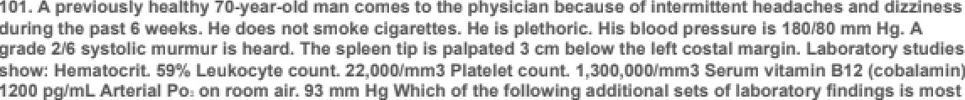

Erythro poietln Concentratlon D. Conten t Arterial Blood

1. Inc reased
2. Inc reased

C. Inc reased





F. Decreased

Inc reased

Normal

Oecreassd

Inc reased

Oecreased

The Correct Answer is . E) Erythropoletln Concentratlon Decreased D: Content Arterial Blood Normal

The patient presents wit headache, dizziness, plethoric appearance. elevated blad pressure, and an enlarged spleen. Laboratory studies show increased hematocrit. leukocym count, and platelet count.

These findings suggest a diagnosis of polycyfemia vera. a myeloproliferafive disorder characterized by the overproduction of red blood cells. white blood cells. and platelets.

In poTycythemia vera, the erythropoietin concentration is typimTTy decreased because the bone marrow is producing blood cells independently of the erythropoiefin signal. The increased producfion of red blood cells in polycythemia vera can lead a an increase in hemoglobin levels and. consequently. be oxygen- carrying capacity of the blood. However, the armrial oxygen content IO. content) remains normal as the arterial panial pressure of oxygen {PaO:) is still wiWin the normal range (93 mm Hg in this oasej.

102 A 25-year-old man has end-stage renal failure. During childhood he had recurrent episodes of gross hernaturia. Other male family members have a similar history. He also has hearing loss. Which o'f the 'following is the most likely diagnosis?

B. \gA (Berger) naphropathy

C. Nephr it is of chronic infection

D. P osNtr ep't ococcal gTomer olo nephr it is

E. Syst em\c \opos e rythe matasus

The Correct Answer is . A. Alport syndrome

The patient's history of recurrent episodes of gross hematuria during childhood. a family history of similar symptoms. and hearing loss suggest Alport Syndrome, a genetic disorder characterized by progressive kidney disease, sensorineural hearing loss. and ocular abnormaliñes.

blood in his urine. He has had intellectual development disorder since early infancy. E xarnination shows choreoathetosis and self-mutilation of the lips and fingers. His serum uric acid concentration is increased. Urinalysis shows numerous uric acid crystals and erythrocytes. The most likely cause of the hyperuricemia is deficient activity of which of the following enzymes?

A. G- Ami no levuTi name synthase

B. Glycine-oxaloacet\c transam\nase

C. GIy cine sy nthase

E. Serene a anshy d roxymethyl ass

The Correct Answer is . D. Hypoxanthine-guanlne phosphorlbosyl transferase

The patient’s Symptoms of intellectual development disorder, choreoathetosis. self-mutilation, and hyperuricemia are indicauve of Lesch-Nyhan syndrome. which is caused by a deficiency in the enzyme hypoxanthine-guanine phosphoribosyl transferase (HGPRT).

104 A 44-year-old man comes to the physician for a health maintenance examination. He has drunk twelve beers nightly for several years. He tells the physician that he is concerned he may have a drinking problem, but he has not mentioned the concern to anyone else. He says, "Most of my friends drink the same amount and I'm afraid they'll think I'm overreacting If I talk to them about it." Which of the 'following best describes this patient's stage of behavioral change?

1. Mai nte nance
2. Relapse

The Correct Answer is . B. Contemplation

The patient has acknowledged that he may have a drinI‹ing problem and is considering making a change. indicating that he is in the contemplation sage of the behavioral change process.

of household cleaning solvent. He is treated for acute hepatic and renal failure for 1 week and then discharged. During the next month, regeneration of this boy's mature hepatocytes and renal tubu lar epithelial cells will be accomplished mostly by which of the **following** mechanisrris?

1. AM\vati on of Mem c'eIIs to eMer G1 phase of the ce IT cycle
2. Decreased apoptos\s at GI-M transition of the ce IT



D. Shortened time for progres sion of cell s Through the c'eII cycle

E. Termi nal d iffera micron by news exM\ng from the ce I\ cycle

The Correct Answer is . C. Recrultment of cells from GO into the cell cycle

Regeneration of mature hepatocyles and renal kbuTar epilhelial cells ocmrs primarily through Ihe recruitment of quiescent cells from the G0 phase of Ihe cell cycle inla the active cell cycle.

1. A 74-year-old man comes to the emergency department because of severe pain between his shoulder blades for 2 hours. His blood pressure is 180/110 mm Hg in the right upper extremity and 120/66 mm Hg in the left upper extremity. The lungs are clear **to auscultation. A** grade 3/6, diastolic decrescendo murtriur is heard at the left eternal border. Which of the following i9 the most likely diagnosis?
   1. Acme myocar d\a\ infarc tion
   2. 



1. Cholec ytM\s
2. C ochond rids
3. edi asti nit is
4. Pri monary embol ism

The Correct Answer is . C. Aortic dissection

The significant difference in blood pressure between lie right and felt upper extremities. the severe pain between the shoulder blades, and the diaslolic decrescendo murmur suggest an aortic dissection.

1. A 23-year-old man cuts his lip inadvertently while shaving. Seconds after the injury, the bleeding nearly stops. Which of the following mechanisms is the most likely cause of the early rapid control of blood loss in this man?
   1. AM\vati on of aMMhrom bin TTI



C. Oxy genhmm uIced cleav age of thrombopTasT\n

D. Polym erizabon of fibrJn

The Correct Answer is . B. Locallzed secretion of endothelln

Localized secretion of endothelin causes vasoconstriction. which helps in lie rapid control of blood loss.

1. A 72-year-old man comes to the physician for a routine examination. He ha9 type 2 diabetes mellitus, hypercholesterolemia, dermatomyositis, and nocturnal heartburn. He has been receiving treatment with prednisone, lovastatin, glyburide, metformin, and famotidine for 6 months. There are rriultiple ecchymoses on the upper extremities that do not blanch on pressure. Which of the following medications is the most likely cause **of this patient’s bruising?**
   1. Famotid ine
   2. GIyburide

C. Lovastatin

or man



The Correct Answer is . E. Prednlsone

Prednisone. a corticosteroid. oan cause thinning of the skin and easy bruising as side effects.



A. Eschari ch\a coil B. 

D. Pseodomonas mroginosa

E. Ba\mona\la typhi

F. BhigeTla dysenteriaa

H. Vibno para haamolyticus

The Correct Answer is . C. Proteus mlrabllls

Infection with Promus mirabilis can fuse alkaline urine and urinary ract caICuIi. This organism is urease- positive. which can lead to be formation of ammonia and hydroxide ions. resulting in an alkaline urine pH. The alkaline environment can promote be formation of urinary ract calculi.



Mean Arterial Blood Systemic Vascular Pressure Resistance

B.



D.



Alveolar Ventilation

The Correct Answer is . A. Mean Arterial Blood Pressure , Systemic Vascular Resistance , Systemic Venous Tone , Alveolar Ventilation

when the common ca olid arse ies are occTuded. blood flow ro the b ai is significantly reduced. In response. the body ac‹ivares a series of compensaro y nechanis ns. The ba o eceptor eflex increases mean arterial blood pressure ( ) and systemic vascular resistance f ) to nainrai pe fusion ro vital organs. The i ie ease in systemic venous tone f ) aids in maintaining venous eturn and cardiac preload. Due to

Ilie educed blood flow ro the brain. the e is an increase in CO2 levels and a decrease in pH. leading to an increase in alveolar venriIa‹ion { ) as a esuTr of Ilie chen oreceplor response.

1. One thousand office workers are surveyed to determine whether or not they use computers and whether or not they have symptoms o'f carpal tunnel syndrome. Wh ich of the 'following best describes this study?



B. Case se nes

C. Cohort study

E. Random ized cl inkcal trial

The Correct Answer is . D. Cross-sectional survey

The study described is a cross-sectional survey, as it examines the prevalence of carpal tunnel Syndrome Symptoms and compumr usage among a group of ogiee workers at a single point in time.

1. A 595-g (1-lb 5-oz) male newborn is delivered at 24 weeks' gestation. Pregnancy was complicated by hypertension and proteinuria. Apgar scores are 4 and 6 at 1 and S minutes, respectively. The newborn is in respiratory distress. Which of the following pathophysiologic findings is most likely in this newborn?



C. Inc reassd Iung com pI\ance

D. Lec\th\n.sph ingomyelin ratio of 2:1

E. PO2 of 9 ' mm Hg

The Correct Answer is . B. De creased surface tension in the small aIveoli

A premature newborn delivered at 24 weeks' gestation is at risk for respiraory disvess syndrome {RDSj due0 insufficient surfactant production, which results in decreased surface tension in small alveoli, leading to collapse and difliCulty in breathing.

1. A 62-year old man is brought to the emergency department 2 hours after the sudden onset o'f pain and coolness in his right leg. He is otherwise healthy except for mild hyperthyroidisrn treated with propylthiouracil. Examination o'f the lower extremities shows normal skin, nails, and hair growth patterns. Pulses are absent in the right lower extremity and normal on the left. Which o'f the following is the most likely diagnosis?



B. 

thrombosis6

O.Lumbardiszñerniwion

E. Rhabdomy any s is

The Correct Answer is . C. Embolic arterial occlusion

The sudden onset of pain and coolness in be right leg. the absence of pulses, and the absence of other lower exvemily abnormalities suggest an embolic arterial occlusion.

1. A 68-year-old man with Parkinson disease is being treated with levodopa and carbidopa. He is doing well and has few adverse effects. Concurrent therapy with levodopa and carbidopa is useful because o'f which of the following characteristics of carbidopa?
   1. Blocks mrs car \nic recept ore



C. En han ces activité of the transporter for Rev odopa

D. Inc reases Int estinal mewbol ism of \ev odopa

E. Inhabit s mo noami ne ox\dase

The Correct Answer is . B. Does not cross the blood-brain barrier

Carbidopa is combined with levodopa in Parkinson's disease veatment because it does not cross be blood-brain barrier, allowing it to inhibit peripheral deoarboxylation of levodopa without afle¢fing its central action. thus increasing the availability Of levodopa in the brain and reducing peripheral side effects.

1. A 56-year-old man comes to the physician because of a 3-month history o'f intermittent regurgitation o'f material with an acidic taste. He is u nable to sleep and has missed 3 days of work during the past month because of the symptoms. Various non- pharrnacologic measures, including elevating the head of his bed and decreasing his dietary fat intake and portion size, have resulted in only mild improvement. Physica examination shows no abnormalities. Esophageal endoscopy shows severe erosion ; there are no other structural abnormalities. The most appropriate pharrnacotherapy for this patient is a drug with which o'f the 'following mechanisms of action on the parietal cells?
   1. Agon ism of c ho lecyst ok in \n B (CC Z} recept or
   2. Agonism of proscagIand\n E reaptor 2 (EP3) receptor
   3. Antagonism of histam\na -2 (H2} receptor
   4. A magon ism of m osc.ari nie (M2 } acery Icho Ians

The Correct Answer is . E. Irreversible Inhibition of H+-K+ ATPase

Prom pump inhibitors. which irreversibly inhibit the H+-K+ ATPase of parietal cells. are be most appropriate pharmacotherapy for his patient with severe gastroesophageal reflux disease (GERD j.

1. A 23-year-old woman who was recently diagnosed with rheumatoid arthritis comes to the physician for a 'follow-up examination. Two months ago, she bagan treatment with adalimurnab, which binds with tumor necrosis factor-a. The patient says that her symptoms have not improved. Physical examination shows mild swelling of the joints of the wrists, hands, ankles, and feet. Which of the following immune system components is most likely contributing to this patient's symptoms?

B. \gE

D.IL-4

E. baseolar endotheI\a I groMh factor

The Correct Answer is . C. Interleukin-J (IL-J)

Interleukin-1 {IL-1) is an important pro-inflammatory cytokine involved in be pathogenesis of rheumatoid arthrifis. Sin¢e adalimumab, a TNF-a inhibitor, did not show improvement. it is likely fat IL-1 is contribufing to the patient's symptoms.

1. 64-year-old woman with atrial fibrillation comes to the physician for a monthly follow-up examination. She began treatment with warfarin 18 months ago. She has not noticed any bleeding and feels well. After an initial period of dose adjustment, her INR has remained at 2.S for the past 6 months with an alternating high- and low-dose regimen. Her pulse is 96/min and irregularly irregular. Physical examination shows no other abnormalities. Laboratory studious show an INR of S.8. Which of the 'following actions by the patient best explains the change in her INR?
   1. Del iberat e decrease in dosage for 5 days whiie awai d og the arriv al of the warfar in refiIT by mam
   2. Tnadve ment s ubst\tot\on of the Tow-dose p\TIs for tha hig h -dose pills

C. Inc reassd consum ptiori of green leafy-vegetables dunng the past 2 weeks

E. M ninænt\onaT ingestion of expi æd medication

The Correct Answer is . D. Self-medlcatlon with an over-the-counter supplement that decreases warfarln metabollsm

The most likely cause of the increased INR is self-medicafion with an over-the-counter supplement that decreases warfarin metabolism. leading0 increased warfarin levels and a higher INR.

mother developed an illness in the first trirnester of pregnancy characterized by low-grade fever, a faint erythernatous rash, occipital lymphadenopathy, and joint

stiffness. The illness resolved within 1 week with complications. She did not receive any immunizations prior to the pregnancy. Which of the 'following viruses is the most likely cause o'f the newborn's illness?



B. Herpes Simp\ex Virus



D. HTL¥-2

E. Measles virus

F. Reovirus

H. ariceTla-zoster v irus

The Correct Answer is . G. Rubella virus

The clinical features in the newborn. such as microcephaTy, cataracts, and chorioretinitis. along wit the models illness during the first trimester. suggest congenital rubella syndrome mused by the rubella viruS.

120 A healthy 28-year-old woman participates in an exercise study. Several physiological variables are measured as she runs on a treadmill. The ambient room temperature is 75

F. She reaches a steady state that increases her oxygen consumption threefold. She continues to exercise at that level for 20 rninutes. During the 'first 5 minutes o'f exercise, the vascular resistance of which of the following is likely to show the greatest increase 'from resting values in this volunteer?



B. Cutaneous

C. Exerc\s\ng M oscle D. 

monary E

F. Sy sErnie

The Correct Answer is . E. Splanchnic

During exercise. be body prioritizes blood flow to the exercising muscles. heart, and skin (for thermoreguTafion). To achieve this. be body increases vascular resistance in areas that are less essenfial during exercise. such as be splanchnic circulation fwhich supplies blood to be gastrointestinal tract. liver. and spleen . This helps to redirect blood Row to areas with higher demand during exercise. So. the vascular resistance of the splanchnic circulation would show the greatest increase from resting values during the initial phase of exercise.

episodes of severe stabbing pain of her left cheek and jaw. She says that the pain occurs suddenly and can be precipitated by chewing, speaking, **or brushing** her teeth; it lasts several seconds and occurs 20 to 30 times daily. She adds, “It feels like lightning i9 **striking rriy** cheek." **Touching** the left cheek reproduces her symptoms. Which of the following is the most likely cause of this patient's symptoms?

A. Comprasshon of the tngem\naT rarve b'y an acoustic neoroma {vestibuTar schwannoma}

B. Uma mm ation of the temporom andi bular joi nt

 Inflam mation of the Trigem i nal nerve by a muM\pIe sc Ieros\s



E. Recu rrent tr ansieM isnhem ia in the venebrobas i\ar system

The Correct Answer is . D. Mlcrovascular compression of the trlgemlnal nerve

The patient is experiencing symptoms consistent with trigeminal neuralgia. which is most commonly caused by microvascular compression of the Migeminal nerve. This compression leads la the severe. slabbing pain that the patient is experiencing.

122 A 4-year-old girl is brought to the physician by her mother 2 hours after falling and scraping her right knee while **playing outside.** Examination of the right lower extremity shows a 6 x 8-cm denuded area over the knee with a serous exudate and an erythematou9 border. The patient's mother says that she recently read a magazine article about staphylococcal skin infection, and she is concerned about her **daughter's** risk for developing this infection as **a re9ult of** the **injury.** The presence of which of the following cell types at the wound site will most likely decrease this patient's risk for developing a bacterial **infection?**



B. C OB+ T lymphonyes



F. Plasma nelIs

The Correct Answer is . E. Neutrophlls

Neutrophils are the primary immune cell type responsible for early defense against bacterial infections Their presence at the would site will help to prevent bacterial infections, including Staphylococcus aureus.

was involved in a motor vehicle collision. Physical examination shows inability to raise the right upper extremity. A CT scan shows a nondisplaced fracture of the right clav icle, in addition to a 4.S-cm rnultiloculated mass in the left kidney and a 4.S-cm aneurysrnal dilution of the ab dorninal aorta. There is also irregular lymphadenopathy o'f the left para- aortic (lumbar) lymph nodes. Laboratory studies show a serum calcium concentration of

13.7 rng/dL. Which of the following is the most likely cause of the serum calcium findings in this patient?

1. Chrange re nal faiIure
2. CIav\c\e fracture
3. Pri mary hype rgarathy roid\sm
4. Sar co idosis

The Correct Answer is . C. Paraneoplastic syndrome

The patient's elevated serum calcium, along with the presence of a renal mass and abdominal aorlic aneu/sm, is suggestive of a paraneoplastic syndrome. which can result from cerain cancers producing hormones that affect calcium levels in the body.

124 A 10-month-old girl develops a cough and grunting 'following a 3-day hospital stay for surgical repair of a cleft palate. Her temperature is 39.2 C (102.6 F), and respirations are 40/min. Crackles are heard over most lung 'fields, and breath sounds are decreased. There is a mild pleural rub in the right upper thorax. Her leukocyte count is 68,000/mm (85'4 segmented neutrophils, 10°/ bands, and less than 5'4 myeloblasts, promyelocytes, and rnyelocytes). Which of the 'following mechanisms most likely caused the increased leukocyte count in this patient?

B. Decreased mang ination and rolTi ng of circ oIating cells

C. Inc reassd prod uceon of myeTobTast s \n the s pie+'n

D. Shift in bone marrow for eos\nophi I production to segmented neotrophi I production

E. Transf or mad on of mye\oid ste m eelIs

The Correct Answer is . A. Accelerated release of cells from the bone marrow postmitotlc reserve pool

The increased leukocym count in this patient is most likely due a an acceleramd release of cells from the bone marrow postmitotic reserve pool. as the body is atmmpting a fight off an infection. as indicamd by the patient's symptoms and physical examination findings.

count is 120/rrirri. A combination of three **antimicrobial** agents **is prescribed** for treatment, one of which is a protease inhibitor. The two additional agents most likely to be administered both work **by inhibiting which** of the following metabolic functions?

A. D MA-dependent RNA polyme rase antivity

B. D MA gyrase activity

C. D MA poly merase antivity

D. Engosterol syMhes\s

E. Fo\\n acid metabo\ism

F. Mitochondr ial funcbon

G. PeptidogTy can syMhes\s



1. Ribosomal funM\on
2. M ncoating of The organ ism

The Correct Answer is . H. Reverse transcrlptase activlty

In addition to a protease inhibitor. lie two other agents in lie patient's Meatment regimen for HIV are likely to target reverse transcriplase activity. as this is a crucial step in the replication of HIV.

126 16-year-old girl comes to the physician because she is concerned that she may be at risk for Huntington disease. Her father, who has been divorced from her mother for many years and lives in another state, was recently diagnosed with thi9 **condition.** The patient says that she knows about the genetic basis of Huntington disease and worries that she may develop it. She adds, “My mother seems **so casual** about it all. She says for me not to worry, that I won't develop the disease, but I can't help worrying.” The **physician,** who has provided care for thi9 patient since birth, knows that the patient's father is not her biological father. Which of the following i9 the most appropriate next step by the physician?

1. Assure the patient that her mv her \s correct not to worry



C. WeTI the pabent the arch a bout her empty

D. Arrange for genetic testi ng knowing mat the resuIt wJII be negReve

E. Refer the The nt to a merrta I health provider to eval use and treat her ant iety

The Correct Answer is . B. Contact the patlent's mother and encourage her to share the patemlty

The physician should contact the patient's mother and encourage her la share the paternity history. as this is a sensitive issue and should be addressed by the mother rather than lie physician.

difficulty urinating. He says that he has difficu lty initiating urination, and once initiated, the urine tends to “dribble.” Rectal examination shows a diffusely enlarged, firm, contender prostate. Which of the following findings is most likely to be found on histologic examination of the prostate?

A. Glands \i ned with fryperglastic rr ans itiorial epithe\i um

B. Masses of psammoma bad ies in th perLoremal zone

C. Mucts -fi wed cysts \n the pos@rior lobe

E. Scarring throoghoot the srroma

The Correct Answer is . D. Nodules formed by prollferatlng stromal and epithelial cells

The patient’s Symptoms and physical examination findings are Suggestive of benign prostauc hyperplasia (BPH , which is characterized by nodules formed by proliferating stromal and epilelial cells.

128 A 35-year-old man has a sinus tachycardia of 120/min. Which o'f the 'following best describes the relationship o'f ventricular contraction and relaxation in this patient?

1. D iasbsTe and syst ale equal Iy prolonged
2. D iasbsTe and syst ale equal Iy shortened

c. Diastoie is prolonged more tha n

E. Syet ads \s prolonged more than diast ale

F. Sy sto ie is shorts ned more than d iastoie

The Correct Answer is . D. Diastoie Is shortene d more than systole

During sinus achycardia. diastole is shortened more than systole. This occurs because the heart is beating faster, causing less fime for relaxation and filling of the ventricles.

newborn aRer an uncomplicated cesarean delivery because of a nonreas9uring fetal stress test. Two days prior to discharge from the hospital, she has persistent nurribness of the area **surrounding** the abdominal incision. The physician assures the patient that sensation will gradually **return as** the nerves regenerate. Which of the following best describes the rate limiting step in this patient's return to normal sensation?



B. Fast ante rograde axonal bansport



D. Rmrogr ade asonal transpon



The Correct Answer is . E. Slow anterograde axonal transport

The rate-limiting step in this patient's return la normal sensation is slow anterograde axonal transport. which is responsible for the regeneration and reestablishment of sensory nerve connections.

130 A 33-year-old homeless man is admitted to the **hospital** with hypothermia after police found him sleeping on a street corner during a snowstorm. Two days later, he becomes agitated and tremulous, and says that he sees bugs crawling on the wall. His temperature is 38.3 C (101 F), pulse is 100/rriin, and blood pressure is 1*8 0I9 0* mm Hg. Physical examination shows a mild intentional tremor He is oriented to person, but not to place or time. The physician orders an MRI of the brain, but the patient becomes uncooperative. Administration of which of the following is most appropriate at this time?

1. AmMri ptyT\ne
2. Ch lorgromazi ne

c. Lithium



E. Propofo\

The Correct Answer is . D. Lorazepam

The patients symptoms are consistent with alcohol withdrawal, and lorazepam is a benzodiazepine commonly used to manage these symptoms.

4#y A M-yaar-ona man & brought O the emeręancy dapanment by ambuTance @ mTnuNa a8er he we found unraaponałve by hł» wlfe. Paramadka aay that hło błood eł cała concaniratun taa 22 węaL by gnger»tick at &

a gwontfi hTotory of epToodaa of owea6ng ad lTTng afiaky. HP aympt o raaolve min he aato a candy bar. PhyolcaT examlnaMon ohowa no abnowaTTMeo. The inMtIve dTagnoaTo of TnauTTnoma la mada. Tn addTMon O a decraaaed gluooae concentrEon, which of & foTTowlng aeta of findTnga Tn thTa gallant during a &atIng-Tnaucad hypogTycamlc eplaade la most TTkaly zo oon€w the dTagnosla 7

InsuIIn C Peptlde Urlne I¢atones



Tł\e Corrent Answer is : B. Insulln (f) C **Peptide** (\)

Urlne Ketoetes (Absent}

In a patient with insulinomą a fasting-induced hypoglycemie episode wouId most likely shcnv the

foIk›wing Endings:

InsuIIn (f)

C **Peptide** (\)

Urlne Ketoetes (Absent}

Insulnornas are kimors that produce excessive amounts of insulin, leading to hypoglyoemizL In such a case, you would expect to see elevated insulin levels during a hypoglycemic episode. Since the nnreased insulin production is due to the kimor arxl not an exogerous souroe, C peptide levels w£I also be elevated (C peptide is released n equal amounts to insulin during its synthesis). Due to the high levels of insuln su{$xessing I$›oIysis arxl ketogenesis, urine ketmes would be absent.

1. A 1-year-old boy receives a left cochlear implant that consists of an array of electrodes. Six months ago, he was diagnosed with severe bilateral hearing deficit. Which o'f the 'following elements of the auditory sy stern must remain intact for this patient to perceive auditory stimulation via activation o'f the electrodes in the implant?
   1. Audit ory hair eelIs

D. Rou nd \gndow

E. Tympan\c membrane

The Correct Answer is . B. Auditory nerve

For a cochlear implant a be ellective. be audiory nerve must remain inset to transmit auditory signals from be implant to be brain. The implant bypasses the hair cells. ossicles. round window. and tympanic membrane.

1. A 70-year-old man comes to the physician because of a 36-hour history of an inability to urinate and a 24-hour history of sharp lower abdominal pain. He has has a decreased urinary stream for 12 months, and he has had to urinate Lwo to four times nightly during this time. His temperature is 37 C (98.6 F), pulse is 110/min, respirations are 20.min, and blood pressure is 160/100 mm Hg. Physical examination shows tenderness and dullness to percussion over the suprapubic region. Serum studies show a urea nitrogen (BUN) concentration of 50 mg/dL and a creatinine concentration o'f 3.0 mg/dL. Insertion of a Foley catheter immediately yields 2 liters of urine. Which of the following findings is most likely during the next 24 hours?
   1. BW
2. Hyperc.al cem\a



1. Hypermagnesem\a
2. Inc reasing serum creati nine concentration

The Correct Answer is . A. Brlsk diuresls

After relieving be patient's urinary obstruction with be insertion of a Foley catheter, a brisk diuresis is li@Ty IO Occur as be body lies a eliminam the accumulated fluid. This will also help to normalize the patient's elevated BUN and creatinine levels.

134. An 18-year-old man is brought to the emergency department 30 minutes after sustaining injuries in a motor vehicle collision. He has abdominal pain. His pulse is 120/min, and blood pressure is *8 l6* mm Hg. Physical examination shows multiple contusions over the trunk and abdominal tenderness. A chest x-ray shows multiple rib fractures. A CT scan of the abdomen is shown. Which of the following organs is most likely injured in this patient?

A. Bladder

B. Lever

E. Stomach

The Correct Answer is . D. Spleen

Splenic injuries are common in blunt abdominal trauma and oan result in internal bleeding. which would explain the patent’s hypotension and abdominal pain. In his case. the spleen is the most likely injured organ in be patient.

135 A 41-year-old man comes to the physician because o'f a 2-day history of intensely itchy hives over his legs. He says that the rash appeared shortly after he returned from a weekend hiking trip. He works in a warehouse and is required to operate heavy machinery. Examination of the lower extremities shows multiple 1- to 2-cm well- circumscribed, edernatous papules. Which of the 'following is the most appropriate pharrnacotherapy for this patient?

1. ChIorghen\r ami ne
2. Di phenhy d

ram ine6

1. Mec\izine
2. Ran\t\di ne

The Correct Answer is . C. Fexofenadine

The patient is experiencing uflicaria fhives) li@Ty due a an allergic reacfion. Fexofenadine is a second- generation antihistamine that has fewer sedative side effects compared a first-generation antihistamines like chlorgheniramine and diphenhydramine. This makes fexofenadine a better choice for someone who operates heavy machinery.



1. Goi IIain-Barre syndrome
2. Imm one comple x
3. React\ve arthritis
4. Rheomawe fever

F. Type \ (immed iata} hyparsens itivi¿y reaction



The Correct Answer is . C. Jarlsch-Herxhelmer reaction

The Jaris¢h-Herxheimer reaction is a self-limi#d SyStemic reaction fat occurs after the initiation of treatment for certain infections. such as Syphilis. It is Thought a be caused by be release of endotoxins from dying bacteria. leading to Symptoms like fewer. chills, and headache.

B. Formation of a Nrnary compTe x with profs in synthesis slangatio n factor-TO

C. Tn\d ation of the process of ribosome assembly

D. Se\ect\on of a specific amino acid for acy\ation

E. Se\ect\on of a specific mRNA for binding to the ri bosom e

The Correct Answer is . A. De codin g of mRNA during trans lation

The anticodon sequence of MRNA is responsible for decoding be mRNA during translafion. It pairs with the complementary codon on the mRNA, allowing the appropriate amino acid0 be added a the growing polypeptide chain.

138 A 32-year-old man comes to the physician for a health maintenance examination. His maternal uncles and grandfather had hypertension, renal calculi, enlargernent of both kidneys, and decreased renal 'function. His maternal grandfather died of a ruptured intracranial berry aneury srn. Physical examination shows no abnormalities.

Ultrasonography shows 'five to seven cysts in both kidneys. The patient most likely has a mutation in the gene that encodes which of the following proteins?

B. N ephr

D. Sodi um c h loride cotransporter

E. Sodi um-potass\om -2 ch lori de era reporter

F. \fo\tage-gated ch lands channex

G. WiTms tumor 1 [WT1 }

The Correct Answer is . C. Polycystin

The patient's family history and ultrasonography findings suggest aufosomal dominant pOTycySñc kidney disease fADPKDj. This condition is caused by mutations in the genes PKD1 or PKD2. which encode the proteins poly¢yStin-1 and polycyStin-2. respectively.

449. 0 uilng a sfudç of a lveolar functlon, a change is lnauced ln fha a lveoli of an experWanta 1 anlma1. Results shore a said decrease Tn gaa dTAalon. Which of the foTTowlng TabeTed cell types In & nozmaT croaa sctTon of the alveolar saTT has coat ITkeTy bean altered Tn this air arlmanMT anTmaTP

2 *C*

D. D

The Correct Ans'‹ver is : B. B

The alveolar wall is ccvnposed of several cell types, incI‹bing type I aNeola oells , type II alveolar cells , alveolar mawophages , and endothelial eels .

Type I &veoIar cels (B) are responsible Iör the majorité of gas excfiange, while type ll alveolar cells produoe arxl **seaete** surfaclant to maintain the stabilité of the aNeoli. Alveolar mawophages are speciaJized immune celb that remove debris and pathogens lien the alveoli, and endotheliaJ œls Io‹wi the blood-air barrier.

A marked dewease in gas dilffision suggests that the structure res$›onsibIe Ibr gas exchnge, i.e., the

aiveoiar-eapiltary membrœe, has been attered.

Tfierehxe, the cell type most likely to be anered n this experimental an?ziaI is type I aNeola oells (B).

department because of a S-day history o'f malaise and vomiting. He takes no medications. His pulse is 104/min, respirations are 3S/min, and blood pressure is 90/64 mm Hg. Physical examination shows dusky-colored skin, peripheral cyanosis, and 10- cmjugular venous distension. Crackles are heard over the lung bases bilaterally.

Cardiac examination shows an S3. There is 2+ pitting edema to the knees bilaterally. Laboratory studies show :

Serum

Na-r

K+

###### ci-

HCD3-

Urea Nitro gen Glucase Creatlnlne

mg/dL Urine

Glucose

Ketones

Arterial blood gas analysls on 26% oxygen

pH PCO2 PO2

127 mEq/L

5.2 mEq/L

79 mEq/L

17 mEq/L

100 mg/dL

171 mg/dL

8.4

4+

absent

7.35

32 *mm* Hg

154 *mm* Hg

HCDa- 17 mEq/L

Which o'f the 'following is the most likely cause of anion gap in this patient?

1. Alcoho Inc ke6ac\dos is
2. D iabet\c ketoac\dos is



1. Hypoa\bom inem ia
2. MetaboIie ac\dos\s F.

H. Resp\raary alka los is

The Correct Answer is . G. Renal failure

This patient has an increased anion gap. which is most likely due to renal failure. The patent’s high creafinine. elevated blood urea nitrogen. and clinical signs of congestive heart failure are consismnt with renal failure.

141. A 62-year-old woman develops difficulty breathing. Pulmonary function tests before and after bronchodilator therapy show no changes. Predicted and patient values are:

Test FVC (L) FEV1 (L)

FEV1 /FVC

Predicted 5.0

4.0

8.0

Patient

4.0

2.4

0.6

Total lung capacity (L) Residual volume (L)

6.0

1.6

7.2

2.T

Which o'f the 'following is the most likely explanation for these findings? Airway Resistance Lung Compliance



C. Normal

E.

The Correct Answer is . B. Airway Resistance , Lung Compliance normal

The patient's pulmonary function test results show a decreased FEV1 ’FVC ratio f0.6 increased tool lung capacity (7.2 L , and increased residual volume f2.7 Lj. These findings are consistent wit obstructive lung disease. The most likely explanafion for these findings is!

* 1. Airway Pesis lance ”. Lu ih C o n pliance no n al

In obstructive lung diseases. such as chronic obstructive pulmonary disease {COPD or asthma, airway resistance is increased due a narrowed airways. while Tung compliance is usually normal or even increased due to the loss of elastic recoil.

1. A 20-month-old girl is brought to the physician by her mother because the mother is concerned about her daughter's development and behavior. The girl is able to walk and run and has a vocabulary of at least 100 words. However, when she attends playdates with other children, she prefers to play by herself and will strike another child on the head if that child attempts to join her in playing with a particular toy. Which of the following best explains this patient’s actions during play?
   1. Atte nfiozi-deFsn it/hyperacti vMy d isorder
   2. Cond uca disorder

C. Early sign of autisT\n disorder

D. Oppositiozial deli ant disonder

The Correct Answer is . E. Normal behavlor for age

The child's behavior is typical for a 20-month-old who is in the parallel play stage of development. Parallel play is when children play near each older but not with each other. Some aggression is also normal at this age as they learn to navigate social situations and assert their independence.

1. 4S-year-old rrian with alcoholism is admitted to the hospital for acute pancreatitis. He initially responds well to bed rest and intravenous fluid, but 1 week later he has a persistent fever and epigastric pain. His temperature is 38.6 C (101.5 F). Abdominal examination shows a tender epigastric mass. Laboratory studies show a leukocyte county of 13,500/mm and serum amylase activity of 300 U/L. Which of the following is the most likely cause of these findings?
   1. Acme gastnn delatati on
   2. Carc\noma of the stoman h

C. Chron\n pancreatitis

D. C ystic adenocarci noma of the

F. Perforated gastric uleer Cth absness

The Correct Answer is . E. Pancreatic pseudocyst

The patients symptoms and history of alcoholism suggest acute pancreatitis. The new onset of a lender epigastric mass. fever. and persislently elevated amylase level is consistent with the formation of a pancreatic pseudocyst, which is a complication of acute pancreatitis.

A 10-month -old boy is brought to the physician because of a 1-week history o'f pale skin. A male cousin on his mother's side had anemia that responded to treatment. Physical examination shows pallor, splenomegaly, and generalized weakness. Laboratory studies show a hypochromic, rnicrocytic anemia. Examination of bone marrow aspirate shows hypercellularity, erythroblasts containing ferritin granules, and a decreased concentration of S-arninolevulinic acid (g-ALA) synthase. Treatment with which o'f the 'following substances is most likely to improve this patient's condition?

A. Eryth ropo\etin

B. Fer rous set fate

E. ¥itami n B T 2 {c yanocoba laman]

The Correct Answer is . D. VitamIn B6 (py rl doxine)

The patient's hypochrornic. microcytic anemia, and decreased concentration of 5-aminoIevulinic acid fg- ALA synthase suggest sideroblastic anemia. This is a rare form of anemia that oan be hereditary or acquired. Treatment with pyridoxine {vitamin B6 may improve the patent’s condifion. as it is a cofactor for the enzyme 5-aminolevulinic acid synthase.

14s. A caoo-control atudy exwTnTng tea reTaMonohTp of exposure to floor radon and Tung cancer generate the following aata. Wfilcfi of the Allowing la the aatTmawa odda ratlo Mr th reTaMonohTp aMeen radon ana lung

kung Cancer

Radon Expoaura Yee

No

Preeam 500

500

1000

Absent



700



800

1Z00

20M

The Correct Answer is : **B. (S00xB00}/ (900** x 700)

In a case-control study, the odds ratio (OR) is used to estimate the association between an expasire and n oiJtnorne. The odds ratio compares the colds of exposure among cases (those with Ing cancer) to the odds of exposure among conbols (those without lung cancer).

To œlculate the odcls ratio, use the foIk›wing forniula: (a x d)/ (b x n), where:

a = number of cases with exposure (lung canœr present and radon expasire) = 500

b = number of controle with expœure (log cancer absent and radon expasire) =

n = number of nases without exposure sung cancer present and no radon exposure) = 5OG d = number of controls without expasire (lung cancer absent and no radon exposure) =

Usng this forniula, the odds ralio is **(500** x 700) **/(300** x **500)** = (500x500g (300 • 700). Theref‹xe. the torrent answer is B.

A S5-year-old man has had transient episodes of syncope with exercise for 6 weeks. He has a loud, harsh systolic murmur that radiates to the neck and dampened peripheral pulses. ECG shows left ventricular strain. Which of the following is the most likely diagnosis?



C. Atrial septal defect

D. Mitral Ans u1f)c\ency

E. M itral valve proda pss

F. Tru ncus arterNosus



The Correct Answer is . B. Aortlc stenosis

The patient’s Symptoms of syncope during exercise, harsh Systolic murrri0r that radiams a the neck. and dampened peripheral pulses are consistent with aorfic smnosis. This condition is a narrowing of the aortic value fat can lead to left ventricular strain, as seen on the ECG.

1. 60-year-old woman comes to the physician because of progressive lethargy, fatigue, rnusc Ie weakness, joint pain, and constipation during the past 2 years. She tells the physician that she feels depressed because of her symptoms. Her only medication is sirnvastatin. She also takes calcium and vitamin D supplement and a rnultivitamin. Physical examination shows no abnormalities. Serum studies show a calcium concentration of 12.8 mg/dL. Her urine calcium output is 250 rng/24 h. The most appropriate next step in management is measurement is which of the 'following serum concentrations?

B. Free by rox\ne



E. Tri iodothyroni ne [T2]

The Correct Answer is . C. Parathyroid hormone

The patient's high serum calcium concentration and sympoms of lethargy, fatigue, muscle weakness, and consfipafion suggest hyperoaleemia. The most appropriate next step is to measure parathyroid hormone levels a determine if be hypercalcemia is due to primary hypergarathyroidism. which is the most common cause of hypercalcemia in the general population.

1. An 84-year-old woman comes to the physician because of a 5-day history o'f pain in her buttocks. Physical examination shows a 2-cm abscess lateral to the an us. Which o'f the 'following nodes is most likely affected by the in'fection in this patient?



B. mornal i\iac



The Correct Answer is . E. Superficial InguInaI

Infections in the perianal area, like the abscess described in this patent, typically drain a the superficia inguinal lymph nodes. These nodes are responsible for draining the lower abdomen. butocJ‹s. and exmmal genitalia.

149. A 34-year-old woman is brought to the emergency department 4S minutes after she was involved in a motor vehicle collision. She says that she has chest pain. Her pulse is 120/min, respirations are *film*i*n,*andblood pressure is 100/70 mm Hg. Breath sounds are decreased on the left. A chest x-ray is shown. Which of the following is the most likely diagnosis?

A. Cand iac mm ponade

B. D iaph ragmawe rupture

C. Hemothorax

D. PuTmo nary embol ism6

The Correct Answer is . E. Tension pneumothorax

The patient’s Symptoms, including chest pain, increased heart rate. rapid breathing, decreased breath sounds on the left side. and be chest x-ray appearance of hyperinflation on the left side. are all consismnt with a mnsion pneumothorax. In a tension pneumoforax. air accumulates in be pleural space, leading to increased pressure and ultimately causing compression of the Tung and compromised blood flow. This is a medical emergency that requires immediam intervenfion.

fiuiober





IIS

2-3 yaara

4-S yeara 106 2S 76

**If a patent survives 2 years after the operation, which of the following**B **tke probablllty**



2 years aller the c$›eration.

Fitst, we need to consider only the pabents who survived 2 years, which is 148.

Now, we want to End the probabilty' ol these patients surviving both the 2-5 year into-vat and the S-4 year into-vat.

The number of patients who survived 3 yeals (S-4 year into-vat) is 851 of 124:

(124 - 18) = 108

They the pto lity of surviving the 2-5 year nterval given that a patient has survived 2 years is:

P(surviving 2-3 yeals | survived 2 years) = 1¢B/148

Now, we want to End the number of patients u/ho survived 4 years (4-5 year nterval). Tf+e table tells us that 761 of the patients survived dunng the 4-5 year into-vat:

(UB - ZS) = 81

So, the probabilly of surviving the 3-4 yes internal given that a pa6ent has survived 3 years is: P(surviving 3-4 yeals | survived 5 years) = 81/108

Now, we want to End the probabilty' ol survi'ñng both the 2-5 year interval and the 0-4 yes interval: P(surviving 2-4 yeats | survived 2 years) = P(survi'ñng 2-5 years | sia-vrved 2 years) ”

P(surviving 3-4 yeats | survived 5 years)

P(surviving 2-4 yeats | survived 2 years) = (10B/148) ” (81/108) The 108 in the numerator and the denominator caroel out

P(surviving 2-4 yeals | survived 2 years) = 81/148

The closest answer among the choiœs is



151 A 34-year-old woman is admitted to the hospital after sustaining third-degree burns over 7S°A of her body surface area, including her 'face and hands, in a house 'fire. After 3 months of appropriate care in the burn unit, she requests to have all care stopped except for pain control. She says that she realizes she will die in a few days if this wish is followed. She undergoes psychiatric evaluation and is found to retain decision- making capacity and to be appropriately depressed for her circumstances. Which o'f the

following is the most appropriate next step in management? a teaeIe be • W

B. Obey tha patient's was hes only if she stsII Is+'Ts the same way afar a 3-month coures of antidepres s ant therapy

C. Obtai n a court order to allow cont\noed a eaonent des plc tha patient's was hes

D. Persuade me mbers of tha patient's family to convince her to all or further treatment

E. \N’ithhoId alI comple x life-saving procedure per the paeent's wishes, but cont\noe with parenteral nutrition and intravenoos fiui d adm in\strat\on

The Correct Answer is . A. Comply wlth the patient's wishes in full

If a patient wit decision-making capacity ¢hOOWs to disconfinue oare. it is the responsibility of the healthcare team to respect their autonomy and comply Mth Weir wishes. In this case, the patient has undergone a pSyJiaVic evaluation. which has determined that she has decision-making capacity, and her request should be honored.



B. Celecoxi b



E. Dipyridamo\e

The Correct Answer is . A. Abclxlmab

Abciximab is a monoclonal anybody that funcfions as a platelet glycopromin Ilb ’IIIa receptor anagonist. inhibiting platelet interacfion wit fibrinogen. II iS used in combination with aspirin and other anfiplatelet agents to present thrombosis during percutaneous coronary intervention. such as coronary angiography and stent placement.

153 A 33-year-old woman comes to the physician because o'f a 1-day history of abdominal cramping and mild vaginal bleeding. Her last menstrual period was 9 weeks ago. Vital signs are within normal limits. Physical examination, including pelvic examination, shows mild lower abdominal tenderness and mild enlargernent of the uterus. Serum studies show an increased human chorionic gonadotropin concentration. Ultrasonography of the uterus shows villus tissue with no obvious gestational sae or fetus. Histopathological examination of uterine tissue obtained via curettage shows in'flarned decidua and immature chorionic villi with marked villous edema and lyrnphoblastic proliferation. lrnmunostaining to detect pS7 protein is done on the tissue, and no staining is noted within the villi. Chromosornal analysis of the villous tissue is most likely to show which of the 'following?

B. 46. XX

E. 92, XXXY

The Correct Answer is . D. 69, XXY

The patient's presentation and histopathologiCal findings are Suggestive of a partial hydatidiform mole, which is characterized by villous edema and lymphoblasfic proliferation. The lack of sailing for p57 promin indicates a paternal origin of the chromosomes. which is consistent with a triploid karyotype f69. XXYj.

145 A 42-year-old man who passed a renal calculus 6 months ago comes to the physician for a follow-up examination. He underwent thyroidectorny for thyroid cancer 3 years ago and has received daily thyroxine (T4) therapy since then. Two maternal uncles died of thyroid cancer. His blood pressure is 160/88 mm Hg. His serum calcium and parathy roid hormone concentrations are increased, and serum phosphorus concentration is decreased. Measurement of which of the following is most likely to establish the cause o'f hypertension?

B. Plasma ren in act\v ip



The Correct Answer is . A. Plasma metanephrlne concentration

The patient has a hisory of fyroid cancer. elevated serum calcium, and parathyroid hormone levels. suggesting the possibility of muTñple endocrine neoplasia type 1 fMEN1 j. This syndrome oan be associated with parafyroid. pituitary. and pancreatic isles cell tumors. including pheochromocytomas, which can fuse hypermnsion. Measuring plasma meanephrine concenvation can help confirm the presence of a pheochromocytoma.

1. A S9-year-old man who is receiving intensive courses of chemotherapy for prostate cancer comes to the physician for a 'follow-up examination. Regular complete blood count measurements have been taken before each course. Laboratory studies today show:

Hernoglobin. 13 g/dL

Hematocrit. 40°4 Leukocyte count. 1200/mm Platelet count. 14S,000/mm

Which o'f the 'following is the most appropriate pharrnacotherapy for this patient at this time?

1. Eltrom bopag
2. Eryth ropo\etin

man P



The Correct Answer is . E. Pegfllgrastlm

This patient has a low leukocyte count, indicating neuvopenia. which can be a side effect of chemoferapy. Pegfilgrastim. a long-acfing granulocyte colony-stimulating factor. is used to stimuTam the production of neutrophils and reduce the risk of infection in patients undergoing chemotherapy.

1. A 45-year-old woman has had progressive 'fatigue, shortness of breath, and menorrhagia for 6 months. She reports feeling cold most of the time. Her voice is deep and hoarse. The thyroid gland is normal in size, crackles are heard at both lung bases, and muscle stretch reflexes at the ankles have a delayed relaxation phase. Hematocrit is 31%, and mean corpuscular volume is 74 um. X-ray o'f the chest shows an enlarged globular heart. Wh ich of the 'following is most likely to establish the diagnosis?
   1. Bone mar row aspiration
   2. Echocar di og raphy

C. Laryngos cop y

D. Pap smear



The Correct Answer is . E. Thyrold-stimulating hormone

The patient’s Symptoms of fafigue. shor+ess of breath. menorrhagia. cold intolerance, deep and hoarse voice. and delayed relaxation phase of ankle reflexes suggest hypothyroidism. The best est to esablish the diagnosis is fo check the thyroid-Stimulating hormone fTSH) level.

1. A 76-year old worrian comes to the physician because of a 2-day history of abdominal pain, nausea, **and vomiting.** Her temperature is 38.9 C (102 F), pulse is 88/min, respirations are 26/min, and blood pressure is 117/79 mm Hg. Abdominal examination shows tenderness of the left lower **quadrant.** Laboratory studies show a leukocyte count of 22,500/mm with 89 bands. A CT scan of the abdomen shows an abscess in the left lower **quadrant.** The patient undergoes drainage of the abscess and a **partial** sigmoidectomy for a ruptured diverticu lurri. Neutrophil activation in this **patient is** directed, in part, by bacterial lipopolysaccharides. As a result, these lipopolysaccharides most likely bind to which of the following neutrophil receptor types?



B. G proteinii nked

C. Ton nhan neTNi nked



The Correct Answer is . E. Toll-like

Bacterial lipopolysaccharides {LPS) are recognized by Toll-like receptor 4 (TLPd) on neutrophils. leading to activation of the innate immune response. LPS binding la TLR4 triggers intracellular signaling pathways that lead to the production of inflammatory cytokines and cflemokines.

1. A 26-year-old woman comes to the physician because of an 8-day history of difficulty swallowing, shortness of breath, and progressive weakness of her legs; she also has a 2-day history of **tingling of** her legs. She had an episode of diarrhea 1 rrionth ago. Physical examination shows decreased deep tendon reflexes in the upper extremities and absent deep tendon reflexes in the lower extremities. A lurribar puncture is performed. Cerebrospinal **fluid analysis** shows a cell count of 4/mm and protein concentration of 65 mg/dL. If a peripheral nerve biop9y specimen were obtained, histologic examination would most likely show which of the following findings?



B. Endoneur \aT neutrophil ie infiMra tes and des truM\on of conneM\v e ties ue

C. P erunsur \aT lym phocytic infiTtrates and vascu lar th rombos is

D. P erunsur \aT neutrophil ie infiMrates and des truM\on of aeons

E. Perunsur \aT neutrophil ie infiMrates and vasn ular necrosis

The Correct Answer is . A. Endoneurial lymphocytlc infiltrates and destruction of myelln

The patients clinical presentation is suggestive of Guillain-Barry syndrome. an immune-mediated disorder affecting peripheral nerves. Histologic examination of a peripheral nerve biopsy specimen would most likely show endoneurial lymphocylic infiltrales and desMuction of myelin. consislent with demyelinating polyneuropalfly.

1. A 32-year-old woman calls the physician because she is concerned that her S-year- old daughter may have aspirin poisoning. Ten minutes ago, she 'found her daughter eating tablets from an open bottle o'f chewable, flavored aspirin. The child

admits eating the aspirin, but the mother is unable to determine how many tablets her daughter consumed. Which o'f the following symptoms is the best indicator that the dose ingested by the daughter is toxic?

* 1. Blurred v is ion
  2. Decreased body temperature

C. Excess\ve sa I\vad on

spe+'c h6

The Correct Answer is . E. Tachypnea

Tachypnea. or rapid breaking. is a common early sign of aspirin fsalicylate) toxicity. Aspirin overdose can lead to respiratory alkalosis due to direct sfimuTafion of the respiraory cen#r in the medulla, causing an increase in respiratory rate.

1. A 78-year-old man comes to the physician because of a 3-week history of shortness of breath, progressive weakness, and limitation o'f physical activity. Physical examination shows a rapid regular pulse, crackles at both lung bases, and left displacement of the point of maximal cardiac impulse. There is a grade *EU* diastolic murmur best heard along the left eternal border. He has no history or laboratory evidence of myocardial infarction. Three weeks after initial evaluation, he has a cardiac arrhythmia and dies. At autopsy the weight of the heart is 33”/ above the reference range, the left ventricle is markedly dilated, and the left ventricular 'free wall is moderately thickened (19 mm). Which of the 'following is the most likely cause of the abnormal weight of this patient's heart?



B. A ecu muTation of





E. Oeposit ion of de nse fibrous scars

The Correct Answer is . C. Cellular enlargement

The patient’s Symptoms and findings Suggest heart failure. and the autopsy findings indicam left ventricular hyp'ertrophy. Cellular enlargement is the most likely cause of be increased heart weight, as it is a common response to increased workload or stress on the heart.

1. A 49-year-old woman comes to the physician because of thinning hair during the past 2 weeks. Three months ago, she began taking several different over-the-counter dietary supplements. Physical examination shows areas o'f alopecia over the scalp, rough skin , and cracked lips. The most likely cause o'f the 'findings is excessive intake o'f which o'f the 'following?

B. B6 (pyr \doirons }

C.C

E. E

The Correct Answer is . A. A

The most likely cause of these findings is excessive intake of Vitamin A {A).

Excessive intake of Vitamin A can fuse a condition known as hyperviLaminosis A, which can lead to Symptoms such as hair loss. rough skin, and cracked lips. Vitamin A is a fat-soluble vitamin that is sured in the body, and an excessive intake can lead to toxicity. ViLamiU A toxicity can be caused by taking high doses of vitamin A supplements. eating large amount of liver or other foods that are high in vitamin A. or using vitamin A-confining creams or ointments for a prolonged period of time.

In conclusion. be most likely cause of these findings is excessive intake of Vi@min A (A).

1. A 55-year-old woman with a history of alcoholic dependence has severe epigastric pain and is vomiting large amounts of blood. She has slightly yellow skin and conjunctiva. Her abdomen is large and distended. The bleeding vessels are most likely enlarged due to increased blood flow directly supplied by which o'f the following veins?



C. R ight gastro-ams ntaT



E. Soper for mess nteri c

The Correct Answer is . B. Left gastric

The patient’s Symptoms and hisory of alcoholism suggest portal hypertension, which can lead to the formation of esophageal varices. These varices are supplied by the left gastric vein.

1. A 54-year-old man comes to the physician because of a 4-month history of progressive shortness of breath and left-sided chest pain; he also has had an unintentional 11-kg (25-lb) weight loss **during** this period. His temperature is 37 C (98.6 F), pulse is 92/min, respirations are 32/min, and blood pressure is 118/72 mm Hg. Breath sound9 are decreased over the leit lung field. A chest x-ray shows a left pleural **effusion** with a pleural-based mass encasing the left lung. A thoracentesis is done. Analysis of **pleural fluid** shows cytologically **malignant** cells that express calretinin. Which of the following best describes the cell of origin of thi9 neoplasm?



1. Lim phoid
2. Neu rd+'ndonr\ne c'eIIs
3. Squamous metapTa can c'eIIs

The Correct Answer is . C. Mesothellal cells

The presence of a pleural-based mass with malignant cells expressing oalretinin suggests malignant mesothelioma. which originates from mesolflelial cells.

1. A **previously** healthy 20-year-old woman comes to the emergency department because of a 3-day history of fever, shaking chills, headaches, fatigue, and joint and muscle pain. She recently 9pent the 9urrimer working as a lifeguard on Long Island, New York. She has never traveled outside the USA. She underwent 9plenectomy for injuries sustained in a motor vehicle collision at the age of 6 years. Her temperature is 39.1 C (102.4 F). Physical examination shows no other abnormalities. A peripheral blood smear shows small intraerythrocytic rings; the result of a polymerase chain reaction test for Plasmodiurri species i9 negative. Which of the following is the most likely cau9al organism?



B. Bart one Isa baciI\iform is



E. Breecha mel itensis

The Correct Answer is . A. Babesla microti

The patients history of working outdoors in Long Island and the presence of inMaerythrocytic rings on blood smear suggest infection with Babesia microti, a tick-borne parasite that muses babesiosis.

1. An investigator studying type 2 diabetes discovers an inhibitor of uncoupling protein-2 that stimulates insulin secretions from mouse pancreatic islet cells. This inhibitor most likely increases insulin secretion by which of the following actions?

B. Inc reasing gTocoki nase activity

c. I ncreasi ng g lucose transporter-2 (GLUT-2]

E. Inh\biti ng the tanget of rapamyc\n [TOR] profin ki nase

F. Sti mutating be hydrolysts of phospho inas itide

The Correct Answer is . D. Increasing the ATP: ADP ratio

Inhibition of un¢oupling promin-2 would result in increased proton gradient across the inner mitochondria membrane. leading to increased ATP producfion. The increased ATP!ADP ratio promotes insulin secretion by closing ATP-sensitive K+ channels. causing membrane depolarizafion and subsequent insulin release.

1. A 60-year-old woman comes to the physician because of a 1-month history o'f bleeding 'from a lesion on her nose. She has no history of major medical illness and takes no medications. Physical examination shows a 1-cm lesion on the right naris.

Microscopic examination of a biopsy specimen of the mass shows neoplastic cells that exhibit dense pigment gran ules. Which of the following is the most likely diagnosis?

B. Basal ce I\ carci noma6

D. Rhabdo myosarcoma

E. Squamous ceTT ca rci nrima

The Correct Answer is . C. Melanoma

The presence of neoplastic hells with dense pigment granules in be biopsy specimen is indicative of melanoma. a malignant skin cancer that originates from melano¢yfes.

1. A 76-year-old woman comes to the emergency department because o'f a 6-hour history of moderate right low back and 'flank pain. Vital signs are within normal limits. Physical examination shows mild vertebral mediastinal recess (costovertebral angle) tenderness. Urinalysis shows no blood. A CT scan of the pelvis shows hydronephrosis with obstruction of the right ureter caused by external compression at the pelvic brim from a vascular structure. This patient most likely has an aneurysm of which of the following arteries?
   1. Abdomi nal aorta

C. Femo ral

D. Tnferior mesent erie

E. Renal

The Correct Answer is . B. Common Iliac

AneurySm of be common iliac artery can cause external compression at the pelvic brim. leading to hydronephrosis and obsvuction of be ureter.



Mother Boyfriend

HLA-A 2, 7 1, 28

HLA-B 27, 53 53, 70

HLA-DR 1, 51 7, 9

**Which o'f the 'following HLA pro'files of the infant's lymphocytes is most likely to provide evidence that a man other than the boyfriend is the biological 'father?**

HLA-A HLA-B HLA-DR

A 2d

* 1. 2,28

D. 9, ZB

E.9.25

52, 70

27,M

**2LI0**

52

'1.7

1,51

1.7

1.9

The Correct Answer is . C) HLA-A 9, 1 HLA-B 27,70 HLA-DR 51,9

In a paternity #St using HLA typing. be child should inherit one allele from each parent at each HLA locus. Therefore. the child's HLA profile should one allele from the mother and one from the alleged father at each HLA locus.

Given the mother and boyfriend's HLA profiles.

Mower! HLA-A {2,7j. HLA-B (27.53). HLA-DR {1.51) Boyfriend. HLA-A f1.28 , HLA- B {53,70j. HLA-DR {7,9j

Now let's analyze each option:

1. HLA-A 2,1 HLA- B 53. 70 HLA- DR 51.7

This option is consistent with The mother s and boyfriend's HLA types. so it doesn't provide evidence of another biological father.

1. HLA-A 2,28 HLA- B 27.53 HLA-DR 1.51

This option is also consistent with the mother's and boyfriend's HP types. so it doesn't provide evidence of another biological father.

1. HLA-A 9, 1 HLA-B 27,70 HLA-DR 51,9

This option has an HLA-A allele f9) that doesn’t match either the mother's or the boyfriend's HLA-A alleles This profile provides evidence fat a man oder than the boyfriend is be biological father.

1. HLA-A 9, 28 HLA-B 27, 70 HLA-DR 1.7

This option has an HLA-A allele f9) that doesn’t match either the mother's or the boyfriend's HLA-A alleles This profile provides evidence fat a man oder than the boyfriend is be biological father.

1. HLA-A 9, 28 HLA-B 53 HLA-DR 1,9

This option has an HLA-A allele f9) that doesn’t math either the mother's or the boyfriend's HLA-A alleles and it's missing one HLA-B allele. This profile provides evidence fat a man oder than the boyfriend is the biological fader.

Options C. D. and E all provide evidence that a man other than be boyfriend is the biological father.

However. option C) HLA-A 9. 1 HLA-B 27 70 HLA-DR 51 9 is be most complex profile among these three options, with one allele from each parent at each HLA locus. Therefore. option C is The most likely to provide evidence fat a man oder than the boyfriend is be biological father.

1. During an experiment, a solution of mixed fatty acids is injected into the duodenum o'f an experimental animal. Under these conditions, the clearance rate o'f an intravenous glucose load from the circulation is doubled. In contrast, an injection of an equal volume amount o'f 0.9”/ saline into the duodenum has much less effect on the plasma clearance rate of glucose. These findings are most likely caused by the secretion of which of the following hormones?



C. MotiIan



E. Tomarstatin

The Correct Answer is . B. Glucose-dependant Insullnotropic peptide

The injection of mixed fatty acids in the duodenum likely stimulates the secretion of glucose-dependent

insulinotropic peptide (CIP), which enhances insulin secretion in response to glucose.

1. Which o'f the 'following agents blocks the release of an autacoid from its cellular storage site?

B. C imetid\ne

D. Omepr azo\e

E. PropranoloI

The Correct Answer is . C. Cromolyn sodium

Cromolyn sodium blocJ‹s the release of autacoids. such as hisâmine, from their cellular sorage sites (e g., mast cells) by stabilising be cell membrane.

1. A 32-year-old woman comes to the physician because of a 6-month history o'f darkening of her skin, muscle weakness, and decreased appetite. Her blood pressure is 105/60 mm Hg. Physical examination shows hyperpigmentation of the mucous membranes and the skin over the elbows, knuckles, knees, and toes. Serum studies are most likely to show wh ich of the 'following sets of 'findings in this patient?

Sodium Potass lum 8 AM Cortls ol

A d26

B. 150

C. 158

E. T 64

2.6

2

2

6.8

z.s

12





The Correct Answer is . D. So dium 125, Potassium 5.2 , 8 AM CortisoI 0.8

The patient’S Symptoms (hyperpigmentafion. muscle weakness. and decreased appefim and low blad pressure are suggesfive of primary adrenal insufficiency, also known as Addison's disease. This condition is characterized by inadequate production of conisol and aldosterone by the adrenal cortex.

In primary adrenal insufficiency. one would expect to see!

Hyponatremia {low sodium levelsj - due to reduced aldosmrone production, which is responsible for sodium reabsorplion in the kidneys.

Hyperkalemia fhigh poassium levelsj - also retard to redumd aldosterone producfion. which promoms potassium excretion in the kidneys.

Low 8 AM cortisol levels - due0 inadeguam corfisol production by the adrenal cortex.

172. A study is performed to evaluate the effect of a new lipid-lowering agent on LDL-cholesterol in 20 persons with dyslipidemia. Results are shown:

Before Therapy (mg/dL)

One

Wee k Afte

Ther apy



Mean fasting LDL- cholesterol

190

dL)

150

Standard deviation 35 25

### The researchers concluded that LDL-cholesterol was significantly decreased by drug therapy, with a level of significance of 5%. If the study is repeated with a larger sample size, which of the following is the most likely outcome?

A. Decreased power of the statistical test



1. Increased mean difference between LDL-cholesterol before and after treatment
2. Increased probability that the statistical test will have a false-negative outcome
3. Increased standard deviations of LDL-cholesterol before and after treatment

The Correct Answer is : B. Decreased standard error of the mean

If the study is repeated with a larger sample size, the most likely outcome is B) decreased standard error of the mean.

A larger sample size generally results in a more precise estimate of the population mean, as the standard error of the mean decreases as the sample size increases. This increased precision may lead to a more accurate determination of whether the observed difference between LDL-cholesterol levels before and after treatment is statistically significant.

Increasing the sample size also increases the power of the statistical test, which is the probability of correctly rejecting a false null hypothesis (i.e. detecting a true effect).

Therefore, option A is incorrect.

### Increasing the sample size is not expected to change the mean difference between LDL-cholesterol levels before and after treatment. so option C is incorrect.

Increasing the sample size decreases the likelihood of a false-negative outcome (i.e., failing to detect a true effect). so option D is incorrect.

Increasing the sample size is not expected to increase the standard deviations of LDL-cholesterol

### levels before and after treatment. so option E is incorrect.

1. A 76-year-old man undergoes laparotomy for resection of an abdominal aortic aneurysm. During the procedure, an incidental finding of acquired colonic diverticula is made. The diverticula in this patient are most likely present in which of the following*
   1. Ascending colon
   2. Cecum

 Descendin

g colon



E. Transverse colon

The Correct Answer is : D. Sigmoid colon

Acquired colonic diverticula, or diverticulosis. are most commonly found in the sigmoid colon, especially in Western populations.

#### Which of the following correctly pairs an effect of histamine with its receptor type?

* 1. Bronchodilation H1
  2. Decrease capillary permeability H2

1. Stimulation of gastric acid secretion H1
2. Mydriasis H2

The Correct Answer is : C. Pain and itching H1

Histamine binding to H1 receptors causes pain and itching, which are common symptoms of allergic reactions.

### In a community survey, the prevalence of asthma among children with mothers who smoke cigarettes is 9.7% compared with a prevalence of 5.4% among children with mothers who do not smoke. The p-value for the difference is 0.03. This p-value indicates the probability of which of the following?

* 1. Detecting a confounding bias
  2. Detecting a measurement bias
  3. Detecting a selection bias
  4. Rejecting a false null hypothesis

The Correct Answer is : E. Rejecting a true null hypothesis

A p-value of 0.03 indicates that there is a 3% chance of observing the given difference in prevalence between the two groups if the null hypothesis (no difference) is true. In other words, it indicates the probability of rejecting a true null hypothesis.

1. A 27-year-old man who works in a boiler room comes to the physician because he and his 32-year-old wffe have been unable to conceive a child for the past 3 years. He had the rnumps at the age o'f 12 years. He tells the physician that his wife was evaluated for infertility and test results were normal. He adds, "Could it be my work? I've heard that high temperatures cause infertility.” He is muscular and has a deep voice. Physical examination shows abundant facial and body hair and a normal penis. His testicles are 3 cm long. Semen analysis shows azoospermia. His serum 'follicle-stimulating hormone and luteinizing hormone concentrations are less than 1 mlU/mL. His serum testosterone concentration is 36 nrnol/L (N=10-3S). Which of the following is the most likely cause o'f the development o'f azoospermia in this patient?
   1. Excess\ve testicular Iemperat ur e
   2. Gonadotropin-releasing hormone deficiency

 Obsrr action of sem inal

E. Viral orch itis

F. BY k aryot ype KIinef elf er syndrome]

The Correct Answer is . D. Use of exogenous testosterone

This patient's azoospermia is most likely due to the use of exogenous testosterone, which suppresses gonadotropin secrefion. leading to decreased sperm producfion. His elevamd serum tesosterone level supports this conclusion.

1. A study is conducted in which the right renal artery of an ex perirnental animal is constricted to decrease accurate artery pressure by 20 mm Hg. Measurement of inulin clearance shows that renal artery constriction has no effect on glornerular 'filtration rate (GFR). Which o'f the following best explains the maintenance o'f a constant GFR in this experiment?

B. Decreased gIrimeruTa r hyd rostatic pressure

C. Decreased rena I blood flow



F. I ncr eased renal blood how

The Correct Answer is . E. Increased efferent arterlolar resistance

Maintaining a constant GFR despite decreased renal army pressure is achieved through the mechanism of autoregulation.

Hernoglobin concentration and eryth rocyte morphology are normal. An x-ray of the chest and an echocardiograrn disclose no abnormalities. Which of the following is the most likely cause of the cy anos is?

1. Hemo Iyñc a nem ia
2. 

anemia N.

1. A-thaTassem ia
2. B-Tha\assem ia

The Correct Answer is . C. Methemogloblnemla

In this case, the cyanosis is due to methemoglobinemia. Melemoglobinemia occurs when be iron in hemoqlobin is oxidized, resulting in an inability to bind and transport oxygen property. The normal chest x- ray. echocardiogram. and erylrocyte morphology rules out be other options.



1. Adenocarci ooma
2. Giant coli c.arc in am a

C. Lange eelI ondifferend and carci noma

D. Small coli care inam a



The Correct Answer is . E. Squamous cell carcinoma

The patient's history of chronic cough. shor+ess of breath. significant smoking hisory. and be presence of a mass in the lung seen on the chest x-ray are all suggestive of lung cancer. The description of "keratinized cells" in the image provided indicams be presence of kerafin. which is characmristic of squamous cell carcinoma. Squamous cell carcinoma is one of the major types of non-small cell lung cancer and is often associated with a history of smoking.

the hemagglutinin glycoprotein of influenza viru9 bound by clas9 II human leukocyte antigen. This clone most likely recognizes a peptide that was combined with a **hurrian** leukocyte antigen in which of the following cellular compartments?



B. EndopTasm ie reticuTom

{Class 1]

D. MMochond ria

E. M ucTeus

The Correct Answer is . C. Endosomes (Class 2)

Class II MHC molecules bind to peptides derived from exogenous proteins that have been inlemalized and processed in the endosomal compartment.

182 An investigator **is studying a** substance abuse problem arriong school-age children that involves taking large doses of over-the-counter cough medication containing dextromethorphan. The effects range from mild excitement with hallucinations to a sense of complete dissociation from the body. The investigator notes that this substance is an N-methyl-D-a9partate receptor antagonist. The psychological effects of this substance most closely resemble those of which of the following?

1. Codeine



C. Mmham phetam\ne

E. Tel ahydronanoab\nol

The Correct Answer is . B. Ketamine

Dextromethorphan is an NMDA receptor antagonist. and its psychological effects are similar to hose of ketamine. which is also an NMDA receptor antagonist.

183. An 18-year-old man is brought to the emergency department 30 minutes after sustaining injuries in a motor vehicle collision. He has abdominal pain. His pulse is 120/min, and blood pressure is *8 l6* mm Hg. Physical examination shows multiple contusions over the trunk and abdominal tenderness. A chest x-ray shows multiple rib fractures. A CT scan of the abdomen is shown. Which of the following organs is most likely injured in this patient?

A. Bladder

B. Lever

E. Stomach

The Correct Answer is . D. Spleen

Splenic injuries are common in blunt abdominal trauma and oan result in internal bleeding. which would explain the patent’s hypotension and abdominal pain. In his case. the spleen is the most likely injured organ in be patient.





C. Pol monary func tio nal resi deal capac if

D. Serum osm olal if

E. Syst em\c vasesIar res istance

The Correct Answer is . B. Hepatic protein production

During the third Vimester of pregnancy. hepafic protein production normally increases to support the demands of be growing fetus and to prepare the mother s body for the upcoming delivery.

1. 22-year-old woman has an increase in blood pressure after using phenylephrine for chronic allergic rhinitis. This increase is caused by activation of which o'f the following enzymes?

B. Goa nylyl cycl ase

C. Phosphod\est erase

D. Phosphod\est erase

E. Phospho ilp

The Correct Answer is . F. Phosphollpase C

Phenylephrine is an alpha-1 adrenergic receptor agonist. Activation of alpha-1 recepors leads to acfivation of phospholipase C. which in tub causes an increase in blood pressure.

1. A 2-month-old boy is brought to the physician because of decreased movement, weakness, and poor suck since birth. His sister died at the age of 2 years because of respiratory **insufficiency. He is** alert. Physical examination shows poor head control, absent deep tendon reflexes, and generalized hypotonia. Results of a mutation analysis show that he is homozygous for deletion of the survival motor neuron (SMN1) gene. Which of the following is the most likely mode of inheritance in this **patient?**

A. Autosom a\ dominant



C. Mitochondr\ al

1. XNi nked domi nar-ñ
2. XNi nked recess\v e

The Correct Answer is . B. Autosomal recessive

The patient has spinal muscular atrophy {SMA), which is caused by homozygous deletion of the SMN1 gene. SMA is inherited in an autosomal recessive manner.

4gy. A 22-year-oM man can to the emergency depaWent bacauza of a paTnfuT rash on hTo rlght as for 8 Maya. Hla temperature To By.B'C {¢00•F). RfiyaTcaT axamTnatTon aUwa a veaTcuTar raah on an azythematoua baae over tha dewatomeo of the rTgfit upper extremTy ad white patches on the buccal muoooa. A pUtomTcrograph of a G&mza ataTn of tTaoue Mhen from the floor of an unroo&d vaaTcTe la ahown. Theo patient ahould be ocraeaa for which of th





The Correct Answer is : E. HIV Infection

The clinical presenlation arxl photomiaograph firxlings ae consistent with herpes zaster, commonly known as shingles. The vesicular rash m an erythernaIo‹Js base over the CS-6 demaIo‹zies of the right upper exlremity, aonor panied by white patches on the buccal mucosa, is typicd of herpes zoste. The photcvniwograph shows multinucleated giant eels, which are characteristic of herges vkus infections.

Theref‹xe, the correct answer is not any of the options given.

The patient should be screened for kIIV infection (nswe nhoice E), as herpes zoster is a common manifeslation of HIV/AIDS. HIV median can lead to a slate of immunosuppression, increasing the risk o herpes zaster and other opportunistic infections. Theref‹xe, the most appropriate answer is E) kIIV infection.

Chronie nulomatous disease (answer choice A) and congenital agammaglobulinemia (answer choice B) are pr?ziary immurodeF<ienny disorders that would inwease susceptibility to bacterial and fungal infections, not vr& medians like herpes zoster.

Creubféldt-Jakob disease (answer ¢fioice C) is a rare neurodegeneralive disorder nhaader 0y r idly progressive dementia, ataxia, and myoolonus, and is not related to herpes zaster.

Epstein-Barr vims (nswer choice D) is a common viral infection that can cause nfectious mononucleosis, dut it is not related to the ethical presentalion and photomicrograph findings in this patient.

188 A 20-year-old woman comes to the physician because of an 8-year history of excessive bleeding with menses. Menses have **occurred at** regular 28-day intervals since menarche at the age of 12 years. She also has a history of easy **bruising and** frequent **rriild gingival** bleeding after brushing her teeth. Her family history is unknown because she was adopted. Physical and pelvic examinations show no abnormalities. Laboratory studies show:

Hemoglobin. 0g/dL

Hematocrit. 27°A Leukocyte count. 5300/mm Platelet count. 14S,000/mm Prothrombin time. 12 sec (INR=1)

Partial thromboplastin time. 48 sec

**This patient’s condition i9** most likely caused by a deficiency of which of the following factor?

1. Epidermal g roMh factor
2. Fantor V Leiden
3. Fantor WITT {antihemoph\I ie f actor}
4. Factor X {Btuan



The Correct Answer is . F. \/on Wlllebrand factor

The patients symptoms, along with the prolonged partial thromboplastin lime, suggest a deficiency of von Willebrand factor. which is a crucial component in the blood clothing process.

189 A 68-year-old woman with a 20-year history of hypertension is brought to the emergency department **30 minutes** after the 9udden onset of right-sided weakness. Her speech is dysarthric. Physical **examination** shows **drooping of** the right side of the face. **Visual** field testing shows no deficits. Mu9cle strength is “. in the right upper extremity and ". in the right lower extremity. Deep tendon reflexes are 2• in the upper extremities and left lower extremity and 3+ in the right lower extremity. Sensation is intact throughout. Babinski sign is present on the right. Mental status examination 9hows no abnormalities. Which of the following is the most likely cause of this patient's condition?

1. Embol ism of the right anter for cer ebral



1. Ruptu red aneurysm of tbe n\rcTe of ITI is
2. Th rembus of the left posteri or cera bral artery

The Correct Answer is . C. Lacunar Infarct of the Internal capsule

The patients symptoms suggest a lacunar infarct. which is a small. deep infarct typically affecting the internal capsule and resulung in localized motor and sensory deficits.

190 An investigator **conducts a study of cranial** nerve regeneration arriong two **groups** of experimental **animals. During** the study, the facial nerves are severed in one group (Group X) and the optic nerves are severed in the second group (Group Y). Three months later, it is found that the severed facial nerves among animals in Group X have regenerated, but the severed optic nerves among animals in Group Y have not regenerated. Which of the following best explains the absence of nerve regeneration among the **animals in Group** Y ?



B. The blood vess eds the supply the nana nanno go To supply the op'tic news

C. Regener#\ng optic news fi bers c.annex cross The optic chiasm

D. Rm\naT ganglion neurons ara formed by neural crest cells

E. RM\naT phs or eceptozs are nonpermiss ice for op'tic rarve regener#\on

The Correct Answer is . A. Axons of the optic nerve are myellnated by ollgodendrocytes

Axons in the optic nerve are myelinated by oligodendrocytes. which do not support regeneration as effectively as Schwann cells. which myelinate peripheral nerves such as the lacial nerve.

191 A 16-year-old **boy is brought** to the physician because of a 3-day history of difficulty walking because his right foot drops when he lifts it. He is a member of a wrestling team at his high school. Physical examination shows weakness of the right ankle dorsiflexor rriu9cles. The right ankle evertor muscles have full power. Sensation to pinprick is decreased between the great and second toes of the right foot. Sensation over the rest of the foot is normal. Which of the following nerves is most likely damaged in this patient?

1. Common fibuTa r (peronea I]



E. Tibia\

The Correct Answer is . B. Deep fibular fperoneal}

The deep fibular (peroneal) nerve is responsible for dorsiflexion of the ankle and sensation behveen the great and second toes. Damage to this nerve can result in foot drop and decreased sensation in the affected area.

192 Patients with a genetic defect in the expression of the beta chain of the B2 **integrins (CD18) do** not express the leukocyte integrins LFA-1, the glycoprotein Mac-1 p1S0,9S, or complement receptors CR3 and CR4. Which of the following best explains the recurrent bacterial infections that occur in these **patients?**

1. B lymphonYes fail To prod uce campus ment-fix ing @G a nti bad ies
2. M eutroph\Is fail To undergo an ox\da fi ve burst \n res panes To i ngested





E. Phagoc ytes faiI ao eRecently ren\rnuTate Through Um ph nodes

F. T lymphonYes fa iT to eg icieMTy matu re in The thymes

The Correct Answer is . C. Phagocytes fail to elllciently emigrate from the blood Into Inflamed tlssues

Palienls with a defect in the beta chain of 02 integrins have impaired leukocyte adhesion. which resuTls in an inability of phagocytes to efficiently emigrate from the blood into inRamed tissues, leading to recurrent bacterial infections.

1. A 35-year-old woman comes to the physician because she **is interested in starting** a weight-loss program. She has a sedentary lifestyle. She is 168 cm (S ft 6 in) tall and weights 82 kg (180 lb), BMI is 29 kg/m. Physical **examination** shows no other abnormalities. **The physician refers** her **to a dietician for** nutritional assessment and **counseling. The dietician** determines that the patient is consurriing 200 g of carbohydrates, 65 g of protein, SO g of fat, and 1S g of alcohol daily. Thi9 **patient’s** average daily caloric intake meal is most likely equivalent to which of the following kilocalories?

A d29O

B. 1615



The Correct Answer is . C. J645

To caTcuTale the patients daily caloric intake. muTuply the grams of carbohydrales. protein, fat. and alcohol by their respective caloric values {4 kcaI/g for carbohydrates and protein. 9 kcakg for fat. and 7 kcaI/g for alcohol) and add the results together. (200 x 4) + (65 x 4)* (50 x 9)* {15 x 7) = 800* 260* 450 * 105 =

1845 kcal.

1. A 20-year-old man is brought to the emergency department 30 minutes after he was found unconscious in the weight room of his college fitness center. His roommate says the patient had injected himself with insulin in an attempt to build rriuscle. He appears comatose. Physical examination shows no other abnormalities. His serum glucose concentration is 25 rrig/dL. The findings in this patient are most likely the re9ult of an increase in which of the following enzyme activities?
   1. Adeny\y I nyn\ase
   2. Goa nylyl cycl ase

D. Phosphoid



F. Tyrosi ne kinase

The Correct Answer is . E. Protein klnase A

Insulin stimulates glucose uptake by activating protein kinase A. which in lum activates the GLUT4 transporter. In this case. the patient's hypoqlycemia (low serum glucose concentration) is due la an increase in protein kinase A activity. which increases glucose uptake into cells and reduces the serum §lueOse levels.

1. A 30-year-old woman, gravida 1, para 0, at 32 weeks' gestation comes to the emergency department because of a 2-day history of fever, nausea, and headache. Physical examination shows a uterus consistent in size with a 30-week gestation. Serologic testing prior to pregnancy showed a positive lgG antibody titer to Toxoplasma gondii. Blood cultures grow a small grampositive rod, which grows a9 pinpoint B- hemolytic colonies on sheep blood agar. The organism is catalase positive and exhibits tumbling rriotility. This infection could have been prevented by avoiding which of the



B. Consum p'tion of gra pefruit juice



E. Contact wMh rabbMs

The Correct Answer is . A. Consumptlon of dellcatessen meats

The organism described is Listeria monocytogenes. which can be found in conlaminated. ready-to-eat foods like delicalessen meats. Pregnant women are at an increased risk of lisleriosis, which can lead to severe complications for the fetus. Avoiding consumption of such foods can help prevent the infection.

1. A 4-year-old girl is brought to the physician by her parents 2-days after the mother noticed streaks of blood on the child's well-formed stools. Her 'father has pigrnented rnacules on his lips. A paternal aunt had breast cancer. Physical examination shows several 2- to 3-mm pigrnented macules on the lips and buccal mucosa. Rectal examination shows no abnormalities. Test of the stool 'for occult blood is positive.

Colonoscopy is done and three polyps are removed, the largest measuring 1 x 1 x 1 cm. This patient's polyps are most likely which of the following types?

* 1. Adeno mat ozs R.



D. Uma mm ato ry

E. Ly mpho\d

The Correct Answer is . B. Hamartomatous

The patient's presentation of pigmenmd macules on the lips and burial mucosa, along with the family history of similar findings and breast cancer. suggest a diagnosis of Peutz-Jeghers Syndrome, which is characerized b y hamartomaous Iy p s.

1. A S5-year-old man comes to the physician because of a 3-week history of night sweats, weakness, fatigue, loss o'f appetite, and lumps in his neck. He owns a printing business and works with paints and solvents. Physical examination shows edernatous tender axillary and inguinal lymph nodes. His leukocyte count is 45,570/mm (80% large, pleornorphic blasts with Auer Rods). Occupational exposure to which of the following most likely contributed to the development of this patient's disease?

B. Cadm ium

C. Ch lor dane

D. Naphthy lam ine

E. ii nyl chl o nde

The Correct Answer is . A. Benzene

The patient’s Symptoms and occupafion suggest he has acute myelogenous leukemia {AML). Exposure to benzene, a component of paints and solvents, is a well-known risk factor for AML.

sweats, weakness, **fatigue,** loss of appetite, and lurrips in his neck. He owns a **printing** business and works with **paints and** solvents. Physical examination shows edematous tender axillary and **inguinal lymph** nodes. His leukocyte count is 45,570/mm (BOYS large, pleomorphic blasts with Auer Rods). Occupational exposure to which of the following most likely **contributed** to the development of this patient's disease?

B. Cadm ium

C. Ch lordane

D. NapMhy lam ine

E. ii nyl chlonde

The Correct Answer is . A. Benzene

The patients symptoms and occupation suggest he has acute myelogenous leukemia {AML). Exposure to benzene, a component of paints and solvents, is a well-known risk factor for AML.

1. A 35-year-old woman and her 35-year-old husband come to the **physician** for genetic counseling after their son **is diagnosed** with a rare metabolic disease. Assuming HardyWeinberg **equilibriurri,** the physician tells the parents about the incidence and carrier frequency of this disorder. Which of the following is most likely to **disturb the** Hardy-We in berg equilibriurri of this disorder?



B. Random mati ngs in the popu lation

D. No selection against a certai n gentlpe

E. Mo s ignifinaM imm\graM popsIation

The Correct Answer is . A. Appreciable rate of gene mutation

Hardy-Weinberg equilibrium can be disturbed by factors like appreciable rale of gene mutation. non- random mating. small population size. selection against a cerlain genotype, or significant immigration. Among the options given, an appreciable rate of gene mulation is the most likely factor to disturb the equilibrium.

progressive shortness of breath during the past 3 months. Her pulse is 94/min, respirations are 20/min, and blood pressure is 100/60 mm Hg. Physical examination shows ascites and marked edema o'f the lower extremities up to the hips. A chest x-ray shows bilateral pleural effusions. Echocardiography shows a left ventricular ejection fraction of 55%.

Which o'f the 'following is the most likely cause of the increased intra-alveolar fluid in

this patient?





C. Inc reassd capiIMary frydrostad c pressure

D. Inc reassd vascu lar perrneab\I if

E. Ly mphatic obstructio n

The Correct Answer is . B. De creased plasma coIloid osmotic press ure

The patient has cirrhosis and signs of portal hypertension, which fuse a reduction in plasma colloid osmotic pressure. This reducfion leads to fluid leaking inc the intersfitial spaces and can cause pleural effusions. The other options are less li@Ty given the patient's presentation and history of cirrhosis.

B.

E.

B.

E.

E.

B.

E.

B.

E.

B.

E.

E.

B.

E.

B.

E.

B.

E.

E.

B.

E.

B.

E.

B.

E.

E.

B.

E.

B.

E.

B.

E.

E.

B.

E.

B.

E.

B.

E.

E.

B.

E.

B.

E.

B.

E.

E.

B.

E.

B.

E.

B.

E.

E.

B.

E.

B.

E.

B.

E.

E.

B.

E.

B.

E.

B.

E.

E.

B.

E.

B.

E.

B.

E.

E.

B.

E.

B.

E.

B.

E.

E.

B.

E.

B.

E.

B.

E.

E.

B.

E.

B.

E.

B.

E.

E.

B.

E.

B.

E.

B.

E.

E.

B.

E.

B.

E.

B.

E.

E.

B.

E.

B.

E.

B.

E.

E.

B.

E.

B.

E.

B.

E.

A.

B.



###### D.

E.

# A 4-year-old girl from a rural community in the southern USA is evaluated for anemia. She has not traveled outside the USA. Her hematocrit is 28%, leukocyte count is 8100/mm with 15% eosinophi s and mean corpuscular volume is 65 um. Which of the following tests is most likely to yield the correct microbiological diagnosis*

1. Blood smear
2. Bone marrow biopsy
3. Microscopic examination of stool
4. Polymerase chain reaction
5. Serology



* 1. B'ood smear

By Box e ma‹io’a biogsy

c› uic‹oscc c examlnñt. L›r\ 0 lino’'

* + 1. Potyrnor sn chain reaction
    2. Seiotogy

# A 10-year-old girl of Hispanic descent is brought to the physician by her grandmother because of an intermittent nonproductive cough during the past 4 months. She eats mostly Cash

food and does not exercise. She lives in an inner city apartment near a highway. Family history includes debilitating multiple sclerosis in her mother and rheumatoid arthritis in her maternal grandmother. She is at the 10 h percentile for height and 70th percentile for weight. Bilateral wheezes are heard on auscul a ion. Which of the following historic factors has most likely increased this patient's risk for this condition?

* 1. Ethnicity
  2. Family history of autoimmune disease
  3. Gender
  4. Height and weight percentiles
  5. Lo ion of home

## Poor died and exercise



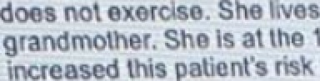

.ii

1. tender

p) Heigpt¿ndyveg tpc£ccD!' S



1. A 20-year-old woman comes to the emergency depa ent 30 minutes after slipping on ice and extending her hand to break her Call. Palpa ion of the anatomic snuff-box produces pain. A wrist x-ray is most likely to show a fracture of which of the following carpal bones*

## S phoid

* 1. Lunate
  2. Triquetrum
  3. Pisiform

## Trapezium

* 1. Trapezoid
  2. Capitate

## Ha a e



 *s rd»Y* box produce s pain A

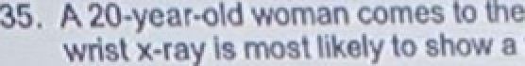

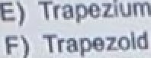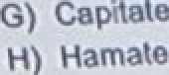

1. A 25-year-old man is brought to the emergency depa ment because of a 30-minute history of perioral tingling, di culty breathing, sweating, vomiting, diarrhea incoordination, and weakness. His symptoms began 30 minutes after he ate shellfish at a restaurant. His respirations are 25/min. Physical examination shows increased salivation and twitching of the muscles of the

lower extremities. Laboratory studies of the ingested fish show a toxin that inhibits axonal transmission. This toxin most likely blocks the action of which of the following?

* 1. lnositol 1 4 5-triphosphate (IP3)-gated Ca 2• channel
  2. Na•-K• ATPase
  3. Na•-linked glucose transporter
  4. Nicotinic acetylcholine channel
  5. Voltage-gated Na• channel

A7,’.,. ,.-..,•.-,.'..,.\”•-.:.-„•,•.-..'. •.•:’,..

1. A35-yearoId womandeveIops{evec headache, chIIs. andmaase2daysaSerdeIivenng a healthy female newborn at 38 weeks gestation. Her temperature is 38.3 C (101 F). Physical examination shows an enlarged, tender uterus. Lochia is profuse and malodorous. A complete blood count shows increased leukocytes. This patient is at greatest risk for developing which of the following complications?
   1. Amniotic fluid overload
   2. Cervical dysplasia
   3. Eclampsia
   4. Endometriosis
   5. Inverted uterus
   6. Thrombophlebitis



1. When control lymphocytes are treated with corticosteroids, a majority of cells shrink in size and develop peripheral chromatin condensation. cytoplasmic organelles are intact. DNA isolated from the control lymphocytes. electrophoresed on an agarose gel. and stained with ethidium bromide. shows a ladder of regularly spaced bands. When lymphocytes from the same culture are transfected so that they overexpress Gene X, which encodes a normal protein product, the cells continue to proliferate and do not undergo any of the morphologic changes seen in the control cells. Gene X is most likely to encode which of the following?
   1. BCL2 protein
   2. ERBB2 protein
   3. P53 protein
   4. Platelet-derived growth factor
   5. Rb protein

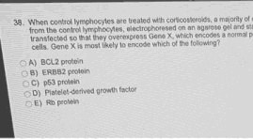

1. A 60-year-old man is brought to the emergency department because of severe pain of the left leg after he fell down a flight of stairs 30 minutes ago. An x-ray of the left lower extremity shows a fracture of the left femur and shows adjacent radiolucent areas. During an operation on the femur tissues from the radiolucent areas is obtained. Analysis of the tissue shows clear cell carcinoma. A primary neoplasm of which of the following is the most likely cause of the findings in this patient?
   1. Bone
   2. Colon
   3. Kidney
   4. Pancreas
   5. Prostate





1. A lesion in which of the following brain structure is most likely to change the affective aspect of pain sensation?
   1. Angular gyrus
   2. Cingulate gyrus
   3. Hippocampal formation
   4. Striate cortex
   5. Supramarginal gyrus



1. A 35-year-oI’d woman comes to the emergency department 3 hours after the sudden onset of severe right-sided back pain. She has a history of recurrent urinary tract infections. Her most recent infection was 1 month ago. she was successfully treated for Klebsiella pneumoniae with antibiotics. The patient is not taking any medication. She says that she has been eating more fast food and drinking less water during the past month because of a busy schedule. She is sexually active and uses a spermicidal cream for contraption. Her temperature is 37 C (98.6 F), pulse is 100/min. respirations are 14/min. and blood pressure is 138/66 mm Hg. Physical examination shows marked tenderness to palpation over the right flank. Urinalysis shows:

pH 8

Protein 1• RBC 30-35/hpf WBC 20-25/hpf

An excess of which of the following is the most likely underlying cause of this patient's flank pain?

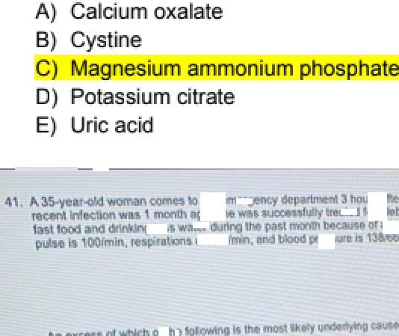

1. A 43-year old woman comes to the physician because of a 2-month history of intermittent abdominal pain. The pain occurs after fatty meals and is localized to the right upper quadrant. Ultrasonography of the abdomen shows cholelithiasis. The patient elects to begin a trail of ursodiol therapy before considering operative treatment. Which of the following is the primary mechanism of action of this medication?
   1. Decreased cholesterol secretion into bile
   2. Enhanced cholesterol absorption
   3. Enhanced hepatic cholesterol synthesis
   4. Inhibition of bile acid synthesis
   5. Inhibition of 3-HMG-CoA
2. In which of the following situations is a virus most likely to be transmitted from the mother to the developing fetus?
   1. Chronic maternal infection prior to conception
   2. Failure of maternal antibody to cross the placenta
   3. Maternal vaccination with live virus vaccine during pregnancy
   4. Presence of maternal antiviral antibody prior to conception
   5. Primary maternal infection during pregnancy

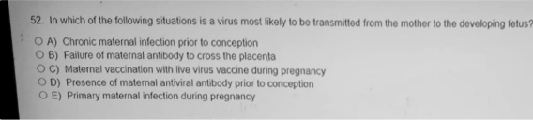

1. A 13-year-old girl ie brought to the physician by her mother becauee of eeveral blemishee on her faoe and back for 8 months. Physical examination ehows scaltered comedonee and papules on the face and back. Treatment with a medication that decreasee cohesion between epidermal celle and increasee epidermal turnover ie initiated. Which of the following drugs wae moet likely prescribed†
   1. Benzoyl peroxide
   2. Clindamycin
   3. Metronidazole

Tetracycline ••• -wv,aWw a di Iron

his is tha MBA given

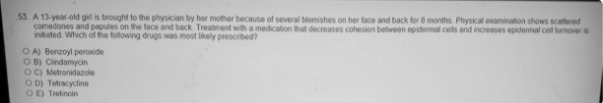

1. A 5-month-old boy ie brought to the emergency department because of a 3-day history of fever and severe wet cough. Hie temperature ie 40.5 C (104.9 F), and reepirations are 65/min. Crackles are heard over all lung fielde. A pfotomicrograph of a silver-stained specimen obtained via bronchoalveolar lavage ie shown. In addition to a lack of expression of human leukocyte antigen-DR moleculee by lymphocytee, flow cytometry of a peripheral blood epecimen will most likely show markedly decreased populations of which of the following cell typea?
   1. CD4+ T fymphocytœ
   2. Dendritic oelle
   3. Monocytee
   4. Naturel killer cells
   5. Segmented neutrophils

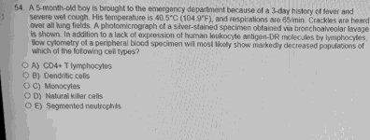 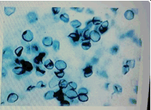

1. Examination of synovial fluid frorri an enlarged tender knee showe numeroue leukocytes with needle-shaped intracytoplaemic inclueions. Which of the following is the moet likely cause of the arthritis?
   1. Autoimmune process
   2. Gout
   3. Lyme disease
   4. Septic gonococcal infection
   5. Trauma

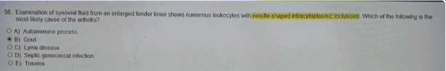

1. A 24-year-old man comes to the physician for a follow-up examination. He has severe Crohns disease that has not responded to initial standard therapy. lnfliximab is recommended. Before beginning this pharmacotherapy , which of the following tests is most appropriate to assess the risk of drug-induced complications?
   1. 24-hour creatinine clearance
   2. PPD akin testing
   3. Pulmonary function testing
   4. Echocardiography
   5. EEC
2. A previously healthy 33-year-old man comes to the physician because of a 3-week history of cough and the frequent need to clear his throat. He takes no medications. He does not smoke cigarettes. Examination of the nasopharynx shows secretions and cobblestoning. The patient says “I am concerned that I may have lung cancer like my dad. His lung cancer started with a cough just like this.” Which of the following is the most appropriate response by the physician?
   1. "I am concerned that you may have an anxiety disorder because of your overreaction to

your father's diagnosis™



* 1. ."It is unlikely that this cough is a symptom of cancer. Let's talk about your symptoms and

"- ._..^’how we can treat them ”

“It's not a good idea to worry about something that hasn't happened yet. Let's discuss why you are bothered by your father's diagnosis.”

1. "It's possible you do have cancer, but it's probably not lung cancer since you don't smoke.'
2. "You don't have to worry about the same thing happening to you because you don't smoke like your dad did.'

###### 88'8’* ** ""'* 8' ‘'-”' 8’**'-'**’"'’ ""!'“'I!* "•**‘--***•--•

^-':

###### -u•*"*-•.

.T• \-' \\.-*,.. T\.•-T\-\ T•-,-.J!-.,'..\• •-.TT\-.:\T TT--T:\t.-•.v. \-@



1. A 23-year-old man is brought to the emergency department by the police after becoming agitated and throwing milk cartons off the shelves in a grocery store. When approached by the store manager he screamed. "I found a turtle! The milk will curdle!" His family is contacted. and they describe him as having been quiet and studious until his freshman year of college 5 years ago. Sincethen. he hasbecomeinceasngIysuspLousand has hadminimal conactwith them. To their knowledge, he has never required admission to the hospital. He is disheveled. malodorous. and appears to be responding to internal stimuli. During the examination he turns away from the physician and yells. "Shut up! I told you to stop talking about the poison.” His speech is incoherent but has a normal rate and rhythm. He says his mood is "okay' but refuses to answer additional questions. Routine laboratory studies are within the reference ranges and urine toxicology screening is negative. Which of the following is the most likely diagnosis*
   1. Bipolar disorder
   2. Schizoaffective disorder
   3. Schizophreriia
   4. Schizophreniform dieorder
   5. Schizofypal personality dieorder



1. A 22-year-old woman comes to the physician because of increaeing fatigue, Iight- headedneae, and palpitations during the past 6 months. she has been following a strict vegetarian diet for 6 years. Her pulse is 100/min. Physical examination ehows pallor. There ie numbneae and pareetheeias of the upper and lower extremitiee. serum studies ehow increased concentratione of methylmalonic acid and homocysteine. Thie patient's symptoms are moat likely due to a deficiency of which of the following vitamins†
   1. FoIic acid
   2. Vitamin B2 (ribo8avin)
   3. Vitamin B6 (pyridoxine)
   4. Vi amne B12 (cobelemn)
   5. Vitamin C (aecorbic acid)

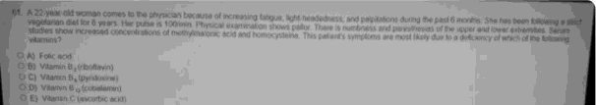

10) Inveatigatore are evaluating oxygen coneumption by different segments of the renal tubulea in experimental animals. Arterial oxygen saturation ie decreaeed in blood delivered to ieolated perfused pig kidneys. Reeults show that ae oxygen delivery declinee, urine output decreaees. A biopay specimen of the ischemic model ie obtained. Tubular cell death is moet likely to be observed in which of the following areas?

1. Cortical collecting duct
2. Distal convoluted tubule
3. Lc›op of henle
4. Papilla

###### Praximal oonvoluted tubule

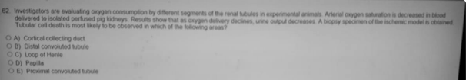

1. A 62-year-old man with a 4-year history of chronic angina pectorie comes to the emergency department because of severe cheet and left shoulder pain. Physical examination shows bradycardia. Ari ECG showe ST—segment elevation in leads II, III, and aVF. Occlueion of blood flow in which of the following arteriee is the most likely cause of the findinge in this patient†
   1. Anterior interventricular (left anterior deecending)
   2. Circumfiex
   3. Left coronary
   4. Right coconery

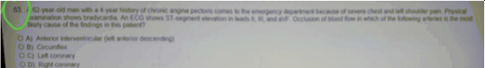

1. A 24-year-old woman comes to the physician because of a 3-clay hietory of vaginal discharge with itching. she ie currently being treated with ciprofloxacin for cystitis. Her vital signe are within normal limits. A photograph of the vaginal area ie shown. Which of the following is the moet likely causal organism†
   1. Chlamydia trachomatis
   2. Herpee simplex virue
   3. Neisseria gonorrhoeae
   4. Trichomonas vaginalis

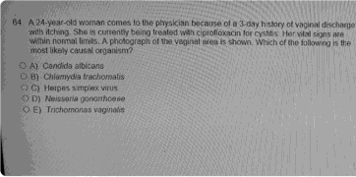 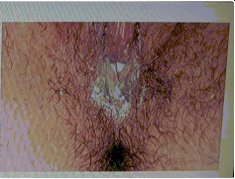

1. A 52-year-old woman comes to the emergency department because of a 2-week history of progressive shortness of breath and fatigue. Her pulse is 102/min respirations are 22/min. and blood pressure is 100/80 mm Hg. Physical examination shows muffled breath sounds. Echocardiography shows a large pericardial effusion. Pericardiocentesis yields cloudy. serosanguineous fluid. Analysis of the fluid shows an increased protein concentration. numerous RBCs and a small number of WBCs, indicative of malignancy. Metastasis from which of the following sites is the most likely cause of the findings in this patient*
   1. Bladder

###### Breast

* 1. Colon
  2. Ovaries
  3. Stomach

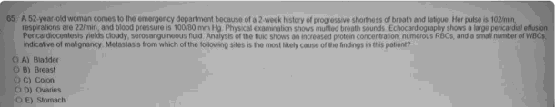

1. A 66-year old woman comes to the physician for a follow-up examination 3 months after she underwent a total colectomy for ulcerative colitis. She subsequently required an ileostomy. She feels generally well and has resumed a nearly normal diet. Her temperature is 37 C (98.6 F) pulse is 92/min, and blood pressure is 100/60 mm Hg. Physical examination shows mildly decreased skin turgor and a well-healed ileostomy site. Laboratory studies show:

Serum

Na* 136 mEq/L

Cl- 114 mEq/L

HCO3- 14 mEq/L

Mrea nitrogen 32 mg/dL

Creatinine 1 mg/dL

Arterial blood gas analysis on room air:

pH 7.32

PCO2 30 mm Hg PO2 80 mm Hg

* 1. Anion gap metabolic acidosis, partially compensated
  2. Anion gap metabolic acidosis, uncompeneated
  3. Chronic respiratory alkalosie, partially compeneated
  4. Chronic respiratory alkalosie, uncompensated
  5. Mon-anion gap metabolic actdoaia, partia0y compenaeted
  6. Non-anion gap metabolic acidoeis, uncompensated

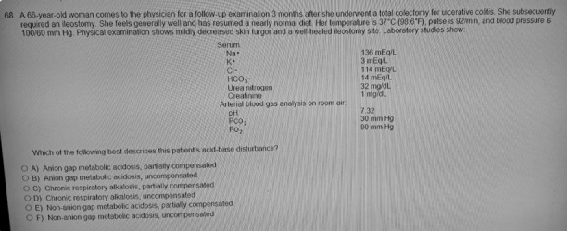

1. A 12-year-old girl hae a painful expanding mase involving the right femur. Examination of tieeue obtained on biopay of the maes showe a lesion compoeed of email, round, undifferentiated cells growing in eheets and rosettes . Cytogenetic analyeis of theae cells shows a reciprocal tranelocation involving chromosomes 11 and 22. Which of the following is the mast likely eflect of the translocation†
   1. Activation of the K-ras oncogene
   2. Deletion of the p53 tumor suppressor gene
   3. Formetion of a chñneñc FWSIFLI1 que
   4. Mutation of the RB gene
   5. Overexpreesion of the MSH2 gene

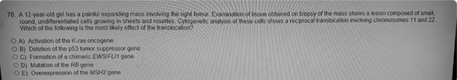

1. A 1-year-old girl is brought to the physician by her mother because of a 1-day history of blisters on her skin. The mother says that she has had several previous similar episodes earlier in the summer. Physical examination shows areas of dense freckling over sun-exposed areas. with hypo-and hyperpigmented macules. The skin appears dry and atrophic. This patient's disorder is most likely caused by a defect in which of the following DNA repair mechanism?
   1. Base excision repair
   2. Mismatch repair
   3. Nonhomologous end joining
   4. Nucleotide excision repair
   5. Recombination repair

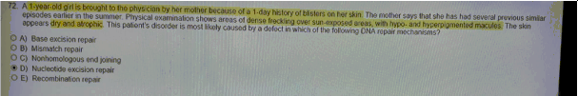

1. Ari 85-year-old man comee to the physician because of a 4-month history of headaches, shortnese of breath, and leg swelling. He has a 15-year history of well-controlled hypertension. Hie pulse ie 80/min, reparatione are 18/min, and blood preesure is 210/110 mm Hg. Crackles are heard at the lung bases. There is a bruit in the left flank and edema in both lower extremitiee. Urinalyeis showe:

Specific gravity 1.015 (N=1.001-1.038)

Blood trace Protein 30 mg/24 h RBC 6/hpf

WBC 0/hpf

Bacteria negative

He dies the next day. Which of the following findings is most likely on autopsy*

* 1. Chronic interstitial nephritis

Ostial stenosis of one renal artery Cost likely TrOID D hcrosclcrosis Presents with biphcsic HTN edema protcinuria

1. Scattered modular aneurysms in the renal arteries

 Solitary left kidney

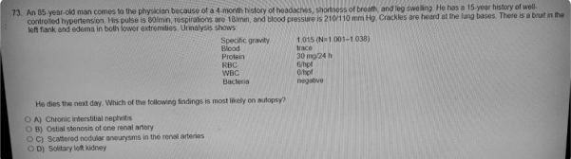

1. A researcher is evaluating the relationship between thrombotic strokes and prior use of oral contraceptives (OCs) in women ages 60 to 80 years. The study consists of 1000 women with a history of thrombotic strokes and 1000 women without a history of thrombotic strokes. Each woman was interviewed and her prior use of OCs was assessed. The results are as follows!

Use of OCs

Yes

##### No

N(%) 567 (57)

433 (43)

N(%)

410 (41)

590 (59)

1. value

0.01

Which of the following types of bias is most likely to affect the results of this study?

* 1. Detection bias
  2. Lead time bias
  3. Recall bias
  4. Test referral bias
  5. Test review bias

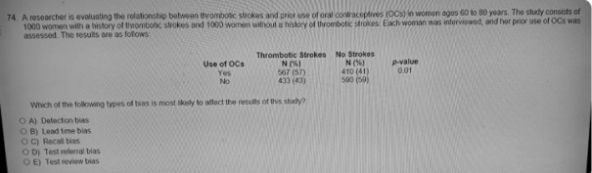

1. A 7-year-old boy is brought to the physician by his mother because of a 3-hour history of pain and stiffness of his neck. Two days ago, he fell off his bike and hurt his neck. Physical examination shows decreased range of motion of the neck. Neurologic examination shows no abnormalities. AP and lateral x-rays of the cervical spine show congenital fusion of the atlas to the occipital bone associated with C2-3 vertebral fusion. Flexion and extension of the neck are most likely placing additional strain on which of the following structures in this patient because of his congenital abnormalities*
   1. Atlant0axial joint
   2. lnterventricular foramen of Monroe
   3. Sternocleidomastoid muscles
   4. Vertebral artery

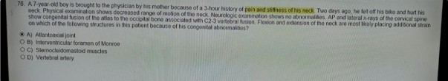

20) A 2-year-old boy is brought to the physician because of a 6-month history of failure to thrive. Cardiac examination shows a grade 4/6 systolic murmur caueed by increased pulmonic flow, followed by a fixed, widely eplit 52. Echocardiography ehowa hypertrophy of the right atrium, right ventricle, and pulmonary arteriee. Thie patient most likely has which of the following congenital cardiac anomaliee†

atrial septal defect

1. Patent ductus arteriosus
2. Persistent truncus arteriosus Tejzelogy qf Fa¥ot
3. ransposition of the great arteries
4. Ventricular septal defect

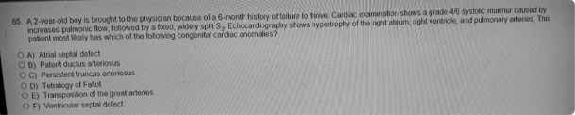

30) Which of the following enzymes in the pathway shown increaaes during fasting†

A) A

B) B

C) C

##### D) D

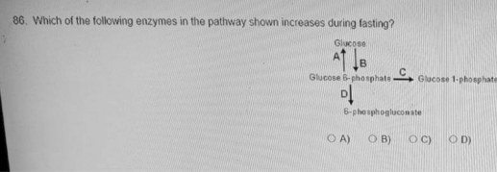

31) A 37-year-old woman comes to the physician because of a 1-month history of anxiety weakness, labile mood insomnia, irritability and angry outbursts especially toward her husband. She says that she frequently feels ”unable to function." She and her husband of 15 years, separated 6 weeks ago after he told her that he is homosexual. Physical examination shows no abnormalities. Which of the following is the most likely diagnosis?

stressful evant prasen¢ less Can 6 monks. and "unabla O function” maans impairment

1. Dysthymic disorder
2. Post—traumatic stress dieorder i4ormal reaction

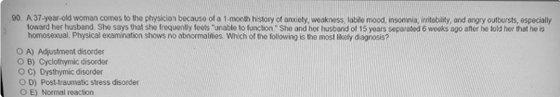

1. A previously healthy 70-year-old man comee to the physician because of intermittent headachee and dizzinese during the past 6 weeke. He does not smoke cigareltee. He ie plethoric. His blood pressure ie 180/80 mm Hg. A grade 2/6 systolic murmur is heard. The spleen tip is palpated 3 cm below the left coetal margin. Laboratory etudies show:

Hematocrit 56%

Leukocyte count 22,000/mm Platelet count 1,300,000/mm

Serum vitamin B12 (cobalamin) 1200 pg/mL Arterial PO2 on room air 03 mm Hg

Which of the following additional sets of laboratory findings is most likely in this patient?

EPO! O2 content in arterial blood:

* 1. Increased Increased
  2. Increased Normal
  3. Increased Decreased
  4. Decreased Increased
  5. Decreased Normal
  6. Decreased Decreased

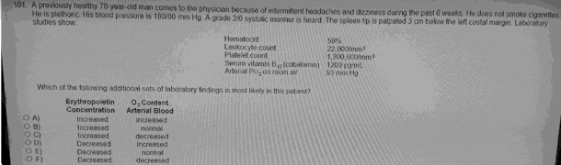

1. A 25-year-old man has end-stage renal failure. During childhood he had recurrent episodes of gross hematuria. Other male family members have a similar history. He also has hearing loss. Which of the following is the most likely diagnosis*
   1. Alport ayndrome
   2. lgA (Berger) nephropathy
   3. Nephritis of chronic infection
   4. Poststreptococcal glomerulonephritis
   5. Systemic lupus erythematosus

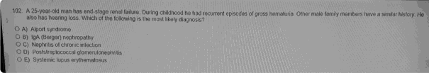

1. Ari 8-year-old boy is admitted to the hospital becauee of severe flank pain and blood in his urine. He hae had intellectual development disorder since early infancy. Examination shows choreoathetoaie and self-mutilation of the lips and fingers. His serum uric acid concentration is increaeed. Urinalysie showa numeroue uric acid cryatale and erythrocytes. The most likely cauee of the hyperuricemia is deficient activity of which of the following enzymee†
   1. G- Aminolevulinate synthase
   2. Glycine-oxaloacetic traneaminase
   3. Glycine synthaee

###### Hypoxan e-0uaene phospkoriboeyl tranefereae

* 1. Serine tranehydroxymethylaee
  2. Xanthine oxidase

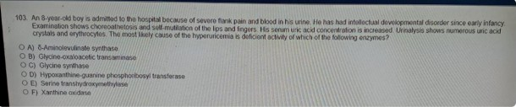

1. A 44-year-old man comes to the physician for a health maintenance examination. He has drunk twelve 12-oz beers nightly for several years. He tells the physician that he is concerned he may have a drinking problem but he has not mentioned the concern to anyone else. He says “Most of my friends drink the same amount and I'm afraid they'll think I'm overreacting if I talk to them about it.' Which of the following best describes this patient's stage of behavior al change*
   1. Precontemplation
   2. Contemplation
   3. Action
   4. Maintenance
   5. Relapse





1. A 5-year-old boy is brought to the emergency department after ingesting 10 oz of household cleaning solvent. He is treated for acute hepatic and renal failure for 1 week and then discharged. During the next month. regeneration of this boy's mature hepatocytes and renal tubular epithelial cells will be accomplished mostly by which of the following mechanisms*
   1. Activation of stem cells to enter G1 phase of the cell cycle
   2. Decreased apoptosis at G1-M transition of the cell cycle
   3. Recruitment of cells from Go into the cell cycle
   4. Shortened time for progression of cells through the cell cycle
   5. Terminal differentiation by cells exiting from the cell cycle

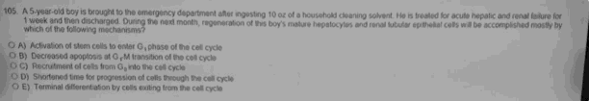

1. A 74-year-old man comee to the emergency department becauee of severe pain between his ehoulder bladea for 2 hours. Hie blood preesure is 180/110 mm Hg in the right upper extremity and 120/66 mm Hg in the left upper extremity. The lungs are clear to auecu6tion. A grade 3/6, diastolic decrescendo murmur is heard at the left stemal border. Which of the following is the moet likely diagnosis†
   1. Acute myocardial infarction
   2. Angina pectoris

##### Aonic dissection

1. Cholecyatitis
2. Coetochondritis
3. Mediaetinitis
4. Pulmonary embolism

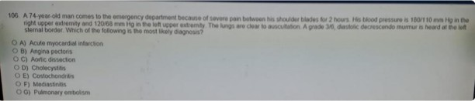

1. A 23-year-old man cute his lip inadvertently while ehaving. Seconds after the injury, the bleeding nearly stops. Which of the following mechanisme is the moat likely cause of the early rapid control of blood loss in thie man†
   1. Activation of antithrombin III
   2. Localized secretion of erdog+elin
   3. Oxygen-etimulated cleavage of thromboplastin
   4. Polymerization of fibrin

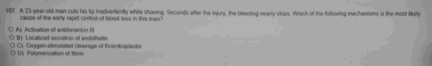

1. A 72-year-old man comes to the physician for a routine examination. He has type 2 diabetes mellitus hypercholesterolemia, dermatomyositis. and nocturnal heartburn. He has been receiving treatment with prednisone. lovastatin glyburide. metformin. and famotidine for 6 months. There are multiple ecchymoses on the upper extremities that do not blanch on pressure. Which of the following medications is the most likely cause of this patient's bruising?
   1. Famotidine
   2. Glyburide
   3. Lovastatin
   4. Metformin
   5. Prednisone

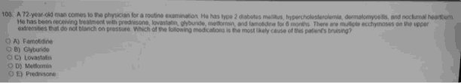

1. Infection with which of the following organieme causea alkaline urine and urinary tract calculi†
   1. Escherichia coli
   2. Pasteurella multocida

###### P«xeua mirebi¥s

* 1. Pseudornonas aeruginoaa
  2. Salmonella typhi
  3. Shigella dyeenteriae
  4. Vibrio cholerae
  5. Vibrio parahaemolyticue

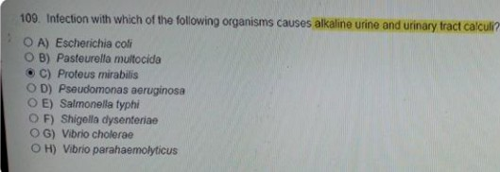

1. During an experiment, the common carotid arteries are aimultaneoualy occluded in an anesthetized experimental animal for 2 minutes. Which of the following seta of physiologic changes ia mast likely to occur?



* 1. Inc‹eesed, lncreeee, **lnageaed, Increased**
  2. Increased, Increased, Increased, Decreased
  3. Increased, Decreaaed, Decreased, Increased
  4. Increased, Decreaaed, Decreased, Decreaaed
  5. Decreased, Increaaed, Increaaed, Increased
  6. Decreased, Increaaed, Decreased, Decreaaed
  7. Decreased, Decreased, Increased, Increased
  8. Decreased, Decreased, Decreaae, Decreased

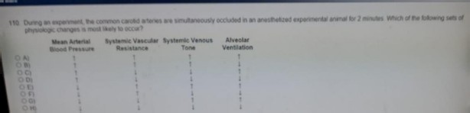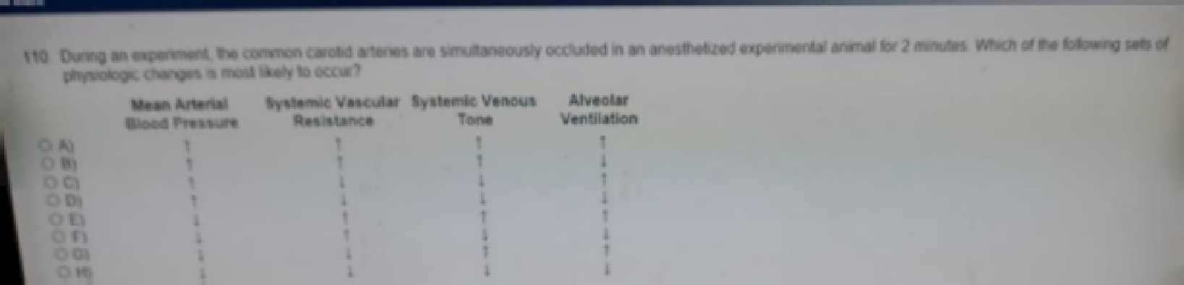

1. One thousand ofiice workers are surveyed to determine whether or not they use computers and whether or not they have eyrriptoms of carpal tunnel eyndrome. Which of the following beat deacribee this study†
   1. Caee-control study
   2. Caee seriea Cohort study

Croee-sectional eurvey

E) Randomized clinical trial

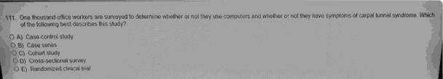

1. A 595-g (1-1b 5-oz) male newborn is delivered at 24 weeks' gestation. Pregnancy was complicated by hypertension and proteinuria. Apgar scores are 4 and 6 at 1 and 5 minutes, respectively. The newborn is in respiratory distress. Which of the following pathophysiologic findings is most likely in this newborn?
   1. Cyanoais
   2. Decreased surface tension in the small alveoli
   3. Increased lung compliance
   4. Lecithin:sphingomyelin ratio of 2:1
   5. PO2 of 95 mm Hg

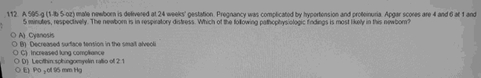

1. A 62-year old man ia brought to the emergency department 2 hours añer the sudden onset of pain and coolneaa in his right leg. He is otherwiae heahhy except for mild hyperthyroidism treated with propylthiouracil. Examination of the lower extremitiea shows normal skin, naila, and hair growth patterns. Pulses are absent in the right lower extremil:y and normal on the lek. Which of the foIk›wing is the moat likely diagnoais?
   1. Cellulitia
   2. Deep venoua thromboais
   3. Embolicartartd o‹xJuegs
   4. Lumbar disc herniation
   5. Rhabdornyolysia

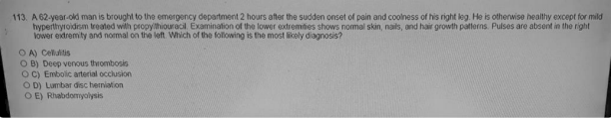

1. A 68-year-old man with Parkinson disease is being treated with levodopa and carbidopa. He is doing well and has few adverse effects. Concurrent therapy with levodopa and carbidopa is useful because of which of the following characteristics of carbidopa*
   1. Blocks muscarinic receptors
   2. Doea not croaa the blood-brain barrier a.e , .. c«lowr N W in B.. @,jhwal»wy.
   3. Enhances activity of the transporter for levodopa
   4. Increases intestinal metabolism of levodopa
   5. Inhibits monoamine oxidase

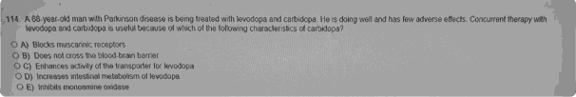

1. A 56-year-old man comes to the physician because of a 3-month history of intermittent regurgitation of material with an acidic taste. He is unable to sleep and has missed 3 days of work during the past month because of the symptoms. Various non-pharmacologic measures including ele vating the head of his bed and decreasing his dietary fat intake and portion size, have resulted in only mild improvement. Physical examination shows no abnormalities. Esophageal endoscopy shows severe erosion’ there are no other structural abnormalities. The most appropriate pharmacotherapy for this patient is a drug with which of the following mechanisms of action on the parietal cells?
   1. Agonism of cholecystokinin B (CCM) receptor
   2. Agonism of prostaglandin E receptor 3 (EP3) receptor
   3. Antagonism of histamine-2 (H2) receptor
   4. Antagonism of muscarinic (M3) acetylcholine receptor
   5. Irreversible inhibition of H+-K+ ATPase

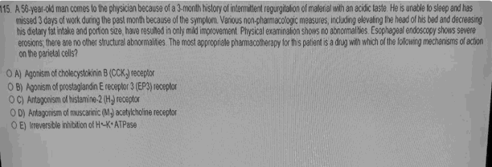

1. A 23-year-old woman who wae recently diagnosed with rheumatoid arthritie comes to the phyeician for a follow-up examination. Two months ago, ehe bagan treatment with adalimumab, which binds with tumor necroeis factor-a. The patient says that her symptoms have not improved. Physical examination ehows mild swelling of the joints of the wriets, hands, anklee, and feet. Which of the following immune syetem components is moet likely contributing to this patient's symptoms†
   1. lgA
   2. lgE
   3. lntwteukin-1 (IL-1)
   4. IL-4
   5. Vascular endothelial growth factor

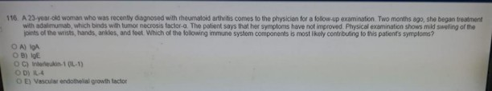

1. 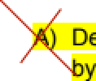A 64-year-old woman with atrial fibrillation comes to the physician for a monthly follow-up examination. She began treatment with warfarin 18 months ago. She has not noticed any bleeding and feels well. After an initial period of dose adjustment, her INR has remained at 2.5 for the past €i months with an alternating high- and low-dose regimen. Her pulse is 96/min and irregularly irregular. Physical examination shows no other abnormalities. Laboratory studious show an INR of 5 8 Which of the following actions by the patient best explains the change in her INR†

Deliberate decrease in da8age fbr 5 days while awaiting the arrival of the warfarin refill

1. Inadvertent substitution of the low-dose pills for the high-dose pills
2. Increased consumption of green leafy-vegetables during the past 2 weeks Self-medication with an over-the-counter supplement that decreases warfarin metabolism



D

E) Unintentional ingeetion of expired medication

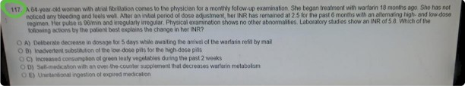

40) A newborn is evaluated for microcephaly, cataracts, and chorioretinitie. The mother developed an illneaa in the first trimester of pregnancy characterized by low-grade fever, a faint erythematous rash, occipital lymphadenopathy, and joint stiffneee. The illneae reeolved within 1 week with complications. she did not reoeive any immunizatione prior to the pregnancy. Which of the following viruses is the most likely cause of the newborn's iIIness‘2

1. Cytomegalovirus
2. Herpee Simplex Virus
3. HIV
4. HTLV-2
5. Measlee virus
6. Reovirus

###### Rubelle vdus

1. Varicella—zoeter virue

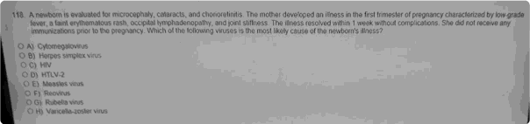

50) A healthy 28-year-old woman participates in an exercise study. Several physiological variables are measured as she runs on a treadmill. The ambient room temperature is 75 F. She reaches a steady state that increases her oxygen consumption threefold. She continues to exercise at that level for 20 minutes. During the first 5 minutes of exercise, the vascular resistance of which of the following is likely to show the greatest increase from resting values in this volunteer

1. Coronary
2. Cutaneous
3. Exercising Muscle
4. Pulmonary
5. Splanchnic
6. Systemic

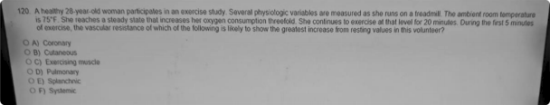

51) A 54-year-old woman comes to the physician because of a 10-day history of episodes of severe stabbing pain of her left cheek and jaw. She says that the pain occurs suddenly and can be precipitated by chewing, speaking, or brushing her teeth; it lasts several seconds and occurs 20 to 30 times daily. She adds “It feels like lightning is striking my cheek." Touching the left cheek reproduces her symptoms. Which of the following is the most likely cause of this patient's symptoms*

1. Compression of the trigeminal nerve by an acoustic neuroma (vestibular schwannoma)
2. Inflammation of the temporomandibular joint
3. Inflammation of the trigeminal nerve by a multiple sclerosis plaque
4. Microvaacular compreasion of the trigeminal nerve
5. Recurrent transient ischemia in the vertebrobasilar system

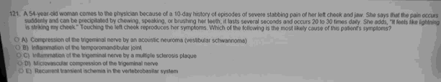

1. A 4-year-old girl ia brought to the physician by her mother 2 hours aRer falling and arzaping her right knee while playing outside. Examinaâon of the right lower extremity ahows a 8 x 8-cm denuded area over the knee with a aeroua exudate and an erythematous border. The patient'a mother says that ahe recently read a magazine article about ataphylocoocal akin infection, and she is concerned about her daughter's riak fbr developing this infection as a resuh of the injury. The preaence of which of the following cell typea at the wound site will moat likely derzeaae thia patient's riak fbr devebping a baderial infection'7
   1. CD4+ T lymphocytes
   2. CD8+ T lymphocytes
   3. Dendritic celia
   4. Maat celia
   5. **Neutrophils**
   6. Plaama celia

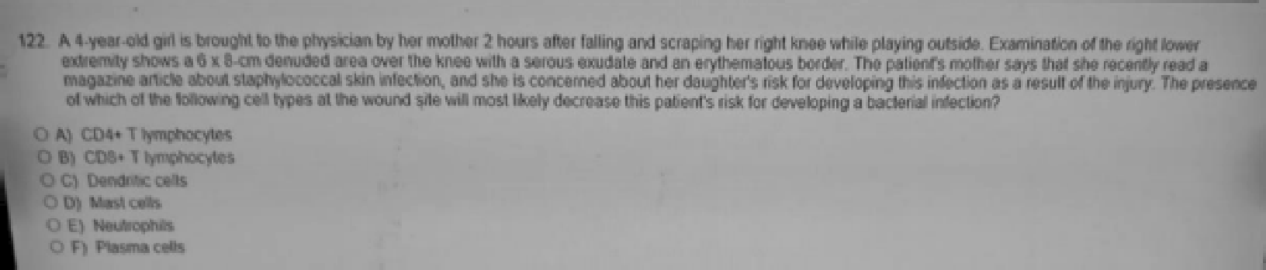

1. A 58-year-old man ie brought to the emergency department 30 minutee after he was involved in a motor vehicle collision. Phyeical examination showe inability la raiee the right upper extremity. A CT scan ehows a nondisplaced fracture of the right clavicle, in addition to a 4.S-cm multiloculated mass in the left kidney and a 4.5-cm aneuryemal dilation of the abdominal aorta. There is also irregular lymphadenopathy of the left para-aortic (lumbar) lymph nodee. Laboratory studiee ehow a serum calcium concentration of 13.7 mg/dL. Which of the following is the moat likely cauee of the eerum calcium findinge in this patient†
   1. Chronic renal failure
   2. Clavicle fracture
   3. Pe‹ar›eopleatic ayndrorr›e
2. Primary hyperparathyroidism
3. Sarcoidosie

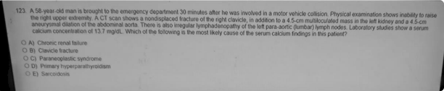

1. A 10-month-old girl developa a cough and grunâng following a 3-day haspital atay for surgical repair of a cleft palate. Her temperature ia 30.2 C (102.8 F), and reapirationa are 40/min. CracNes are heard over moat lung fields, and breath aounda are decreaaed. There ia a mild pleural mb in the right upper thorax. Her leukocyte count ia 68,000/mm (85% segmented neutrophils, 10% banda, and leaa than 5% myebblasta, promyelocytes, and myelocytes). Which of the following mechaniama moat likely caused the increaaed leukocyte count in thia patient†



red

Accelerated release of celia from the bone marrow poatmitotic reserve

merginetion end rollkig of circuletirq ce0a

1. Shift in bone marrow for eoainophil producâon to aegis neutrophil production
2. Tranafowiaâon of myebid atem cells

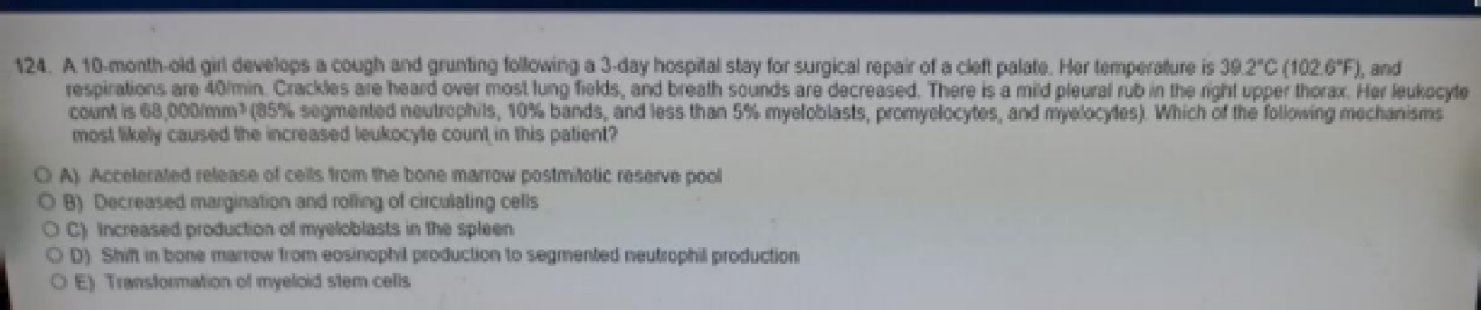

1. An aeyrriptomatic 37-year-old man is eeropoeitive for HIV. CD4+ T lymphocyte count is 120/mm. A combination of three antimicrobial agente is prescribed for treatment, one of which ie a protease inhibitor. The two additional agents most likely to be administered both work by inhibiting which of the following metabolic functione†
   1. DNA-dependent RNA polymerase activity
   2. DNA gyraee activity
   3. DNA polyrrierase activity
   4. Ergoeterol synthesie
   5. Fdic acid metabolism
   6. Mitochondrial function
   7. Peptidoglycan eynthesis
   8. Reverse **pansalptase** activity
   9. Ribosomal function
   10. Uncoating of the organism





1. A 16-year-old girl comes to the physician because she is concerned that she may be at risk for Huntington disease. Her father who has been divorced from her mother for many years and lives in another state. was recently diagnosed with this condition. The patient says that she knows about the genetic basis of Huntington disease and worries that she may develop it. She adds, "My mother seems so casual about it all. She says for me not to worry, that I won't develop the disease. but I can't help worrying.” The physician, who has provided care for this patient since birth knows that the patient's father is not her biological father. Which of the following is the most appropriate next step by the physician?
   1. Assure the patient that her mother is correct not to worry
   2. Contact the patient's mother and encourage her to share the paternity history
   3. Tell the patient the truth about her paternity
   4. Arrange for genetic testing knowing that the result will be negative
   5. Refer the patient to a mental health provider to evaluate and treat her anxiety

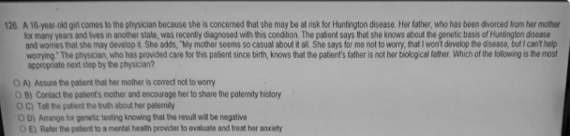

1. A 65-year-old man comes to the physician because of a 1-month history of difficulty urinating. He says that he has difficulty initiating urination, and once initiated, the urine tends to "dribble." Rectal examination shows a diffusely enlarged, firm, nontender prostate. Which of the following findings is most likely to be found on histologic examination of the prostate?

Glands lined with hyperplastic transitional epithelium



A)

1. Masses of psammoma bodies in the periurethral zone
2. Mucus-filled cysts in the posterior lobe

Nodulea formed by proliferaâng stromal and epithelial cells

E) Scarring throughout the stroma

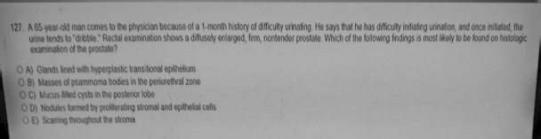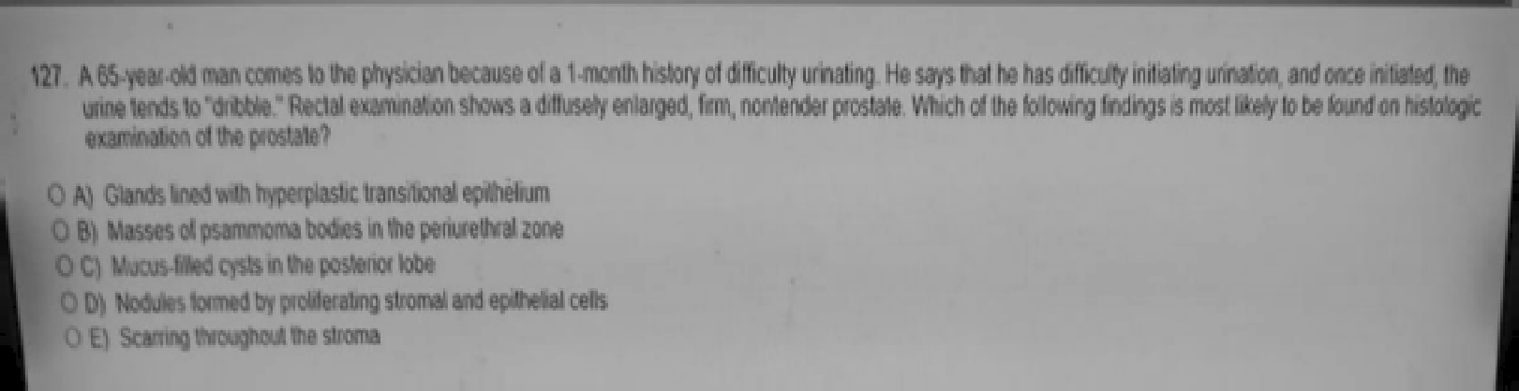

1. A 35-year-old man has a einus tachycardia of 120/min. Which of the following best describee the relationship of ventricular contraction and relaxation in thie patient?
   1. Diastole and systole equally prolonged
   2. Diestole arid ayetole equelfy shortened
   3. Diastole ie prolonged more than syetole
   4. Diastole ie ehortened more than eyetole
   5. Systole ie prolonged more than diaetole
   6. Systole ie shortened more than diaetole

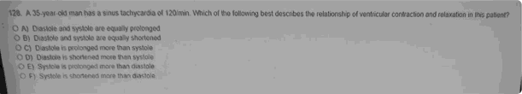

1. A 32-year-old primigravid woman delivers a healthy 34O2-g (7-1b 8-oz) male newborn after an uncomplicated cesarean delivery because of a nonreassuring fetal stress test. Two days prior to discharge from the hospital, she has persistent numbness of the area surrounding the abdominal incision. The physician assures the patient that sensation will gradually return as the nerves regenerate. Which of the following best describes the rate limiting step in this patient's return to normal sensation?
   1. Dorsal root ganglion cell proliferation
   2. Fast anterograde axonal transport
   3. Fibroblast proliferation
   4. Retrograde axonal transport
   5. Slow anterograde axonal transport

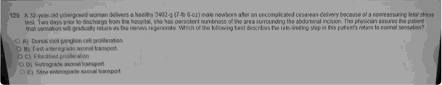

1. A 33-year-old homeless man is admitted to the hospital with hypothermia after police found him sleeping on a street comer during a snowstorm. Two days later, he becomes agitated and tremulous, and says that he sees bugs crawling on the wall. His temperature is 38.3 C (101 F), pulse is 100/min, and blood pressure is 180/90 mm Hg. Physical examination shows a mild intentional tremor He is oriented to person, but not to place or time. The physician orders an MRI of the brain, but the patient becomes uncooperative. Administration of which of the following is most appropriate at this time?
   1. Amitriptyline
   2. Chlorpromazine Lithium carbonate

D) orazepam *““ """'”' Propofol

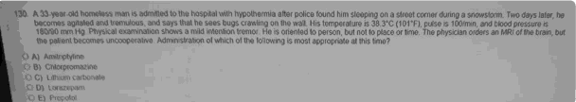

1. A 32-year-old man is brought to the emergency department by ambulance 3O minutes after he was found unresponsive by his wife. Paramedics say that his blood glucose concentration was 22 mg/dL by fingerstick at the scene. He became responsive following administration of an ampule of 50oé dextrose. On arrival, he says that he has a 3-month history of episodes of sweating and feeling shaky. His symptoms resolve when he eats a candy bar. Physical examination shows no abnormalities. The tentative diagnosis of insulinoma is made. In addition to a decreased glucose concentration, which of the following sets of findings in this patient during a fasting-induced hypoglycemic episode is most likely to confirm the diagnosis?

Insulin C Peptide Urine Ketones

* 1. Increase, Increased, present
  2. Increased, Increased, absent
  3. Increased, Decreased present
  4. Increased, Cecreased absent
  5. Decreased, Decreased, present
  6. Decreased, Decreased, absent

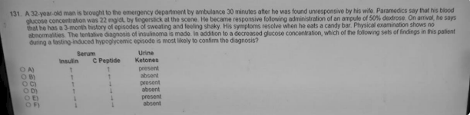

€t2) A 1-year-old boy reoeives a left cochlear implant that consists of an array of electrodes. Six months ago, he was diagnosed with severe bilateral hearing deficit. Which of the following elements of the auditory system must remain intact for this patient to perceive auditory stimulation via activation of the electrodes in the implant†

1. Auditory hair oells
2. Auditory nerve
3. Ossicles
4. Round Window
5. Tympanic membrane

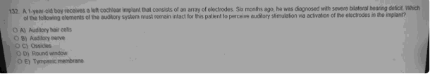

1. A 70-year-old man comes to the physician becauee of a 36-hour hietory of an inability to urinate and a 24-hour history of sharp lower abdominal pain. He has hae a decreaeed urinary stream for 12 months, and he has had to urinate Mo to four timee nightly during this time. His temperature is 37 C (08.6 F), pulse ie 110/min, respirations are 20.min, and blood pressure is 160/100 mm Hg. Phyeical examination ehowa tenderness and dullness to pemusaion over the suprapubic region. serum studies ehow a urea nitrogen (BUN) concentration of 50 mg/dL and a creatinine concentration of 3.0 mg/dL. Insertion of a Foley catheter immediately yields 2 litera of urine. Which of the following findings is most likely during the next 24 hours?
   1. Brisk diuresia
   2. Hypercalcemia
   3. Hyperkalemia
   4. Hypermagnesemia
   5. Increasing serum creatinine concentration

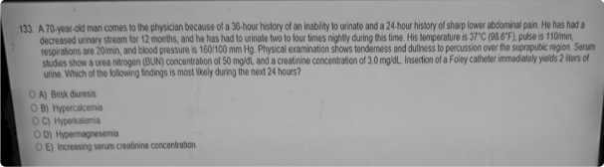

1. An 18-year-old man is brought to the emergency department 30 minutes after sustaining injuries in a motor vehicle collision. He has abdominal pain. His pulse is 120/min, and blood pressure is 80/60 mm Hg. Physical examination shows multiple contusions over the trunk and abdominal tenderness. A chest x-ray shows multiple rib fractures. A CT scan of the abdomen is shown. Which of the following organs is most likely injured in this patient*
   1. Bladder
   2. Liver
   3. Pancreas
   4. Spleen
   5. Stomach

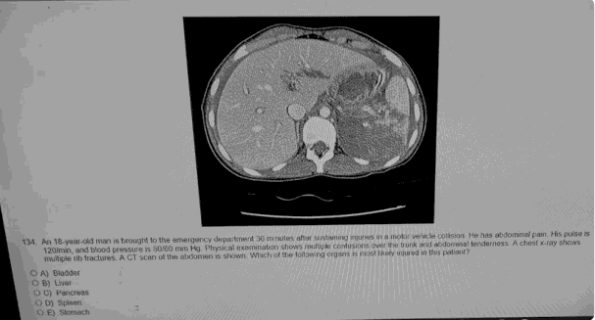

1. A 41-year-old man comes to the physician because of a 2-day history of intensely itchy hives over his legs. He says that the rash appeared shortly after he returned from a weekend hiking trip. He works in a warehouse and is required to operate heavy machinery. Examination of the lower extremities shows multiple 1- to 2-cm well-circumscribed, edematous papules. Which of the following is the most appropriate pharmaootherapy for this patient?
   1. Chlorpheniramine
   2. Diphenhydramine
   3. Fexofenadine
   4. Meclizine
   5. Ranitidine

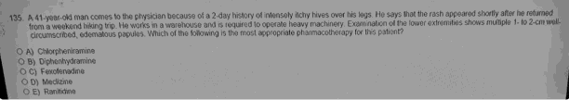

1. A 37-year-old man with HIV infection is admitted to the hospital for treatment of syphilis. Two hours after receiving an intravenous dose of penicillin G, he develops progressive headache and shaking chills. He has received penicillin therapy in the past with no adverse eflects. His temperature is 38.4 C (101.1 F), pulse is 120/min, and respirations are 31/min and shallow. Pulse oximetry on room air shows an oxygen saturation of 04%. Physical examination shows no new findings since admission. Which of the following is the most likely diagnosis?
   1. Guillain-Barre syndrome
   2. Immune complex disease
   3. Jariach-Herxheimer reacgon
   4. Reactive arthritis
   5. Rheumatic fever
   6. Type I (immediate) hypersensitivity reaction
   7. Type IV (delayed) hypersensitivity reaction

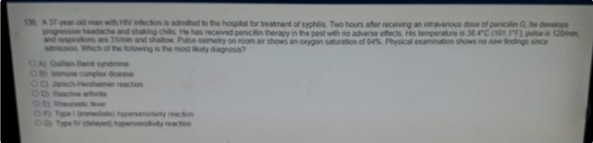

1. The anticodon sequence of tRNA performs which of the following functions?
   1. Decoding of mRNA during translation
   2. Formation of a ternary complex with protein synthesis elongation factor-T1
   3. Initiation of the process of ribosome assembly
   4. Selection of a specific amino acid for acylation
   5. Selection of a specific mRNA for binding to the ribosome



O /‹ • tO0 Ol 8 ternary complex with & C) lnitia\\o• •l lh6 p\ocess ol



OlO8g4t‹On factgr.T j

a speci\ c amiro acid

’! ection of a *r•c‹›C mRHA for

Of8 Wt%n

1. A 32-year-old man comes to the physician for a health maintenance examination. His maternal uncles and grandfather had hypertension, renal calculi, enlargement of both kidneys. and decreased renal function. His maternal grandfather died of a ruptured intracranial berry aneurysm. Physical examination shows no abnormalities. Ultrasonography shows file to seven cysts in both kidneys. The patient most likely has a mutation in the gene that encodes which of the following proteins*
   1. Fibroc ystin
   2. Nephrocystin
   3. Polycystin
   4. Sodium chloride cotransporter
   5. Sodium-potassium-2 chloride transporter
   6. Voltage-gated chloride channel
   7. Wilms tumor 1 (WT1)

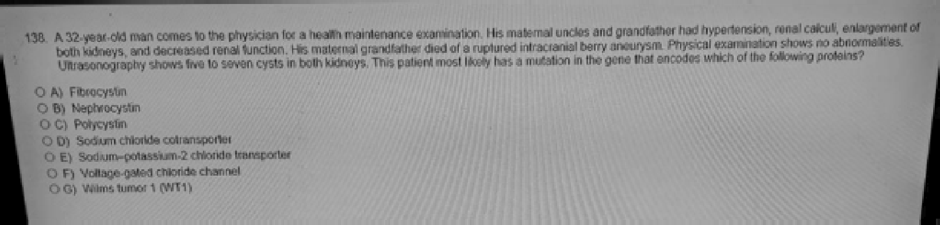

60) During a etudy of alveolar function, a change ie induoed in the alveoli of an experimental animal. Resulte ehow a marked decrease in gas diffusion. Which of the following labeled cell typee in the normal croes section of the alveolar wall hae most likely been altered in thie experimental animal†

1. A
2. B
3. C
4. D

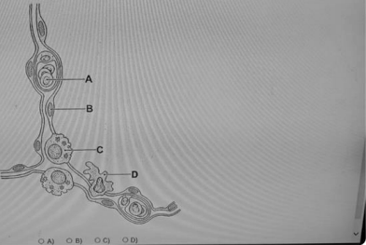



70d A 72-year-old man with severe congestive heart failure is brought to the emergency department because of a 5-day history of malaise and vomiting. He takes no medications. His pulse is 104/min. respirations are 35/min. and blood pressure is 90/64 mm Hg. Physical examination shows dusky-colored skin peripheral cyanosis, and 10-cm jugular venous distension. Crackles are heard over the lung bases bilaterally. Cardiac examination shows an S3. There is 2• pitting edema to the knees bilaterally. Laboratory studies show:

###### Serum

Na+ 127 mEq/L

K• 5.2 mEq/L

Urine

CI- 79 mEq/L

HCO3— 17 mEq/L

Urea Nitrogen 100 mg/dL Glucose 171 mg/dL

Creatinine 8.4 mg/dL

Glucose 1+ Ketones absent

Arterial blood gas analyeis on 26% oxygen

pH 7.35

PCO2 32 mm Hg PO2 154 mm Hg HCO3— 17 mEq/L

Which of the following is the moet likely cause of anion gap in this patient†

1. Alcoholic ketoacidasis
2. Diabetic ketoacidosis
3. Hyperperfueion
4. Hypoalbuminemia
5. Metabolic acidoaie
6. Milk-alkali syndrome

 Renal failure

H) Reepiratory alkaloaie

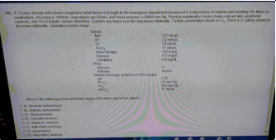

1. A 62-year-old woman develops difficulty breathing. Pulmonary function teats before and after bronchodilator therapy show no changes. Predicted and patient valuea are

|  |  |  |
| --- | --- | --- |
| Test | Predicted | Patient |
| FVC (L) | 5.0 | 4.0 |
| FEV1 (L) | 4.0 | 2.4 |
| FEV1/FVC | 0.8 | 0.6 |

Total lung capacity (L) 6.0 7.2

Reeidual volume (L) 1.6 2.7

Which of the following is the most likely explanation for these findings*

Airway resistance Lung compliance

* 1. Increased Increased
  2. Increased normal
  3. Normal Decreased
  4. Decreased Increased
  5. Decreased Decreased



1. A 20-month-old girl is brought to the physician by her mother because the mother is concerned about her daughter's development and behavior. The girl is able to walk and run and has a vocabulary of at least 100 words. However. when she attends playdates with other children, she prefers to play by herself and will strike another child on the head if that child attempts to join her in playing with a particular toy. Which of the following best explains this patient's actions during play*
   1. Attention-deficit/hyperactivity disorder
   2. Conduct disorder
   3. Early sign of autistic disorder
   4. Oppositional defiant disorder
   5. Normal behavior for age

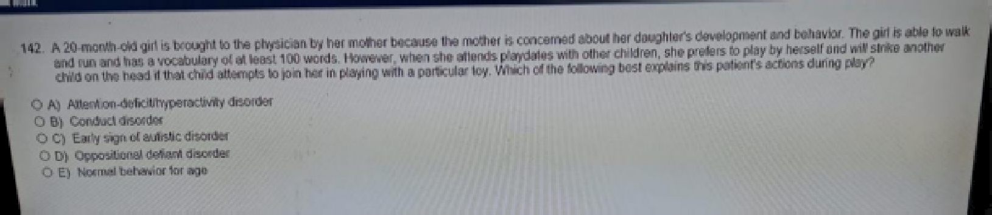

1. A 45-year-old man with alcoholiem is admilted to the hospital for acute pancreatitis. He initially responds well to bed reat and intravenous fluid, but 1 week later he has a persietent fever and epigaetric pain. Hie temperature ie 38.6 C (101.5 F). Abdominal examination showe a tender epigastric maee. Laboratory etudies show a leukocyte counfy of 13,500/mm and eerum amylaee activity of 300 U/L. Which of the following is the moat likely cauee of theee findings†
   1. Acute gastric dilatation
   2. Carcinoma of the storriach
   3. Chronic pancreatitis

Cystic adenocarcinoma of the pancreae Pancreatic pseudocyst



E)

1. Perforated gastric ulcer with abscess

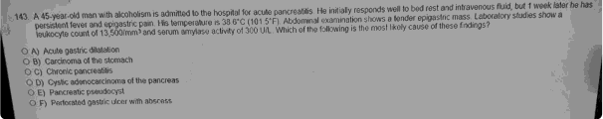

1. A 10-month-old boy is brought to the physician because of a 1-week history of pale skin. A male cousin on his mother's side had anemia that responded to treatment. Physical examination shows pallor, splenomegaly, and generalized weakness. Laboratory studies show a hypochromic, microcytic anemia. Examination of bone marrow aspirate shows hypercellularity, erythroblasts containing ferritin granules, and a decreased concentration of 5-aminolevulinic acid (g-ALA) synthase. Treatment with which of the following substances is most likely to improve this patient's condition?
   1. Erythropoietin
   2. Ferrous sulfate
   3. Fdic acid
   4. Vitamin B6 (pyridoxine)
   5. Vitamin B12 (cyanooobalamin)

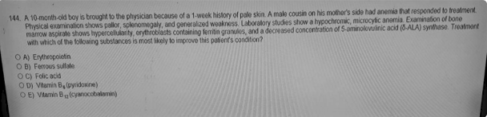

1. A case control study examining the relationship of exposure to indoor radon and lung cancer generated the following data.

|  |  |  |  |
| --- | --- | --- | --- |
| Yes  No | Present 500  500 | Absent    700 | 1200 |
| 1000 | | 1000 | 2OOO |

1. Which of the following is the estimated odde ratio for the relationehip between radon and lung cancer?
   1. (500 x 300) / (500 x 700)
   2. (500 x 500) / (300 x 700)

##### C} t6tXl x 7tXll / t500 x 300)

1. (500 x 500 x 300 x 700) / (1000)
2. Cannot be determined

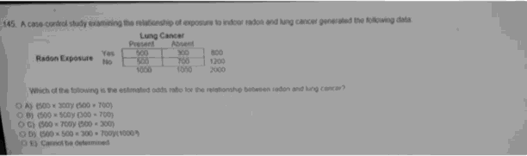

1. A 55-year-old man has had traneient episodes of syncope with exercise for 6 weeka. He has a loud, harsh eystolic murmur that radiates to the neck and dampened peripheral pulees. ECG shows left ventricular etrain. Which of the following ie the most likely diagnosie†
   1. Aortic insufficiency
   2. Aortic stmosia
   3. Atrial septal defect
   4. Mitral insuGciency
   5. Mitral valve prolapae
2. Truncus arteriosus
3. Ventricular septal defect

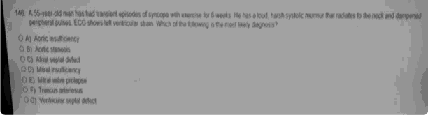

1. A 60-year-old woman comes to the physician because of progressive lethargy, fatigue muscle weakness joint pain. and constipation during the past 2 years. She tells the physician that she feels depressed because of her symptoms. Her only medication is simvastatin. She also takes calcium and vitamin D supplement and a multivitamin. Physical examination shows no abnormalities. Serum studies show a calcium concentration of 12.8 mg/dL. Her urine calcium output is 250 mg/24 h. The most appropriate next step in management is measurement is which of the following serum concentrations*
   1. AM cortisol
   2. Free thyroxine (FT4)
   3. Parathyroid hormone
   4. PM cortisol

. E) Triio Jorhyronirie (T3)

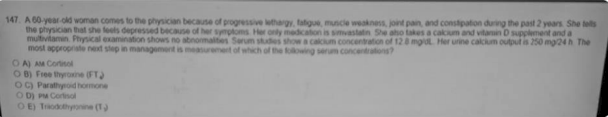

70) Ari 84-year-old woman comes to the physician because of a S-day hietory of pain in her buttocke. Phyeical examination showe a 2-cm abscess lateral to the anue. Which of the following nodes ie most likely affected by the infection in this patient?

1. External iliac
2. Internal iliac
3. Rectal
4. Sacral

##### Superficial inguinel

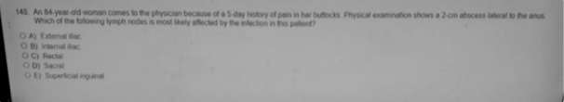

1. A 34-year-old woman ia brought to the emergency department 45 minutes after ahe waa involved in a motor vehicle collision. She saya that ahe haa cheat pain. Her pulse ia 120/min, respirations are 30/min, and bk›od preaaure ia 100/70 mm Hg. Breath aounda are decreaaed on the leaf. A cheat x-ray ia ahown. Which of the foIk›wing is moat likely the moat likely diagnosis?
   1. Cardiac tamponade
   2. Diaphragmatic rupture

###### Hemothorax

* 1. Pulmonary embolism

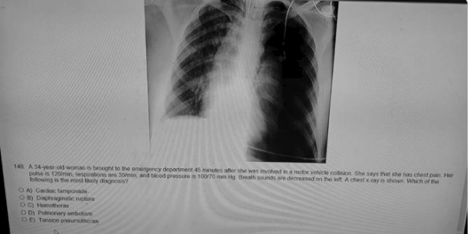

1. The table reporte eurvival of patiente who had an operation for a particular form of cancer:

If a patient eurvives 2 years after the operation, which of the following ie the probability of surviving at least 4 years†



1. .85
2. .&4 x 85
3. .62 x .80 x .84 x .85
4. .85 — .80

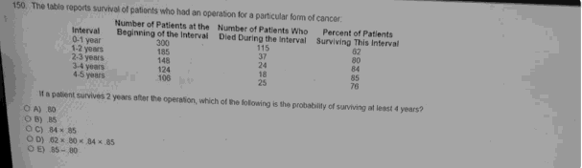

1. A 34-year-old woman is admitted to the hospital after sustaining third-degree bums over 75% of her body surface area, including her face and hands, in a house fire. After 3 months of appropriate care in the bum unit, she requests to have all care stopped except for pain control. She says that she realizes she will die in a few days if this wish is followed. She undergoes psychiatric evaluation and is found to retain decision-making capacity and to be appropriately depressed for her circumstances. Which of the following is the most appropriate next step in management?
   1. Comply with tha patient's wishea in full
   2. Obey the patient's wishes only if she still feels the same way after a 3-month course of antidepressant therapy
   3. Obtain a court order to allow continued treatment despite the patient's wishes
   4. Persuade members of the patient's family to convince her to allow further treatment
   5. Withhold all complex life-saving procedure per the patient's wishes but continue with

parenteral nutrition and intravenous fluid administration



1. A 67-year-old man with poorly controlled unstable angina is about to undergo coronary angiography with stent placement. Prior to the procedure, treatment is initiated with aspirin and a drug that inhibits platelet interaction with fibrinogen. This drug most likely which of the following?
   1. Abciximab
   2. Celecoxib
   3. Cilostazol
   4. Clopidogrel
   5. Dipyr idamole

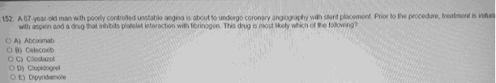

1. A 33-year-old woman comes to the physician because of a 1-day history of abdominal cramping and mild vaginal bleeding. Her last menstrual period was 9 weeks ago. Vital signs are within normal limits. Physical examination, including pelvic examination, shows mild lower abdominal tenderness and mild enlargement of the uterus. Serum studies show an increased human chorionic gonadotropin concentration. Ultrasonography of the uterus shows villus tissue with no obvious gestational sae or fetus. Histopathological examination of uterine tissue obtained via curettage shows inflamed decidua and immature chorionic villi with marked villous edema and lymphoblastic proliferation. Immunostaining to detect p57 protein is done on the tissue and no staining is noted within the villi. Chromosomal analysis of the villous tissue is most likely to show which of the following?
   1. 45, X
   2. 48, XX
   3. 69, MX



E) 92, XXXY

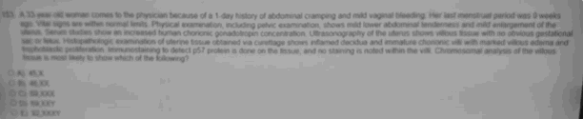

1. A 42-year-old man who passed a renal calculus 6 months ago comes to the physician for a follow-up examination. He underwent thyroidectomy for thyroid cancer 3 years ago and has received daily thyroxine (T4) therapy since then. Two maternal uncles died of thyroid cancer. His blood pressure is 160/88 mm Hg. His serum calcium and parathyroid hormone concentrations are increased, and serum phosphorus concentration is decreased. Measurement of which of the following is most likely to establish the cause of hypertension*
   1. Plasma metanephrine concentration
   2. Plaama renin activity 

renin and P rP

* 1. Serum aldosterone concentration
  2. Serum cortisol concentration



(MEN2A). not blood. Would also complain of palpitationa. sweatnp ed.

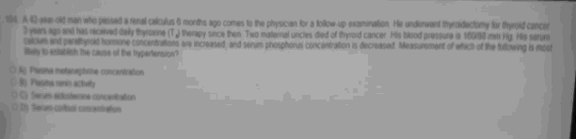

1. A 59-year-old man who is receiving intensive courses of chemotherapy for prostate cancer comes to the physician for a follow-up examination. Regular complete blood oount measurements have been taken before each course. Laboratory studies today show:

Hemoglobin 13 g/dL Hematocrit 4Ooé Leukocyte count 1200/mm

Platelet count 145,000/mm

Which of the following is the most appropriate pharmaootherapy for this patient at this time?

* 1. Eltrombopag
  2. Erythropoietin
  3. Oprelvekin
  4. Palifermin

###### Pegfilgraatim

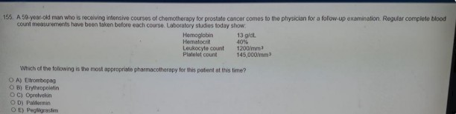

1. A 45-year-old woman has had progressive fatigue, shortness of breafh, and menorrhagia for

€i months. She reports feeling cold most of the time. Her voice is deep and hoarse. The thyroid gland is normal in size, cracNes are heard at both lung bases, and muscle stretch reflexes at the ankles have a delayed relaxation phase. Hematocrit is 31%, and mean corpuscular volume is 74 um. X-ray of the chest shows an enlarged globular heart. Which of the following is most likely to establish the diagnosis†

* 1. Bone marrow aspiration
  2. Echo ardiography
  3. Laryngoscopy
  4. Pap smear
  5. Thyroid-stimulating hormone

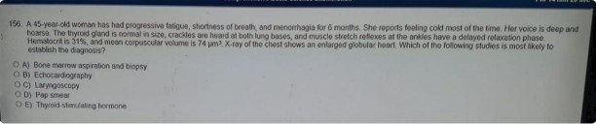

1. A 76-year old woman comes to the physician because of a 2-day history of abdominal pain, nausea, and vomiting. Her temperature is 38.8 C (102 F), pulse is 88/min, respirations are 2€t/min, and blood pressure is 117/76 mm Hg. Abdominal examination shows tenderness of the left lower quadrant. Laboratory studies show a leukocyte count of 22,500/mm with 8% bands. A CT scan of the abdomen shows an abscess in the left lower quadrant. The patient undergoes drainage of the abscess and a partial sigmoidectomy for a ruptured diverticulum. Neutrophil activation in this patient is directed, in part, by bacterial lipopolysaccharides. As a result, these lipopolysaccharides most likely bind to which of the following neutrophil receptor types†
   1. Cytokine
   2. G protein-linked
   3. Ion channel-linked
   4. Nuclear

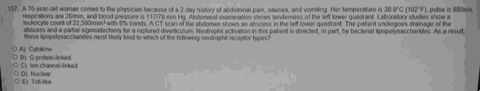

1. A 26-year-old woman comes to the physician because of an 8-day history of difficulty swallowing, shortness of breath and progressive weakness of her legs; she also has a 2-day history of tingling of her legs. She had an episode of diarrhea 1 month ago. Physical examination shows decreased deep tendon reflexes in the upper extremities and absent deep tendon reflexes in the lower extremities. A lumbar puncture is performed. Cerebrospinal fluid analysis shows a cell count of 4/mm and protein concentration of 65 mg/dL. If a peripheral nerve biopsy specimen were obtained, histologic examination would most likely show which of the following findings?
   1. **Fndoneurial** lymphocytic infihrates and deatruction of myelin
   2. Endoneurial neutrophilic infiltrates and destruction of connective tissue
   3. Perineurial lymphocytic infiltrates and vascular thrombosis
   4. Perineurial neutrophilic infiltrates and destruction of axons
   5. Perineurial neutrophilic infiltrates and vascular necrosis

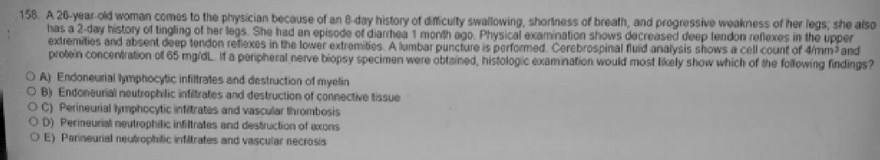

00) A 32-year-old woman calls the phyeician becauee she is concerned that her S-year-old daughter may have aepirin poisoning. Ten minutes ago, she found her daughter eating tablets frorri an open bottle of chewable, flavored aspirin. The child admita eating fhe aepirin, but the mother is unable to determine how many tablets her daughter consumed. Which of the following symptome is the beat indicator that the doee ingested by fhe daughter is toxic†

1. Blurred vision
2. Decreaeed body temperature
3. Exceseive salivation
4. Slurred speech

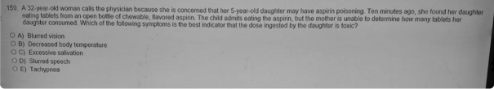

91) A 78-year-old man comes to the physician because of a 3-week history of shortness of breath, progressive weakness, and limitation of physical activity. Physical examination shows a rapid regular pulse, crackles at both lung bases, and left displacement of the point of maximal cardiac impulse. There is a grade 3/6 diastolic murmur best heard along the left sternal border. He has no history or laboratory evidence of myocardial infarction. Three weeks after initial evaluation, he has a cardiac arrhythmia and dies. At autopsy the weight of the heart is 33°/ above the reference range, the left ventricle is markedly dilated, and the left ventricular free wall is moderately thickened (19 mm). Mhich of the following is the most likely cause of the abnormal weight of this patient's heai1?

1. Accumulation of fluid
2. Accumulation of hemosiderin
3. Cellular enlargement
4. Cellular proliferation
5. Depoeition of dense fibrous ecara

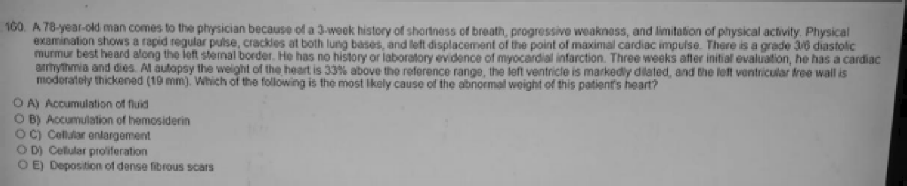

02) A 46-year-old woman comes to the physician because of thinning hair during the paet 2 weeks. Three monthe ago, she began taking several different over-the-counter dietary supplemente. Phyeical examination showe areae of alopecia over the scalp, rough ekin, and cracked lips. The most likely cause of the findinge is exceesive intake of which of the following?

1. A
2. B6 (pyridoxine)
3. C
4. D
5. E

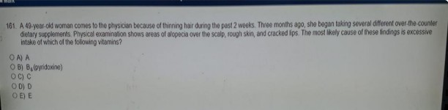

1. A 55-year-old woman with a history of alcoholic dependence has severe epigastric pain and is vomiting large amounts of blood. She has slightly yellow skin and conjunctiva. Her abdomen is large and distended. The bleeding vessels are most likely enlarged due to increased blood flow directly supplied by which of the following veins?
   1. Hepatic
   2. Left gastric
   3. Right gaslro-omental
   4. Splenic
   5. Superior mesenteric

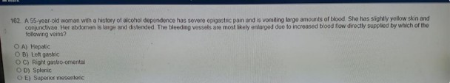

1. A 54-year-old man comes to the physician because of a 4-month history of progressive shortness of breath and left-sided chest pain; he also has had an unintentional 11-kg

weight loss during this period. His temperature is 37 C (98.6 F), pulse is 92/min, respirations are 32/min, and blood pressure is mm Hg. Breath sounds are decreased over the left lung field. A chest x-ray shows a left pleural effusion with a pleural-based mass encasing the left lung. A thoracentesis is done. Analysis of pleural fluid shows cytologically malignant cells that express calretinin. Which of the following best describes the cell of origin of this neoplasm*

* 1. Clara cells
  2. Lymphoid cells
  3. Mesothelial cella
  4. Neuroendocrine cells

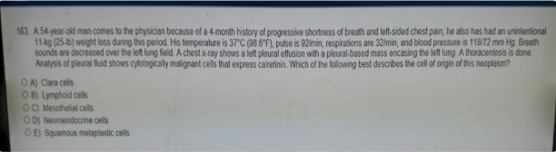

1. A previously healthy 20-year-old woman comes to the emergency department because of a 3-day history of fever, shaking chills headaches. fatigue, and joint and muscle pain. She recently spent the summer working as a lifeguard on Long Island New York. She has never traveled outside the USA. She underwent splenectomy for injuries sustained in a motor vehicle collision at the age of 6 years. Her temperature is 39.1 C (102.4 F). Physical examination shows no other abnormalities. A peripheral blood smear shows small intraerythroc ytic rings' the result of a polymerase chain reaction test for Plasmodium species is negative. Which of the following is the most likely causal organism*
   1. Babesia microti
   2. Bartonella bacilliformis
   3. Bordetella bronchiseptica
   4. Borrelia burgdorferi

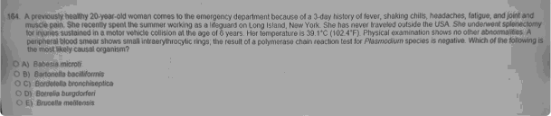

1. An investigator studying type 2 diabetes discovers an inhibitor of unooupling protein-2 that stimulates insulin secretions from mouse pancreatic islet cells. This inhibitor most likely increases insulin secretion by which of the following actions?
   1. Inactivating a tyrosine kinase
   2. Increasing glucokinase activity
   3. Increasing glucoae transporter-2 (GLUT-2) expression Increasing the ATP!ADP ratio
2. Inhibiting the target of rapamycin (TOR) protein kinase
3. Stimulating the hydrolysis of phosphoinositide

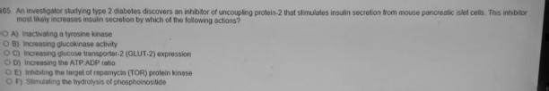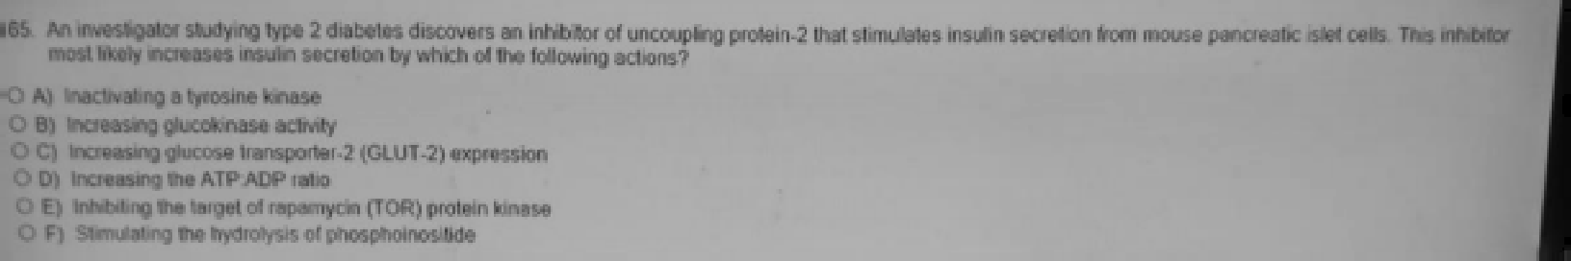

07) A 60-year-old woman comes to the physician because of a 1-month history of bleeding from a leeion on her noee. She has no hietory of major medical illness and takes no medications. Physical examination slows a 1-cm lesion on the right narie. Microscopic examination of a biopsy specimen of the mase ehows neoplaetic oelle that exhibit denee pigment granulee. Which of the following is the moet likely diagnosis†

1. Actinic keratoeis
2. Besal cell caboma
3. Melanoma
4. Rhabdomyosarcoma
5. Squamous cell carcinoma





1. A 76-year-old woman comes to the emergency department because of a 6-hour history of moderate right low back and flank pain. Vital signs are within normal limits. Physical examination shows mild vertebral mediastinal recess (costovertebral angle) tenderness. Urinalysis shows no blood. A CT scan of the pelvis shows hydronephrosis with obstruction of the right ureter caused by external compression at the pelvic brim from a vascular structure. This patient most likely has an aneurysm of which of the following arteries?
   1. Abdominal aoRa
   2. CommOn iTi8C can oomprcss urctcr as it divides into internal and eternal iliac A.
   3. Femoral
   4. Inferior mesenteric
   5. Renal

    



1. A 23-year-old woman files a paternity suit against her boyfriend. claiming that he is the father of her 3-year-old child. Human leukocyte antigen (HLA) typing is done on leukocytes from the mother and boyfriend. Results show!

##### Mother Boyfriend

HLA- A 2. 9 1, 28

HLA-B 27. 53 53, 70

HLA-OR 1 51 7,9

Which of the following HLA profiles of the infant's lymphocytes is most likely to provide evidence that a man other than the boyfriend is the biological father?

|  |  |  |
| --- | --- | --- |
| HLA- A | HLA-B | HLA-DR |
| A) 2. 1 | 53, 70 | 51, 7 |
| B) 2, 28 | 27, 53 | 1, 51 |
| C) 9. 1 | 27, 70 | 51, 9 |

* 1. 9. 2B
  2. 9.2B

27,70

53

1, 7

1, 9



1. During an experiment, a solution of mixed fatty acids is injected into the duodenum of an experimental animal. Under these conditions the clearance rate of an intravenous glucose load from the circulation is doubled. In contrast, an injection of an equal volume amount of 0.9% saline into the duodenum has much less effect on the plasma clearance rate of glucose. These findings are most likely caused by the secretion of which of the following hormones?
   1. Gastrin
   2. Glucose-dependant insulinotropic peptide
   3. Motilin
   4. Secret in
   5. Somatostatin

101) Which of the following agents blocks the release of an autacoid from its cellular storage

site*

1. Atropine
2. Cimetidine
3. C£OWOlgn sOd iUM prcvc nts release of histamincs and Ie uLo ricncs from mas cclIs.
4. Omeprazole
5. Propranolol
6. A 32-year-old woman comes to the physician because of a 6-month history of darkening of her skin, muscle weakness. and decreased appetite. Her blood pressure is 105/60 mm Hg. Physical examination shows hyperpigmentation of the mucous membranes and the skin over the elbows. knuckles knees. and toes. Serum studies are most likely to show which of the following sets of findings in this patient?

|  |  |  |
| --- | --- | --- |
| Sodium | Potassium | 8 AM Cortisol |
| A) 125 | 2.6 | 2.6 |
| B) 150 | 3 | 12 |
| C) 158 | 3 | 31 |
| D) 125 | 5.2 | 0.8 |
| E) 164 | 6.8 | 18 |

  

1. A study is performed to evaluate the effect of a new lipid-lowering agent on LDL- cholesterol in 20 persons with dyslipidemia. Results are shown!

Mean fasting LDL-cholesterol Standard deviation

Before Therapy

190

35

One week after therapy

150

25

The researchers concluded that LDL-cholesterol was significantly decreased by drug therapy. with a level of significance of 5%. If the study is repeated with a larger sample size which of the following is the most likely outcome?

* 1. Decreased power of the statistical test
  2. Decreased standard of error of the mean
  3. Increased mean difference between LDL-cholesterol before and after treatment
  4. Increased probability that the statistical test will have a false-negative outcome
  5. Increased standard deviations of LDL-cholesterol before and after treatment

1. A 76-year-old man undergoes laparotomy for resection of an abdominal aortic aneurysm. During the proced ure, an incidental finding of acquired colonic diverticula is made. The diverticula in this patient are most likely present in which of the following*
   1. Ascending colon
   2. Cecum
   3. Descending colon
   4. Sigmoid colon
   5. Transverse colon



1. Which of the following correctly pairs an effect of histamine with its receptor type?
   1. Bronchodilation H1
   2. Decrease capillary permeability H2
   3. Pain and itching H1
   4. Stimulation of gastric acid secretion H1
   5. Mydriasis H2

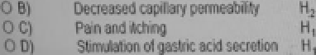

1. In a community eurvey, the prevalence of asthma among children with mothers who emoke cigareltee is 0.7% compared with a prevalence of 5.4% among children with mothers who do not smoke. The p-value for the difference ie 0.03. Thie p-value indicates the probability of which of the following†
   1. Detecting a confounding biae
   2. Detecting a measurement bias
   3. Detecting a selection bias

Reje g a falae null hypot eeta

Rejecting a true null hypotheeis

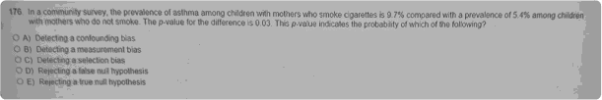

1. A 27-year-old man who works in a boiler room comes to the physician because he and his 32-year-old wife have been unable to conceive a child for the past 3 years. He had the mumps at the age of 12 years. He tells the physician that his wife was evaluated for infertility and test results were normal. He adds. "Could it be my work? I've heard that high temperatures cause infertility.” He is muscular and has a deep voice. Phy sical examination shows abundant facial and body hair and a normal penis. His testicles are 3 cm long. Semen analysis shows azoospermia. His serum follicle-stimulating hormone and luteinizing hormone concentrations are less than 1 mlU/mL. His serum testosterone concentration is 36 nmoI/L (N=10-35). Which of the following is the most likely cause of the development of azoospermia in this patient*
   1. Excessive testicular temperature
   2. Gonadotropin-releasing hormone deficiency
   3. Obstruction of seminal vesicles
   4. Use of exogenous testosterone
   5. Viral orchitis
   6. XXY karyotype (Klinefelter syndrome)

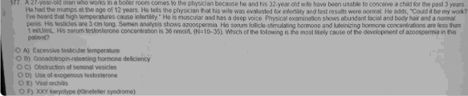 

1. A study is conducted in which the right renal artery of an experimental animal is oonstricted to decrease accurate artery pressure by 20 mm Hg. Measurement of inulin clearance shows that renal artery constriction has no effect on glomerular filtration rate (GFR). Mhich of the following best explains the maintenance of a constant GFR in this experiment?
   1. Decreased glomerular filtration ooefficient
   2. Decreased glomerular hydrostatic pressure
   3. Decreased renal blood flow
   4. Increased afferent arteriolar resistance
   5. Increaaed efferent arteriolar reaistance
   6. Increased renal blood flow

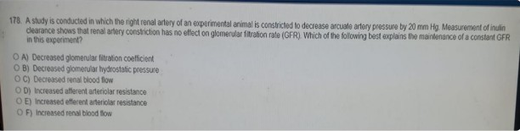

1. A 2-week-old boy is brought to the physician because of persistent cyanosis. Hemoglobin concentration and erythrocyte morphology are normal. An x-ray of the chest and an echocardiogram disclose no abnormalities. Which of the following is the most likely cause of the cyanosis?
   1. Hemolytic anemia
   2. Megaloblastic anemia
   3. Methemoglobinemia
   4. A-thalassemia
   5. B-Thalassemia

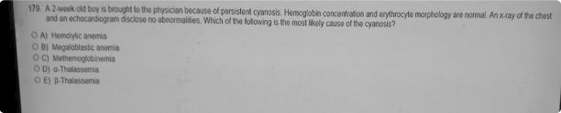

1. A 56-year-old woman comes to the physician because of cough productive of blood-tinged sputum for 8 days. She also has a fatigue, loss of appetite, and an unintentional 6.8-kg (15-lb) weight loss during the past 2 months. She has a 5-year history of chronic cough and shortness of breath that she had attr ibuted to smoking 2 packs of cigarettes daily for 42 years. She appears ill. Physical examination shows dullness to percussion over the right lower lung lobe. A chest x-ray shows a mass in the right upper lung lobe. The gross and microscopic appearance of a lung from a patient with a similar condition are shown. Which of the following is the most likely type of neoplasm in this patient?
   1. Adenocarcinoma
   2. Giant cell carcinoma
   3. Large cell undifferentiated carcinoma
   4. Small cell carcinoma
   5. Squamous cell caminoma

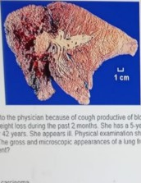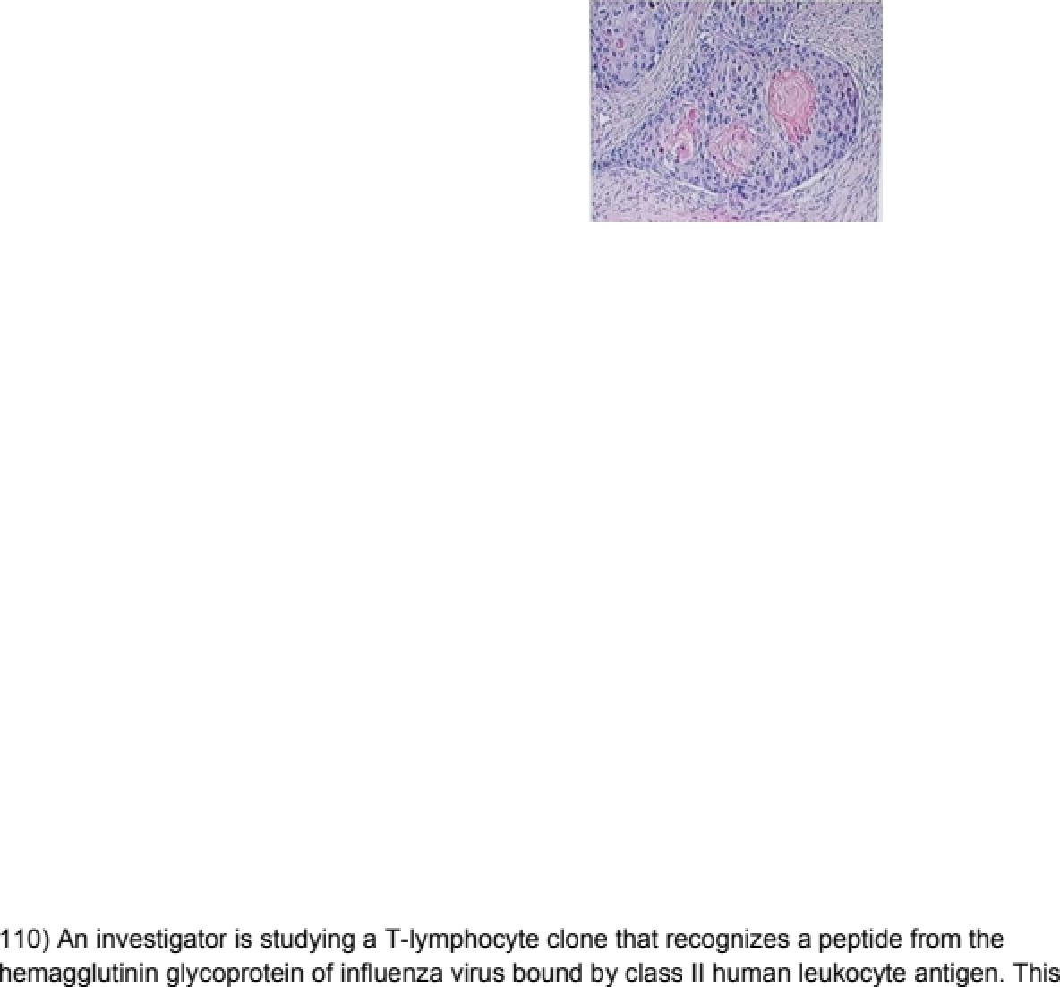

###### conemos+Iikely ecognizesa pepfldethatwas combined with a humanleukocyeanflgenin

which of the following cellular compartments*

1. Cytosol
2. Endoplasmic reticulum (Class 1)
3. Endosomes (Class 2)
4. Mitochondria
5. Nucleus



1. An investigator is studying a substance abuse problem among school-age children that involves taking large doses of over-the-counter cough medication containing dextromethorphan. The effects range from mild excitement with hallucinations to a sense of complete dissociation from the body. The investigator notes that this substance is an N-methyl-D-aspartate receptor antagonist. The psychological effects of this substance most closely resemble those of which of the following?



* 1. Methamphetamine
  2. Propofol
  3. Tetrahydrocannabinol

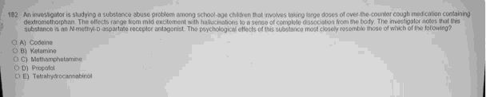

1. A 6O-year-old man comes to the physician because of a 6-month history of Iight- headedness, numbness and paresthesias of his hands and feet and fatigue. Physical examination shows pallor and decreased positional and vibration senses. Laboratory studies show:

Hemoglobin 9 g/dL

Hematocrit 27%

Serum

102 um

Gastrin Markedly increased Intraluminal stomach acid Markedly decreased

The most likely cause of this patient's symptoms is destruction of which of the following labeled areas in the photomicrograph of normal stomach mucosa*

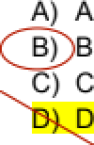



1. A 24-year-old woman at 33-weeks’ gestation comes to the physician for a routine prenatal visit. She has had fatigue and mild shortness of breath with exertion. Which of the following is normally increased at this stage of pregnancy*
2. Arterial carbon dioxide tension
3. Hepatic protein production
4. Pulmonary functional residual capacity
5. Serum osmolality
6. Systemic vascular resistance

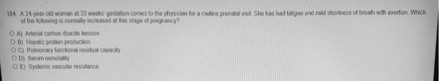

1. A 22-year-old woman hae an increase in blood preseure after using phenylephrine for chronic allergic rhinitie. Thie increase ie caused by activation of which of the following enzymee†
2. Adenylyl cyclaee
3. Guanylyl cyclase
4. Phosphodiesterase
5. Phosphodiesteraee
6. Phospholipase A2
7. Phospho ›aae C
8. Protein kinase A

BâmuTatim of avg 1 receptors (VC veBsaN noBe to breathe. Afiin) leads to rac6on, BâmuTatim of Qq pa&way, PLC, TPS. PM. Ca DAD.

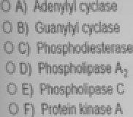

1. A 2-month-old boy is brought to the physician because of decreased movement, weakness, and poor suck since birth. His sister died at the age of 2 years because of respiratory insufficiency. He is alert. Physical examination shows poor head control absent deep tendon reflexes, and generalized hypotonia. Results of a mutation analysis show that he is homozygous for deletion of the survival motor neuron (SMN1) gene. Which of the following is the most likely mode of inheritance in this patient?

Autosomal dominant Autosomal recessive Mitochondrial



B)

)

X-linked dominant

X-linked recessive

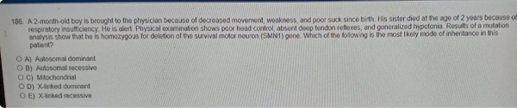

1. A 22-year-old man comes to the emergency department because of a painful rash on his right arm for 3 days. His temperature is 37.8 C (100 F). Physical examination shows a vehicular rash on an erythematous base over the C5-6 dermatomes of the right upper extremity and white patches on the buccal muoosa. A photomicrograph of a giemsa stain of tissue taken from the floor of an unroofed vesicle is shown. This patient should be screened for which of the following*
2. Chronic granulomatous disease
3. Congenital agammaglobulinemia
4. Creutzfeldt-Jakob disease
5. Epstein-Barr virus
6. HIV infection

 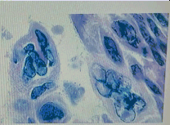

1. A 2O-year-old woman comes to the physician because of an 8-year history of excessive bleeding with menses. Menses have occurred at regular 28-day intervals since menarche at the age of 12 years. She also has a history of easy bruising and frequent mild gingival bleeding after brushing her teeth. Her family history is unknown because she was adopted. Physical and pelvic examinations show no abnormalities. Laboratory studies show!

Hemoglobin 9g/dL Hematocrit 27oé Leukocyte count 5300/mm

Platelet count 145,000/mm Prothrombin time 12 sec (INR=1 ) Partial thromboplastin time 48 sec

This patient'a condition is moat likely caused by a deficiency of which of the foIkr›ving factor2

1. Epidermal growth factor
2. Factor V Leiden
3. Factor VII (prooonvertin)
4. Factor VIII (antihemophilic factor)
5. Factor X **(Sltualt factor)**
6. Vqn Willebrend fectxs



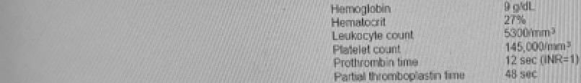

1. A 6&year-old woman with a 20-year history of hypertension ia brought to the emergency department 30 minutes afler the sudden onset of right-sided weakness. Her apeech is dyaarthric. Physical examination ahows g of the right side of the face. Viaual field testing shows no deficits. Muacle strength is ‘A in the right upper extremity and X in the right lower extremity. Deep tendon reflexea are 2+ in the upper extremitiea and left k›wer extremity and 3+ in the right lower extremity. jet throughout. Babinski aign ia present on the right. Mental atatua examination shows no abnorrrialities. Which of the following ia the moat likely cauae of thia patient's condition‘2

Fmbolism of the right anterior cerebral artery Lacunar infarct of the internal capaule Ruptured aneurysm of the cimle of Willis

" Thrombua of the M paaterior cerebral artery

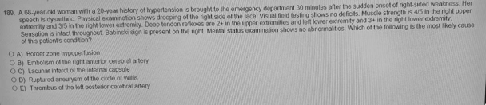

1. An investigator conducts a study of cranial nerve regeneration among two groups of experimental animals. During the study, the facial nerves are severed in one group (Group X) and the optic nerves are severed in the second group (Group Y). Three months later, it is found that the severed facial nerves among animals in Group X have regenerated, but the severed optic nerves among animals in Group Y have not regenerated. Which of the following best explains the absence of nerve regeneration among the animals in Group Y?
2. Axona of the optic nerve are myelinated by oligodendrocytea
3. The blood vessels that supply the retina cannot grow to supply the optic nerve
4. Regenerating optic nerve fibers cannot cross the optic chiasm
5. Retinal ganglion neurons are formed by neural crest cells
6. Retinal photoreceptors are nonpermissive for optic nerve regeneration
7. A 16-year-old boy ie brought to the physician because of a 3-day history of difficulty walking because his right foot drops when he lifte it. He ie a member of a wreetling team at his high echool. Physical examination showe weaknese of the right ankle dorsiflexor muecles. The right ankle evertor muscles have full power. Seneation to pinprick ie decreaeed between the great and second toee of the right foot. sensation over the rest of the fc›ot is normal. Which of the following nerves ie moet likely damaged in this patient†
8. Common fibular (peroneal)
9. Deep fibuler (peror›eal)
10. Sciatic
11. Superficial fibular (peroneal)
12. Tibial
13. Patients with a genetic defect in the expression of the beta chain of the B2 integrins (CD18) do not express the leukocyte integrins LFA-1. the glycoprotein Mac-1 p150,95 or complement receptors CR3 and CR4. Which of the following best explains the recurrent bacterial infections that occur in these patients?
14. B lymphocytes fail to produce complement-fixing IgG antibodies
15. Neutrophils fail to undergo an oxidative burst in response to ingested bacteria
16. Phagocytes fail to efficiently emigrate from the blood into inflamed tissues
17. Phagocytes fail to efficiently ingest bacteria in tissues
18. Phagocytes fail to efficiently recirculate through lymph nodes
19. T lymphocytes fail to efficiently mature in the thymus



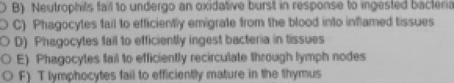

1. A 35-year-old woman comes to the physician because she is interested in starting a weight-loss program. She has a sedentary lifestyle. She is 168 cm (5 ft 6 in) tall and weights 82 kg (180 lb), BMI kg/m. Physical examination shows no other abnormalities. The physician refers her to a dietician for nutritional assessment and counseling. The dietician determines that the patient is consuming 200 g of carbohydrates, 65 g of protein, 50 g of fat, and 15 g of alcohol daily. This patient's average daily caloric intake meal is most likely equivalent to which of the following kilocalories?
2. 1615
3. 1845

#)

carbs and protein- 4 al alcoho-l 7caI

fat -9aI

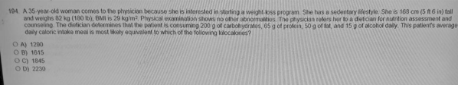

1. A 2O-year-old man is brought to the emergency department 30 minutes after he was found unconscious in the weight room of his oollege fitness center. His roommate says the patient had injected himself with insulin in an attempt to build muscle. He appears comatose. Physical examination shows no other abnormalities. His serum glucose ooncentration is 25 mg/dL. The findings in this patient are most likely the result of an increase in which of the following enzyme activities?
   1. Adenylyl cyclase
   2. Guanylyl cyclase
   3. Phospholipase A2
   4. Phospholipase C
   5. Protein kinase A
   6. Tyrasine kinaae
2. A 30-year-old woman, gravida 1 para 0, at 32 weeks' gestation comes to the emergency department because of a 2-day history of fever, nausea, and headache. Physical examination shows a uterus consistent in size with a 30-week gestation. Serologic testing prior to pregnancy showeda posiflveIgGanGbodytiter+oToxopasmagondii Boodculuesg owasmalg am- positive rod which grows as pinpoint B-hemolytic colonies on sheep blood agar. The organism is catalase positive and exhibits tumbling motility. This infection could have been prevented by avoiding which of the following?
   1. Consumption of delicatessen meats r t «
   2. Consumption of grapefrui( juice
   3. Contact with cats
   4. Contact with dogs
   5. Contact with rabbits

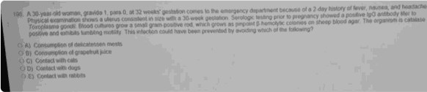

1. A 4-year-old girl is brought to the physician by her parents 2-days after the mother noticed streaks of blood on the child's well-formed stools. Her father has pigmented macules on his lips. A paternal aunt had breast cancer. Physical examination shows several 2- to 3-mm pigmented macules on the lips and buccal mucosa. Rectal examination shows no abnormalities. Test of the stool for occult blood is positive. Colonoscopy is done and three polyps are removed, the largest measuring 1 x 1 x 1 cm. This patient's polyps are most likely which of the following types?
   1. Adenomatoua Hamartomatous "““°'•’
2. Hyperplastic
3. lnflammatory
4. Lymphoid

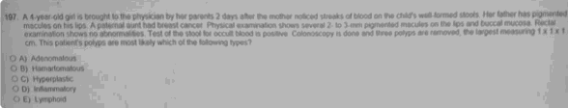

1. A 55-year-old man comes to the physician because of a 3-week history of night sweats, weakness, fatigue, loss of appetite, and lumps in his neck. He owns a printing business and works with paints and solvents. Physical examination shows edematous, tender axillary and inguinal lymph nodes. His leukocyte count is 45,570/mm (80°/ large, pleomorphic blasts with Auer Rods). Occupational exposure to which of the following most likely contributed to the development of this patient's disease?
   1. Benzene
   2. Cadmium
   3. Chlordane
   4. Naphthylamine
   5. Vinyl chloride

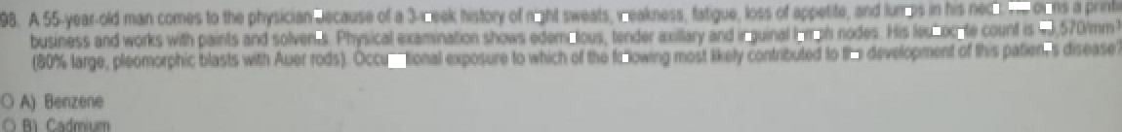

1. A 35-year-old woman and her 35-year-old husband come to the physician for genetic counseling after their son is diagnosed with a rare metabolic disease. Assuming Hardy- Weinberg equilibrium. the physician tells the parents about the incidence and carrier frequency of this disorder. Which of the following is most likely to disturb the Hardy-We inberg equilibrium of this disorder*
   1. Appreciable rate of gene mutation
   2. Random matings in the population
   3. Relatively large population
   4. No selection against a certain genotype
   5. No significant immigrant population



1. A 65-year-old woman with cirrhosis comes to the physician because of progressive shortness of breath during the past 3 months. Her pulse is 94/min, respirations are 20/min and blood pressure is 100160 mm Hg. Physical examination shows ascites and marked edema of the lower extremities up to the hips. A chest x-ray shows bilateral pleural effusions. Echocardiography shows a left ventricular ejection fraction of 55%. Which of the following is the most likely cause of the increased intra-alveolar fluid in this patient*
   1. Decreased cardiac systolic function
   2. Decreased plasma colloid osmotic pressure
   3. Increased capillary hydrostatic pressure
   4. Increased vascular permeability
   5. Lymphatic obstruction

